(Director, Khateeb Institute of Technical Education)

**Sunville Properties Database management Sys**



Submitted by:

Gaurav Suvarna

Submitted to:

Sunville Properties

Under the Guidance of:

Prof. Junaid Khateeb (Director, Khateeb Institute of Technical Education)

Date of Submission: 10th July 2020.

**Certificate Of completion**

**This is to certify that, Mr has**

**successfully implemented an application .**

**The Application has been accepted as a completed project as it meets all the requirements specified.**

**12th July 2020**

**_______________________**

**(Khateeb Institute of Technical Education)**

Acknowledgements

I would like to express my sincere gratitude to thank my professors and

supervisors & for providing their proper and invaluable guidance, comments and suggestions throughout the course of the project. I would specially thank for constantly motivating me to work harder. Also, I would like to thank for his assistance for the code & for his help during the preparation of the sample, for providing me an overview of the entire project.

Table of Contents

1. Introduction
2. Section 1: System Requirement Specifications
3. Section 2: Technology Used
4. Section 3: Database
5. Section 4: Snapshots
6. Section 5: Testing
7. Section 6: Source Code
8. Conclusion

**INTRODUCTION OF THE PROJECT**

**1. OBJECTIVE**

**Sunville Properties is a Colorado based property consultancy firm. They have appointed their agents across Major Cities around the world. They have sub-Companies which take care the business in different countries and are placed in the countries from where they operate from. The Company currently has been using multiple forms of data storage and want to streamline their working using an application, which can help them seamlessly navigate via different forms of**

**storage. Also, the company seeks some insights into the current data and also going further in future. So, it has requested specific modules to be introduced in the system.**

**Section 1 :**

**System Requirement Specifications:**

**So, we had to build an application for a real estate company “Sunville Properties” which can help them keep a track of their business and help them grow accordingly. To make that happen, we have to provide them with a proper visual interface so that only their agents can access their data.**

**1) A Visual Interface to add the data inside each of their tables. A login authentication is mandatory for anyone to be able to modify the data.**

**2) The company needs an order look up (i.e. search) based on the following criteria,**

**a) Order number**

**b) Order Date**

**c) Customer code**

**kindly note: the company might use either one or all of them together at a time.**

**3) Generate a report that highlights the balance amounts for all orders in descending order. Do mention the name and code of the agent handling the order. This information needs to be updated in the database.**

**4) Which is the country with maximum number of registered customer and what is the collective payment amount and outstanding amount for all these customers collectively.**

**The company needs the following insights**

**1) On selection of the year, system should help them get the following**

**a) The total property area sold vs total property are leased in Sq-M only.**

**b) Of the years 2017,2018,2019- which year got maximum leased area in CA and WS countries.**

**c) What are the Agent codes of all the agents who have got deals in ‘OWNED’ categories across the years.**

**d) For the city of Chilliwack, which agent has got the maximum deals in leased form.**

**e) Compare the performance of all agents based on the area leased and owned for the years 2017,2018 and 2019. Who has been the best performer?**

**f) The Company seeks a time series analysis report of the orders received.**

**(in this section explain in details, what is the system to be designed, requirements and the desired results)**

**Section 2:**

**Technology used**

**We have made use of python programming language to build the application**

**While building this project we have extensively used the softwares such as PyCharm (python interpreter), Xamp server (for handling database) and the internet.**

**From Python module we have used Tkinter to build the GUI for the application**

**Section 3:**

**Data Provided by the client:**

**We were given a dataset of a Real Estate Company called Sunville Properties   
We were also provided with all the properties sold in the month July from years 2017,2018,2019,2020.  
We were also provided with the company details of the agents, orders, company, customers photos of which are as follow**

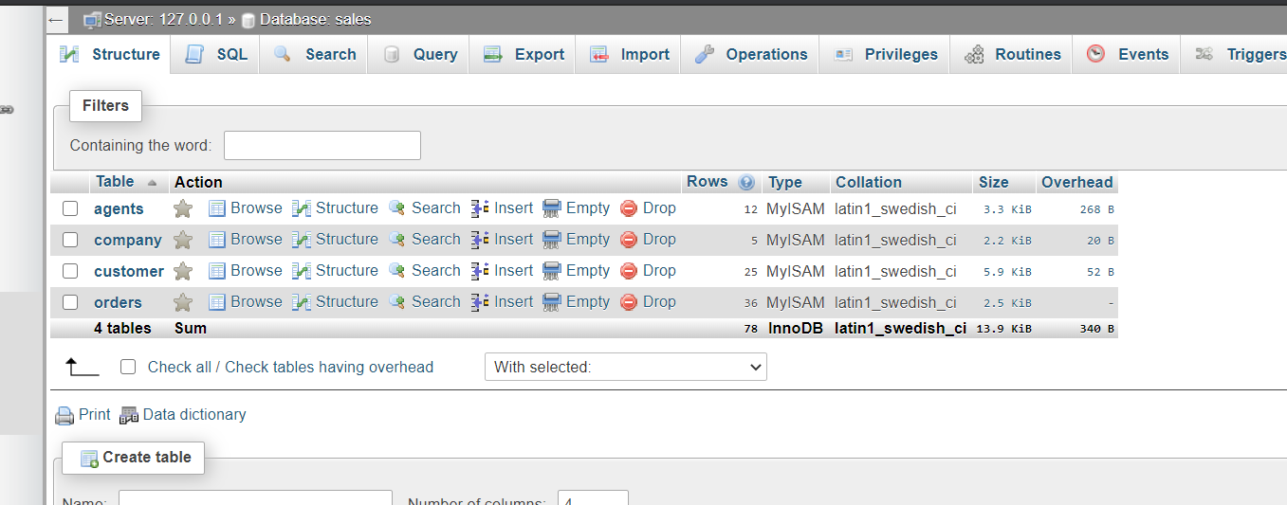

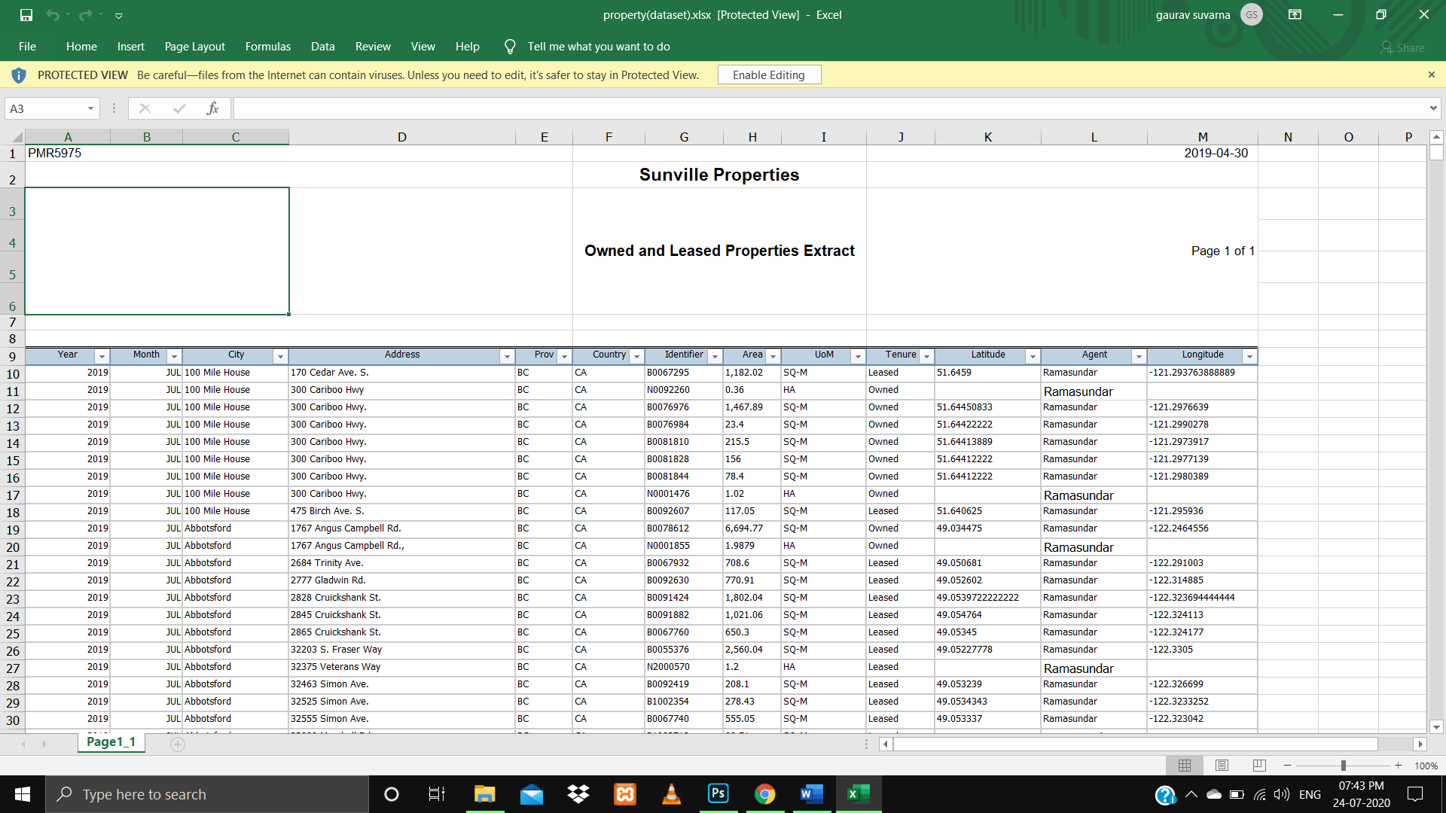

**Section 4:**

**Screenshots:**

**Login page:**

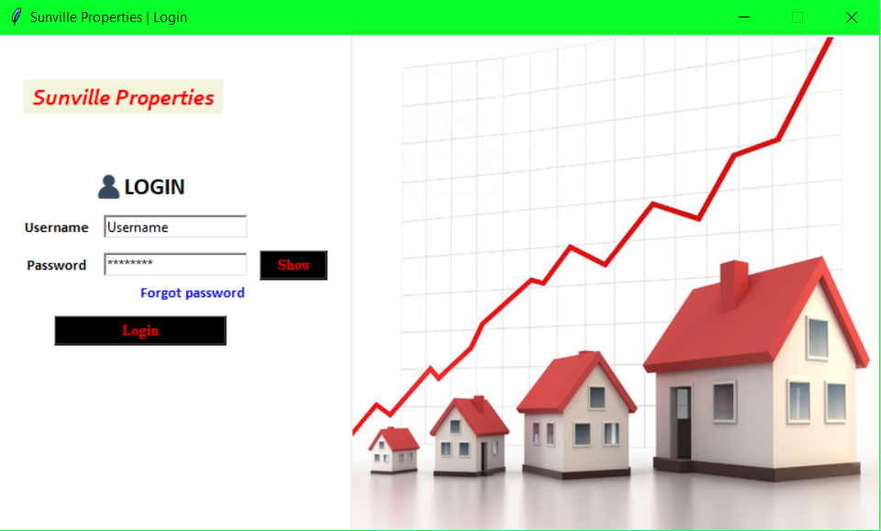

**Forgot Password Page:**

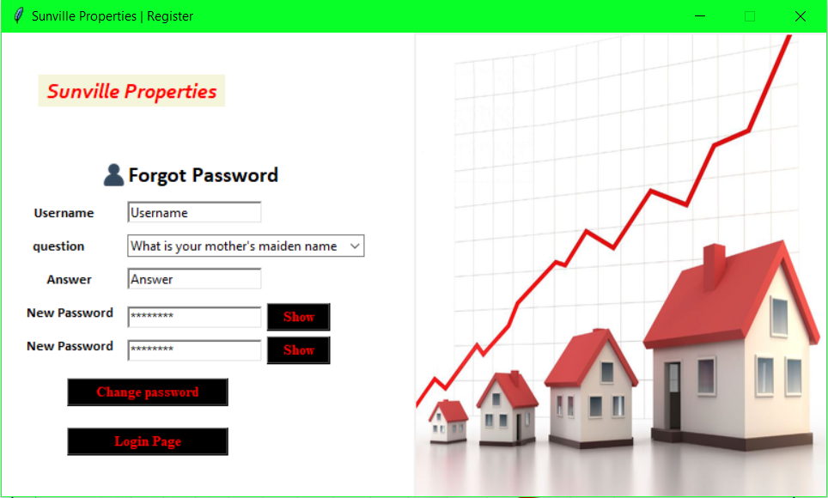

**Menu page:**

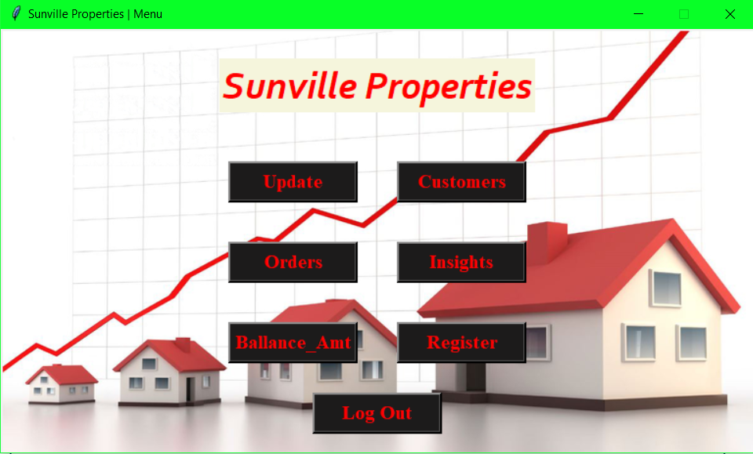

**Register Page**

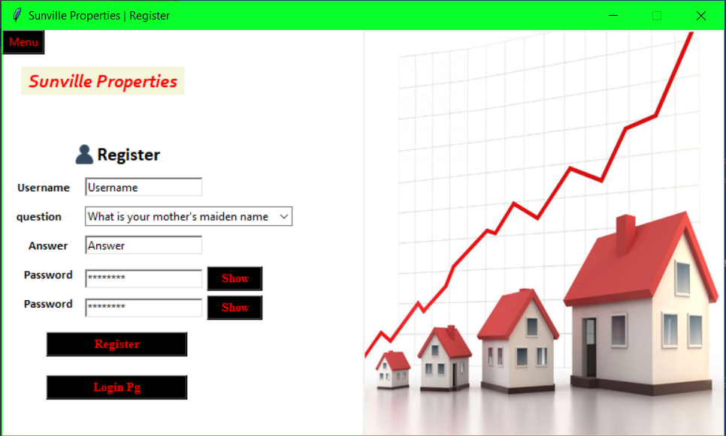

**Update page:**

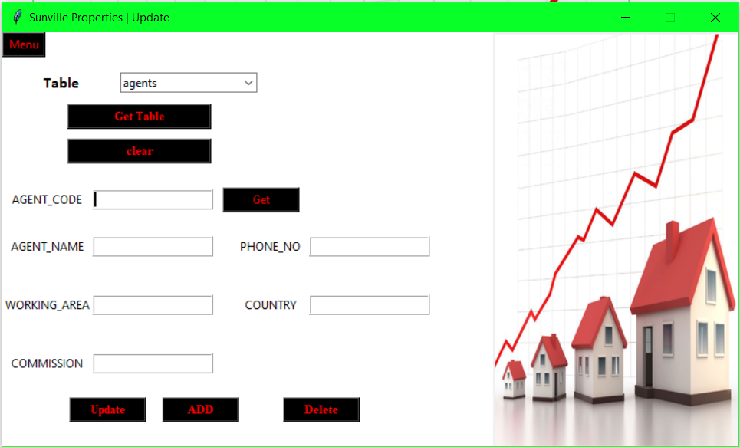

**Orders Page:**

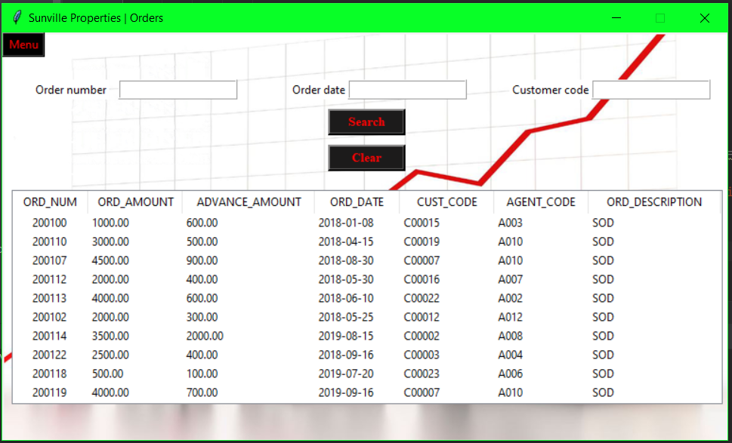

**Balance amount:**

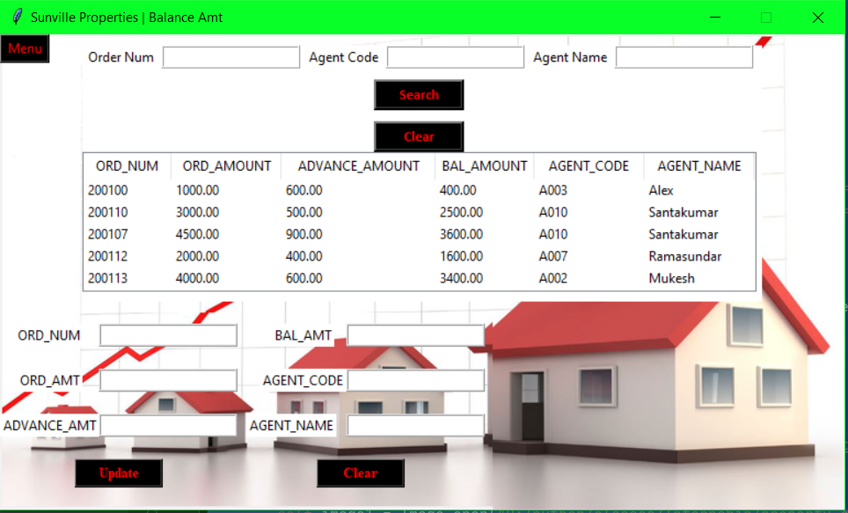

**Customers page:**

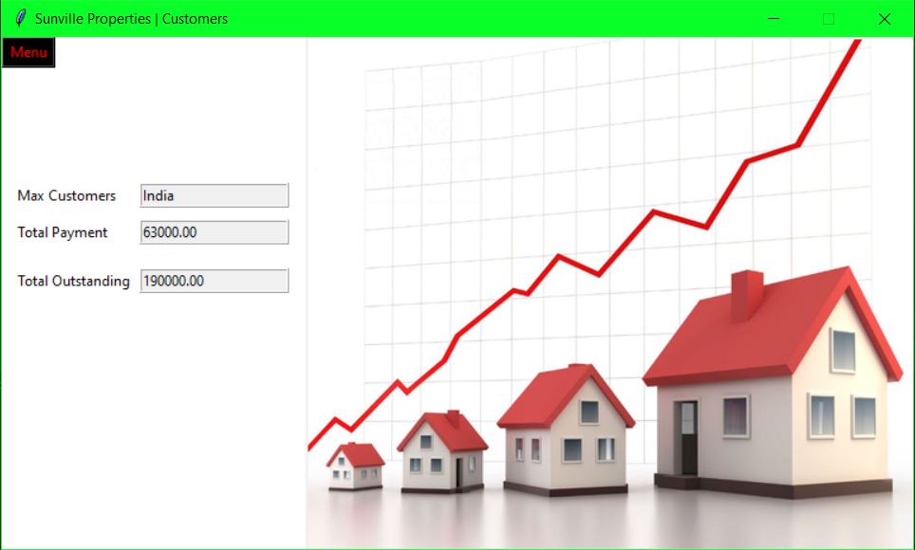

**Insights page:**

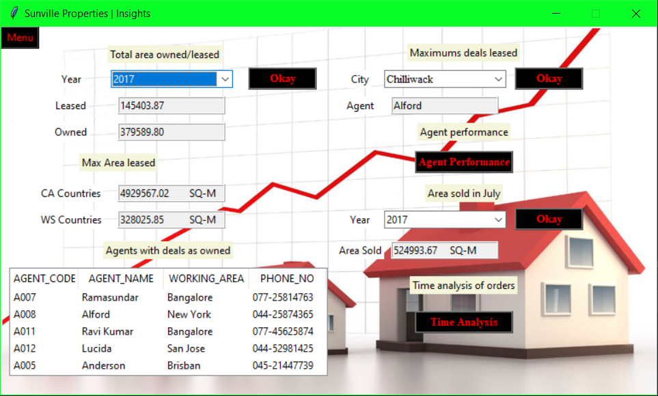

**Section 5:**

**Testing:**

**The application has been tested to make it as fool-proof as possible. There are validations in place that do not allow wrong data format entry, as in entering letters where only numbers should be allowed or the correct phone no format and such**

**Login page**

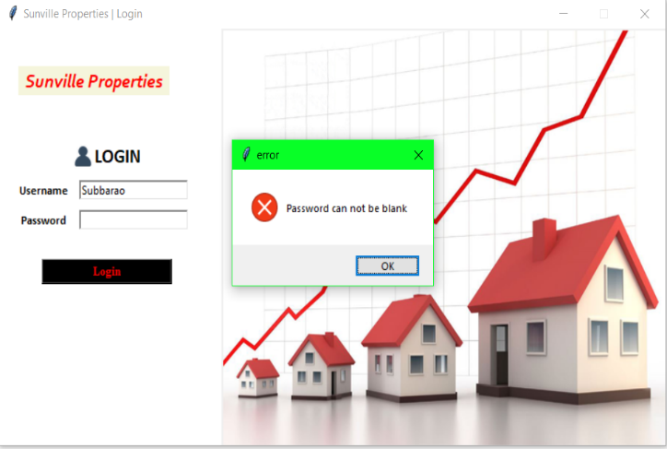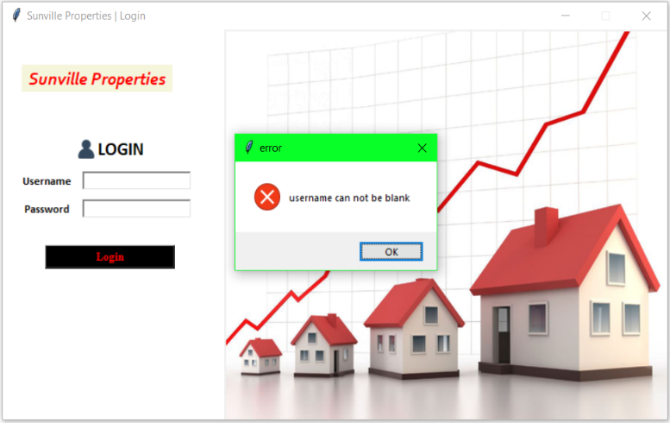

**On entering correct username and password**

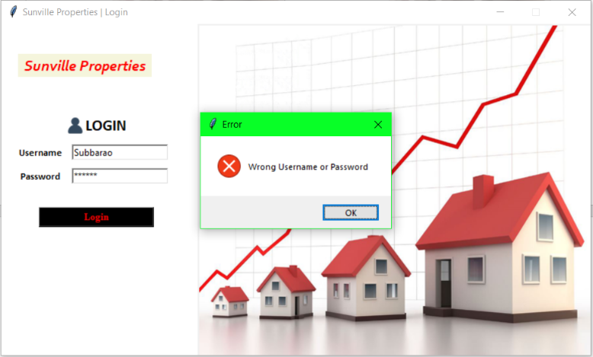

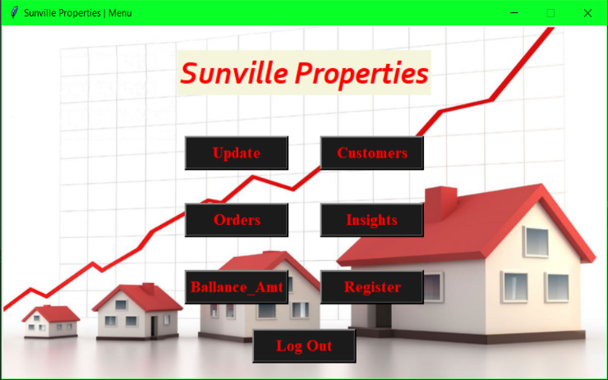

**Update page:**

**Using the get button:**

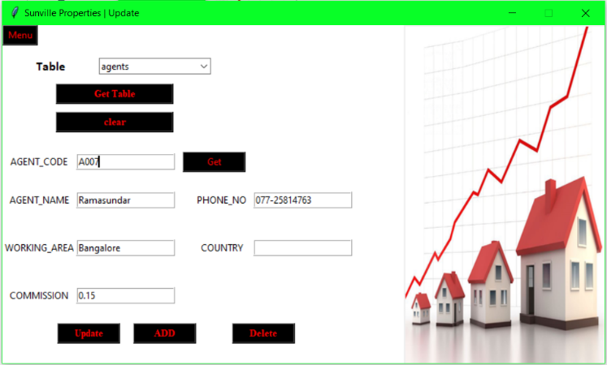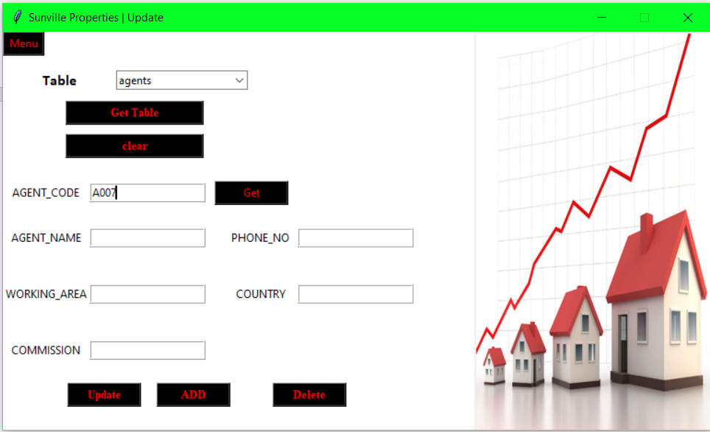

**Using Add button:**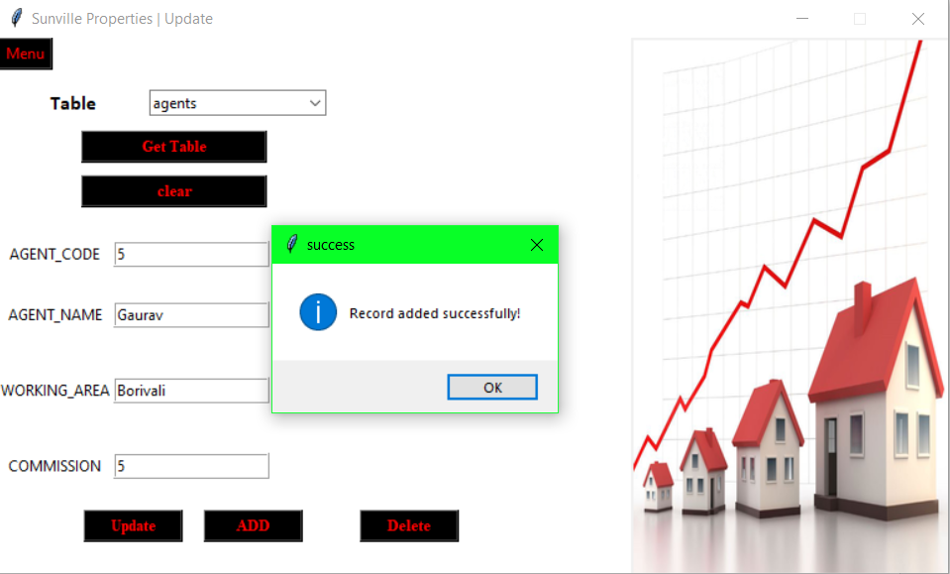

**When trying to add a record with code (primary key) that already exist**

**It gives the option of weather to update the record or not**

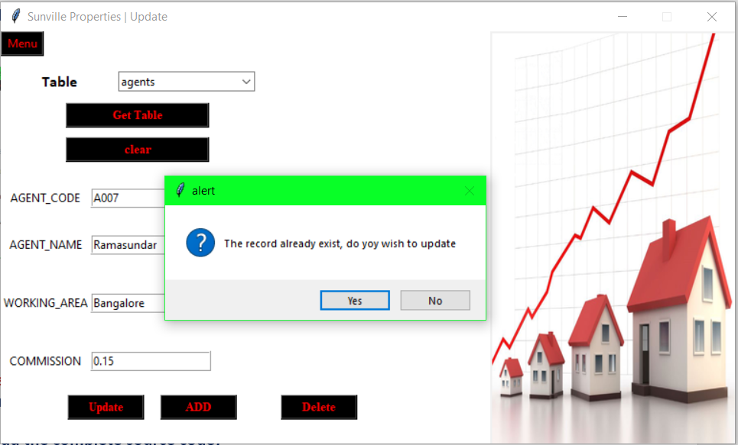

**Using the get table button**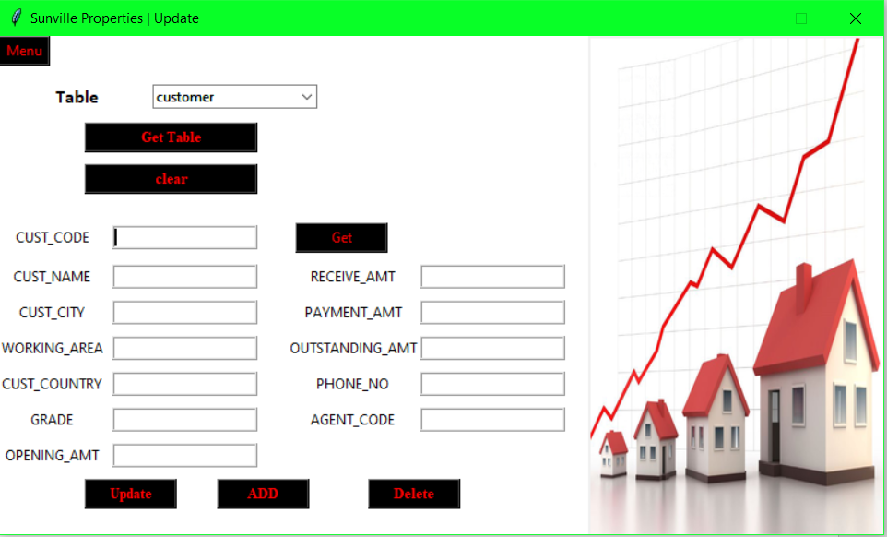

**Using the clear button:**

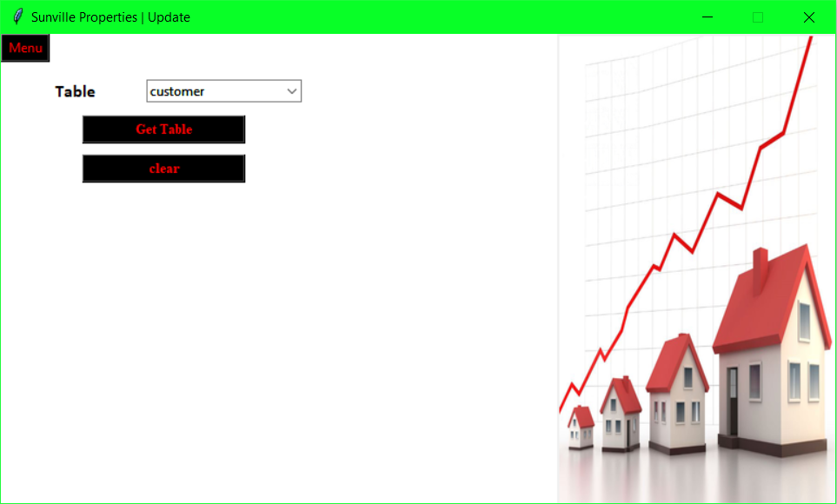

**Using update button:**

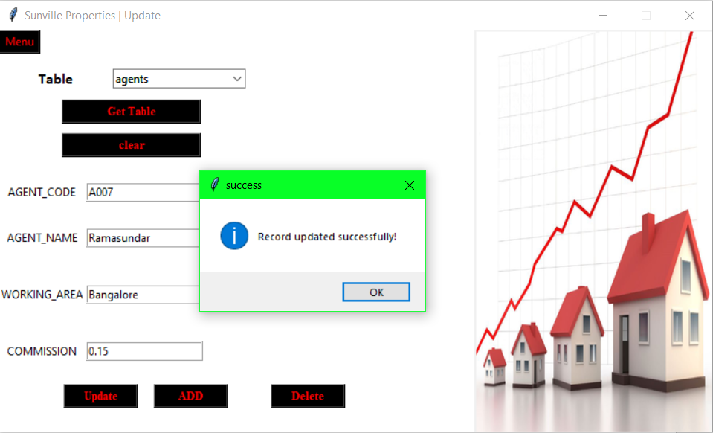

**Using get button on a record that doesn’t exist:**

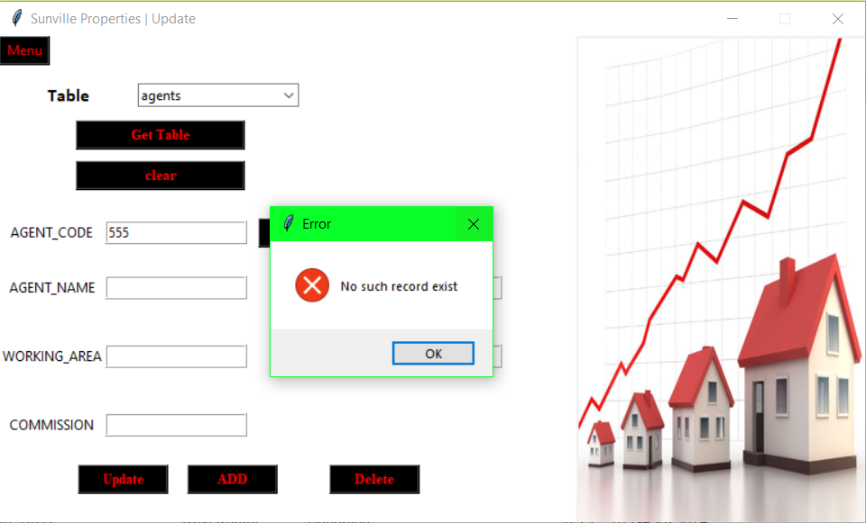

**Using the delete button:**

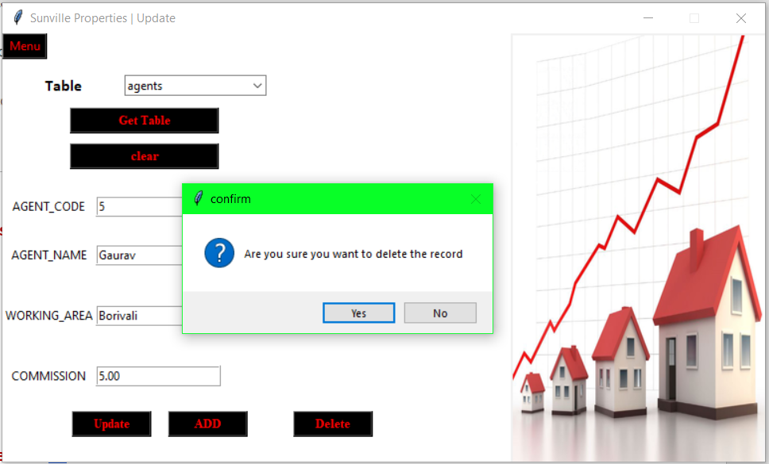

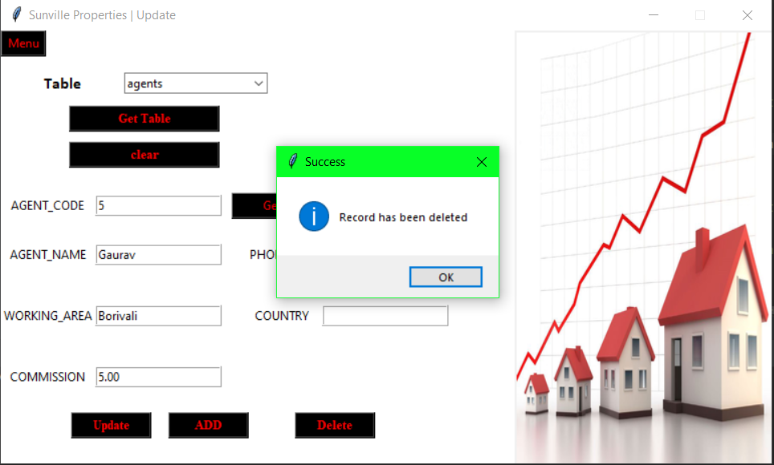

**Orders page:**

**Using search with one field:**

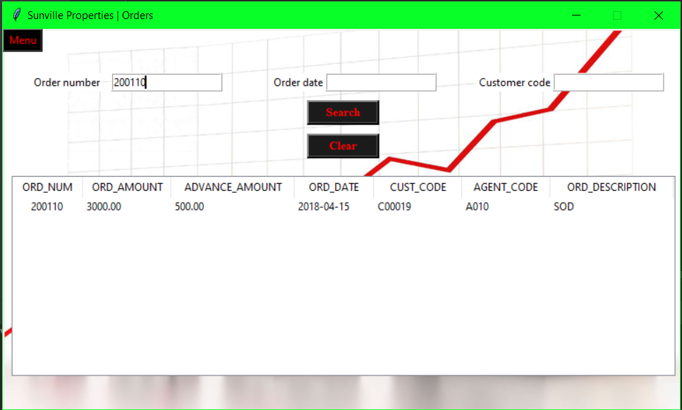

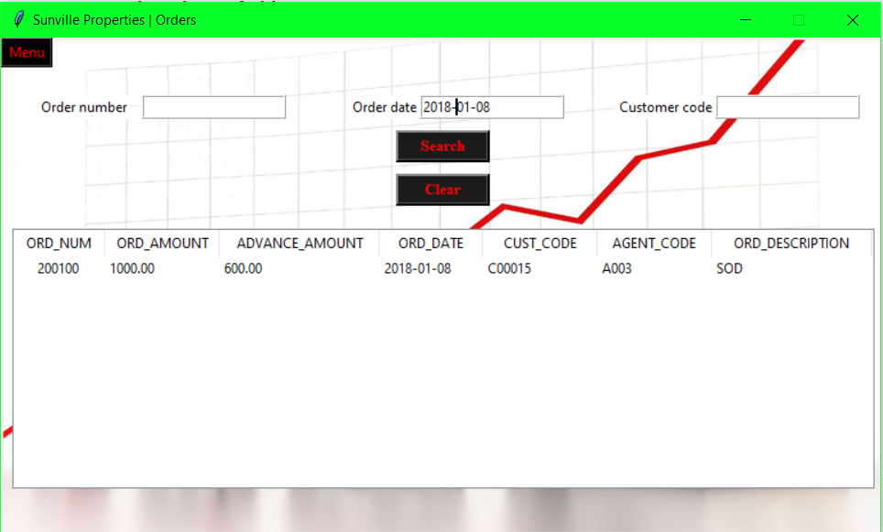

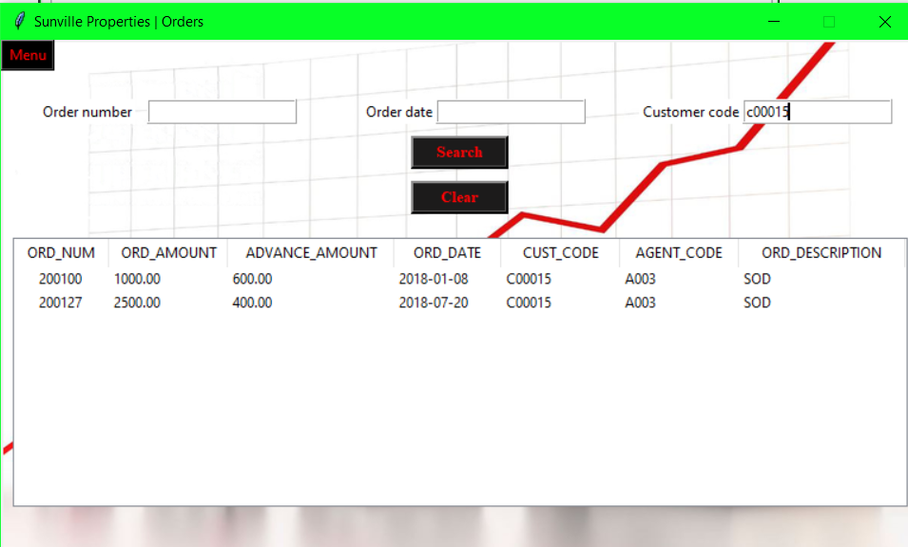

**Using 2 fields:**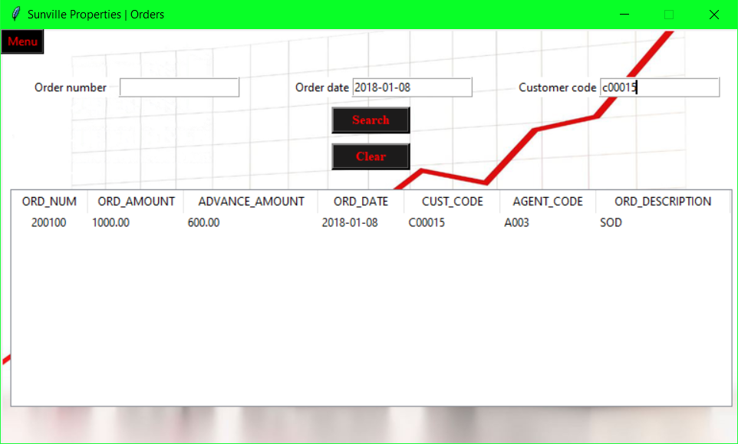

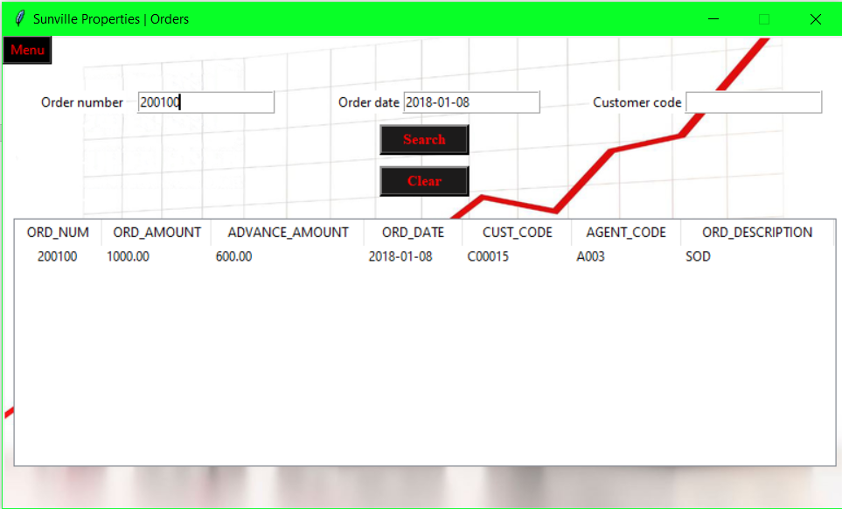

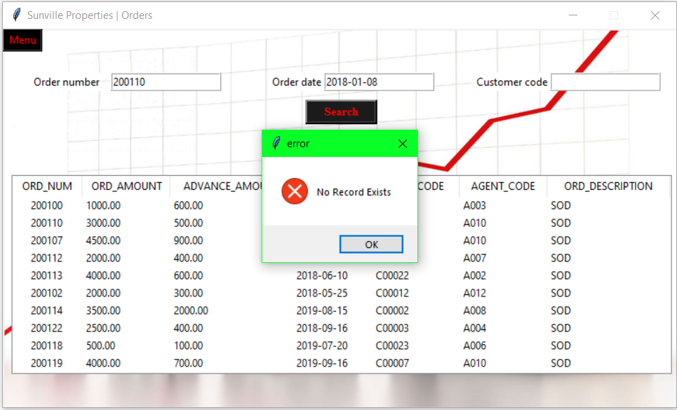

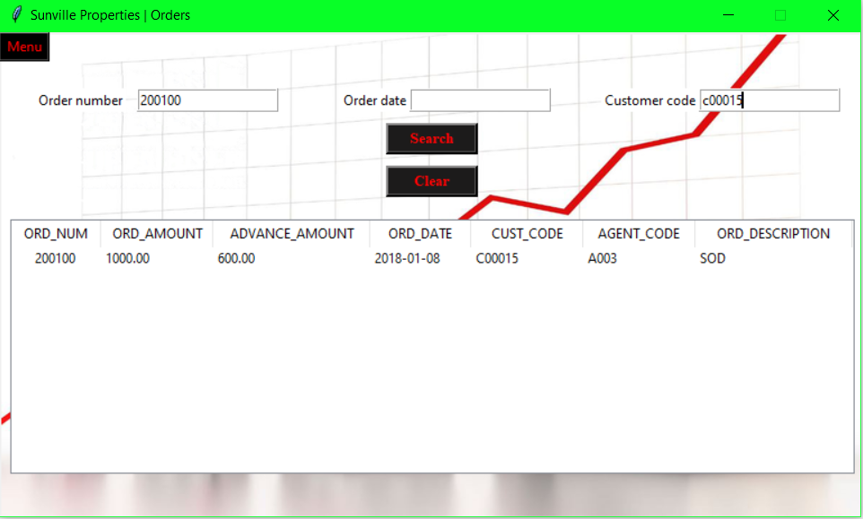

**All 3 fields:**

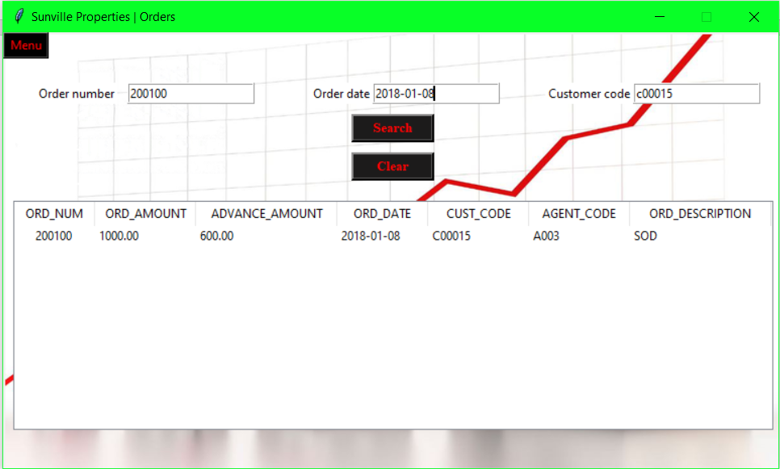

**Using ‘clear’ button:**

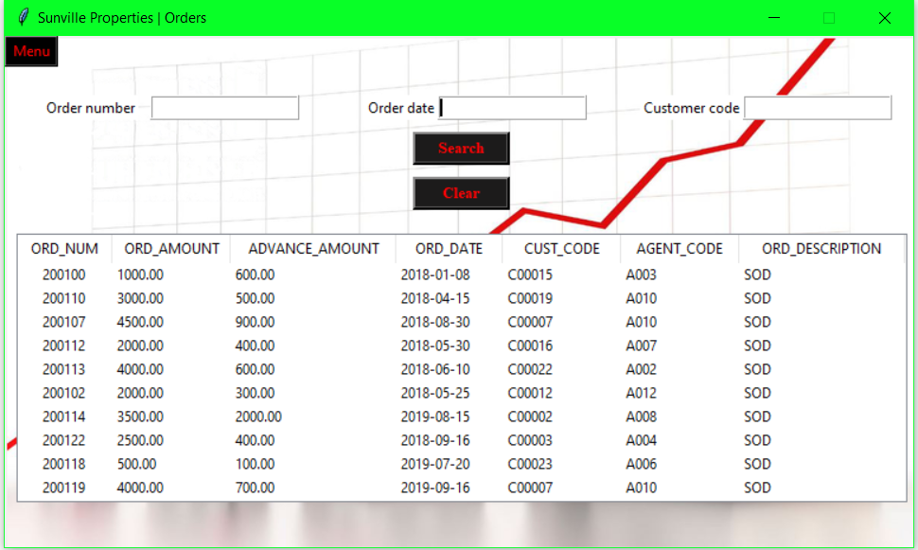

**Balance amount page:**

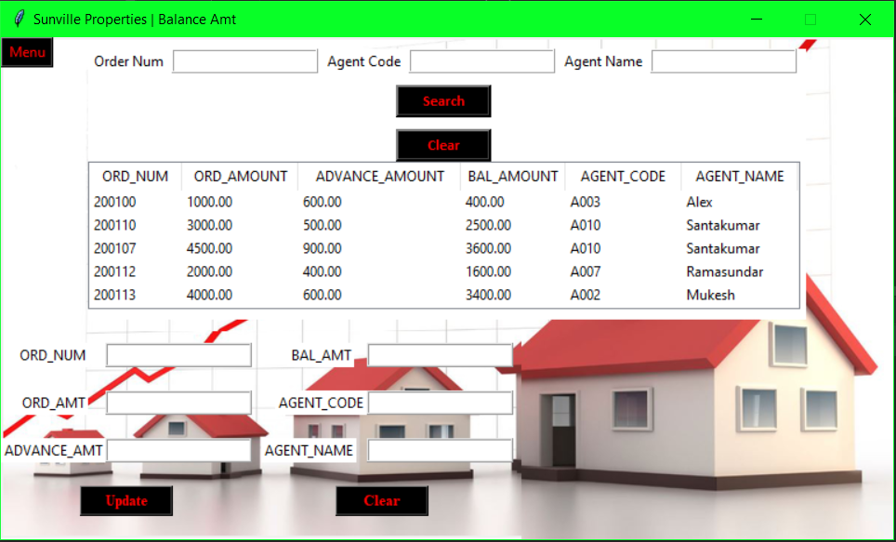

**Search fields:**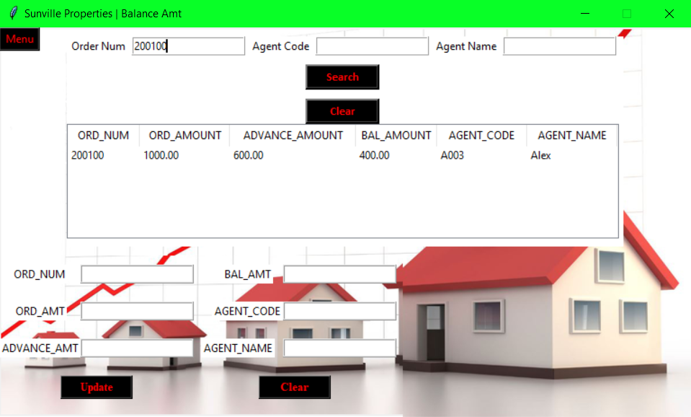

**double click on a record to get value:**

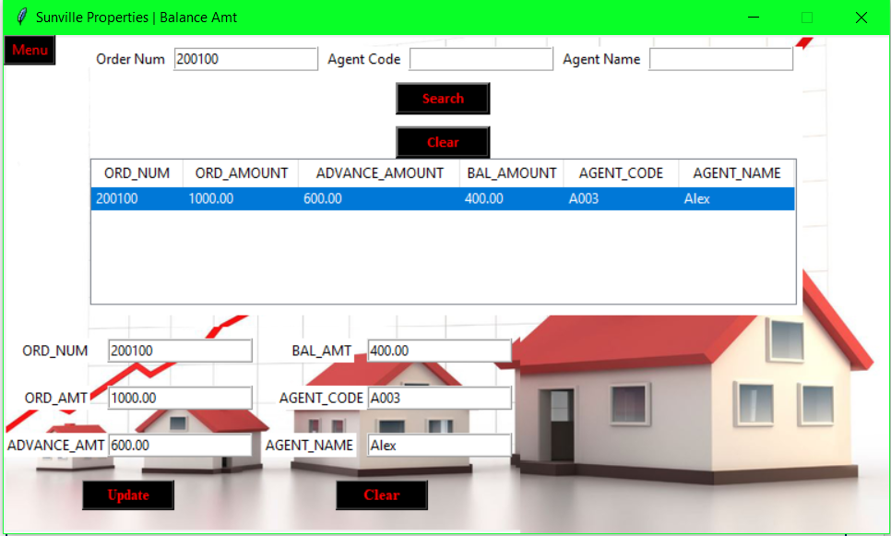

**Update button:**

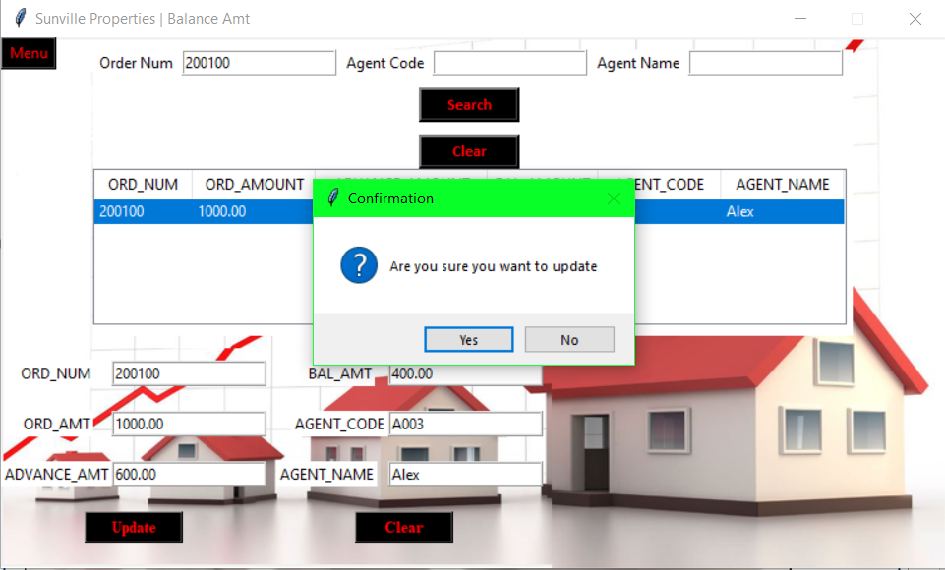

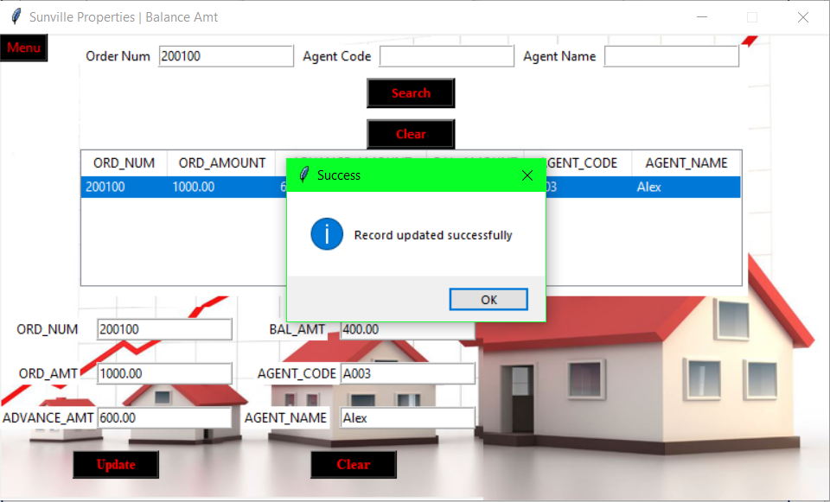

**Insights page:**

**Year is changed in ‘total area owned/leased’ section:**

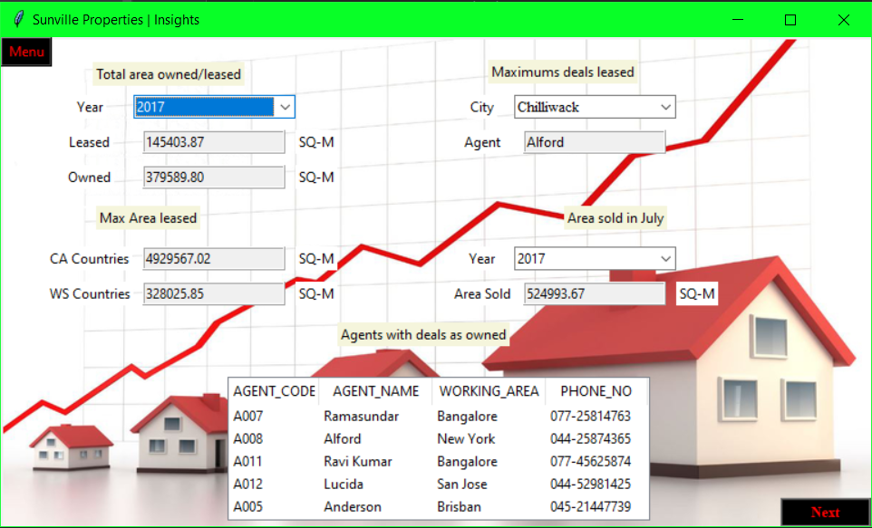

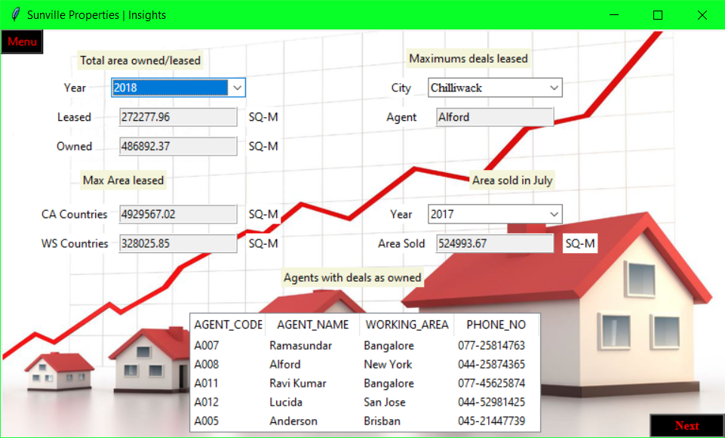

**City is changed in ‘Maximum deals Leased’ section:**

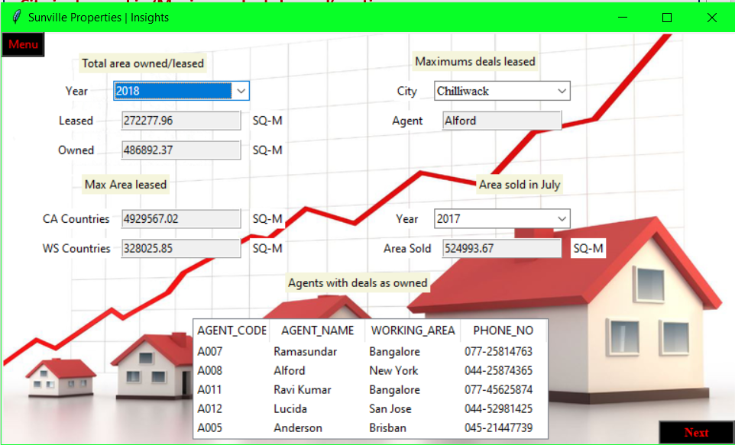

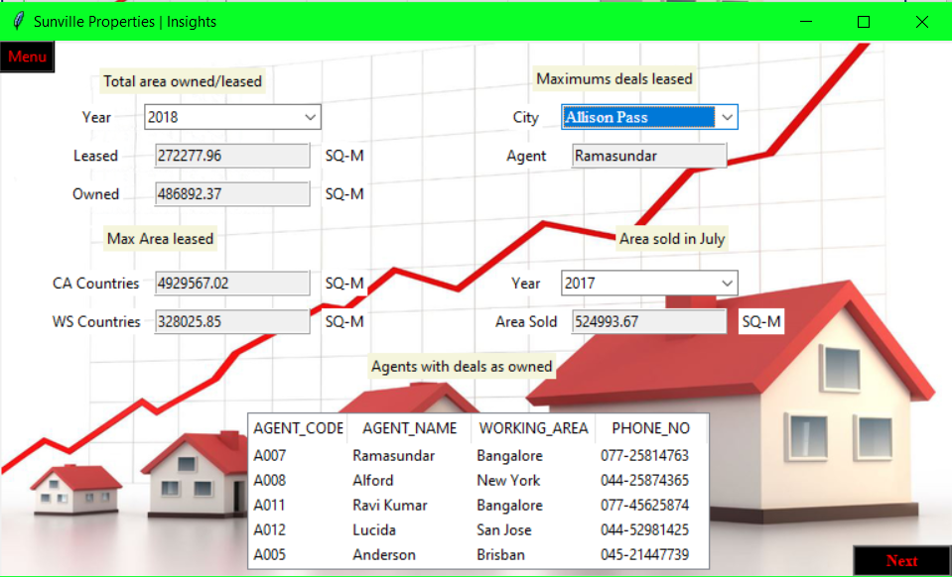

**Area sold in July:**

**Year is changed:**

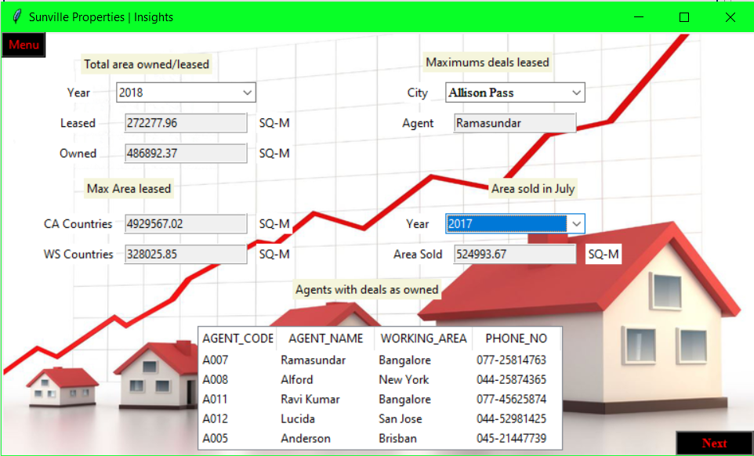

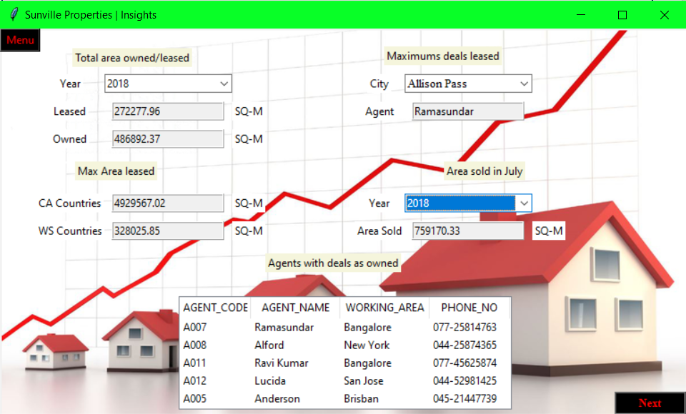

**Agent performance Next is clicked:**

**Year: 2017**

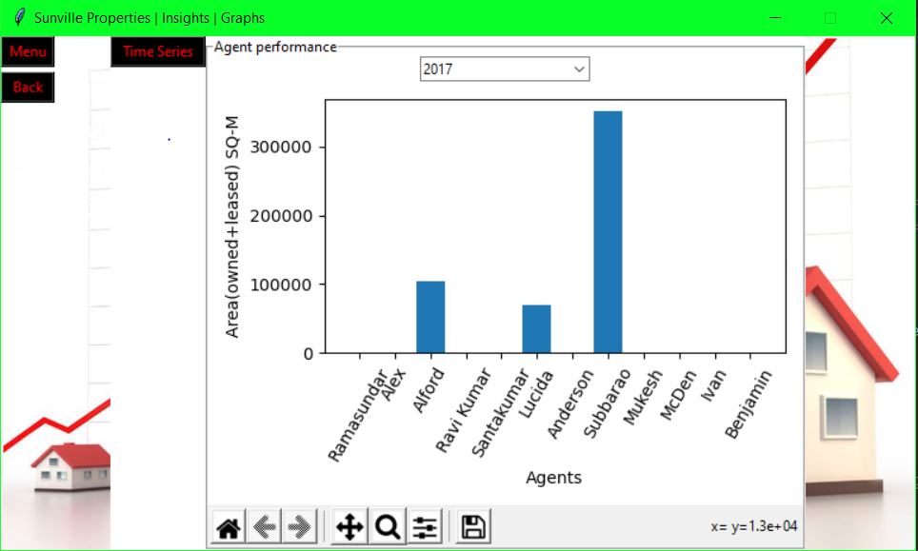

**Year: 2018**

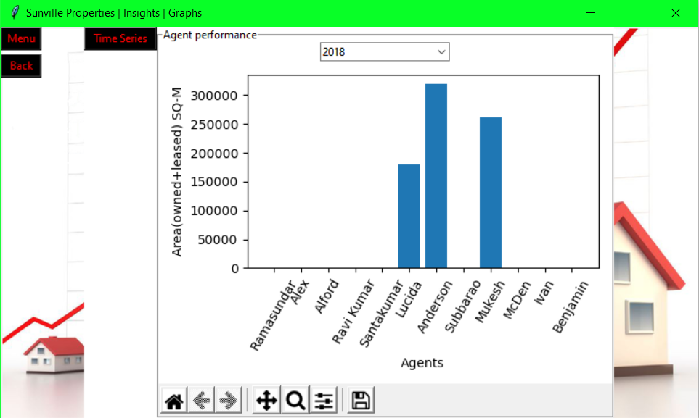

**Year: 2019**

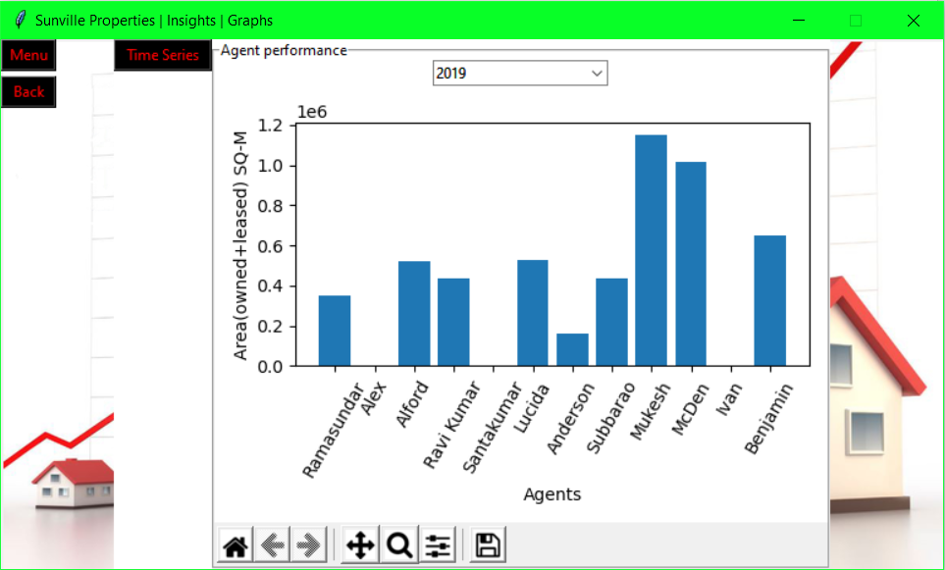

**Year 2020:**

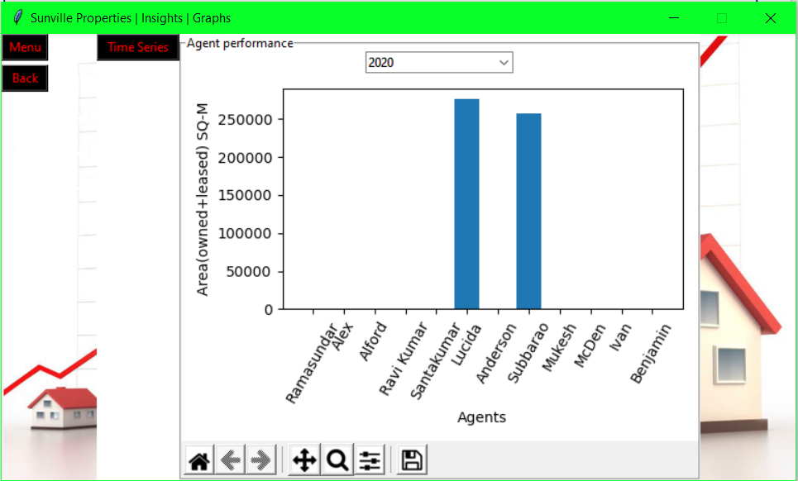

**Year 2017-2020:**

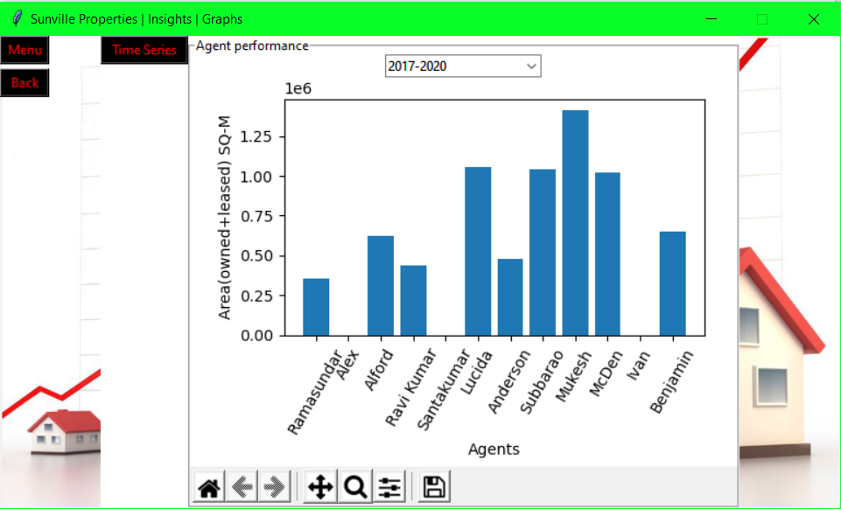

**Time analysis button is clicked:**

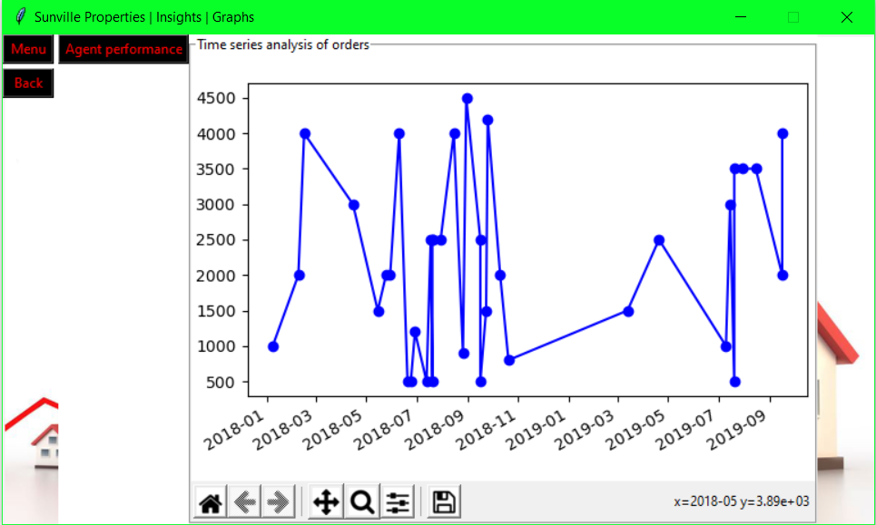

**Agent performance Button is clicked again**

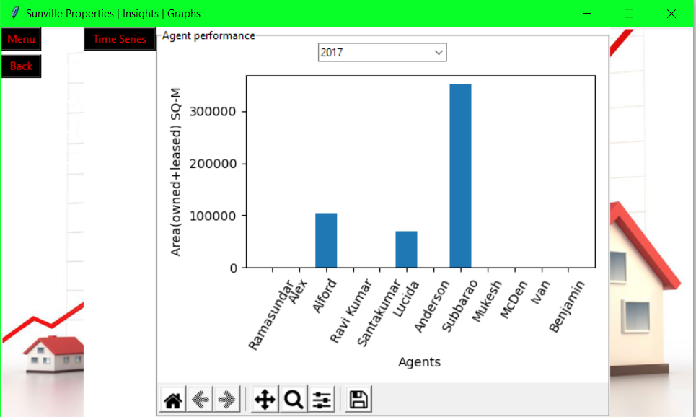

**Register Button is clicked:**

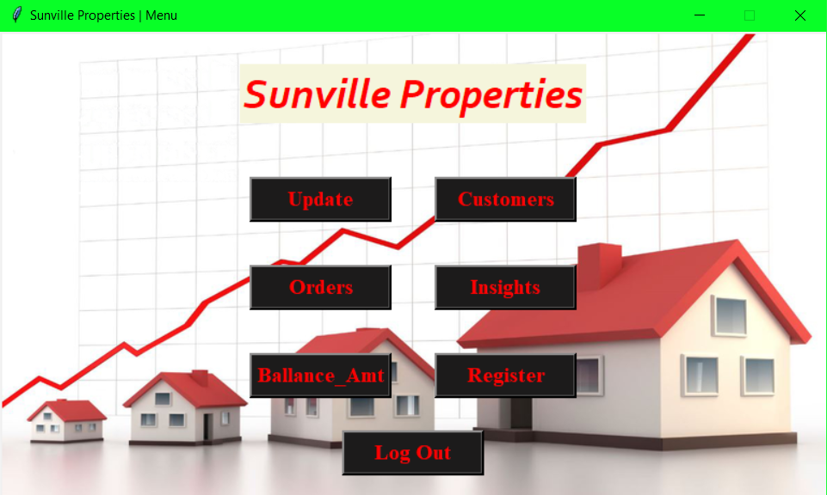

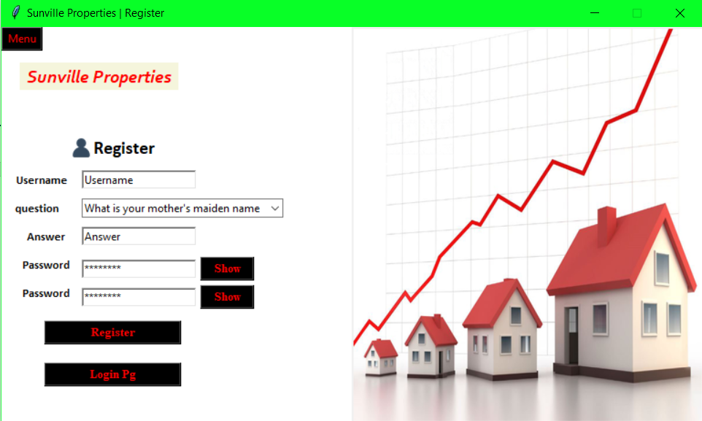

**Log out is clicked on meu screen:**

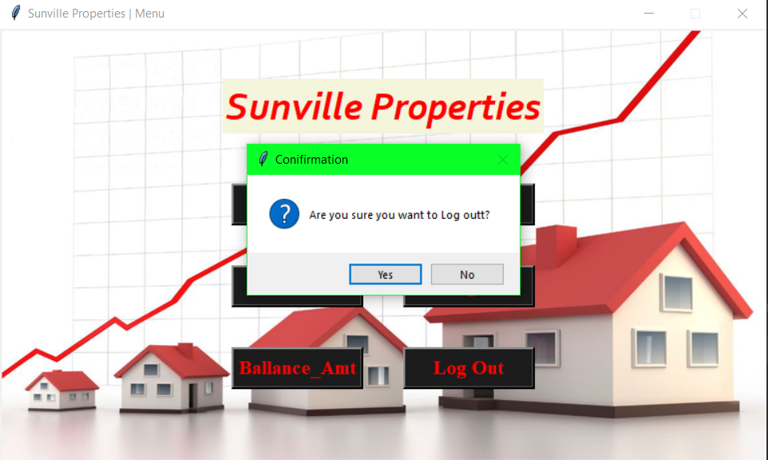

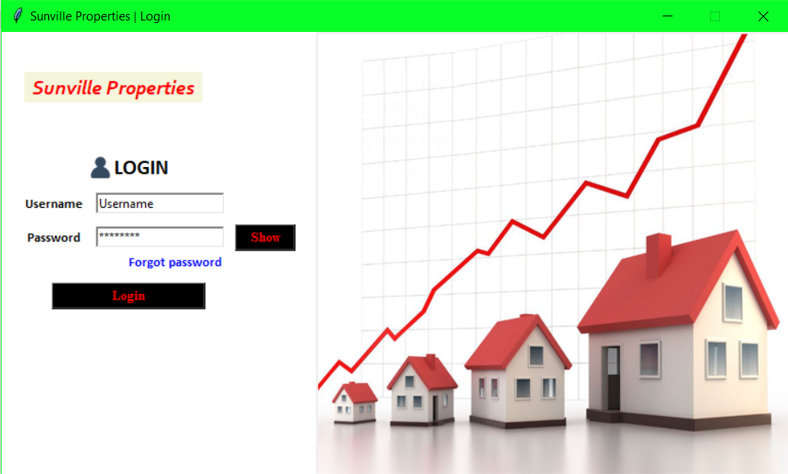

**Forgot Password is clicked:**

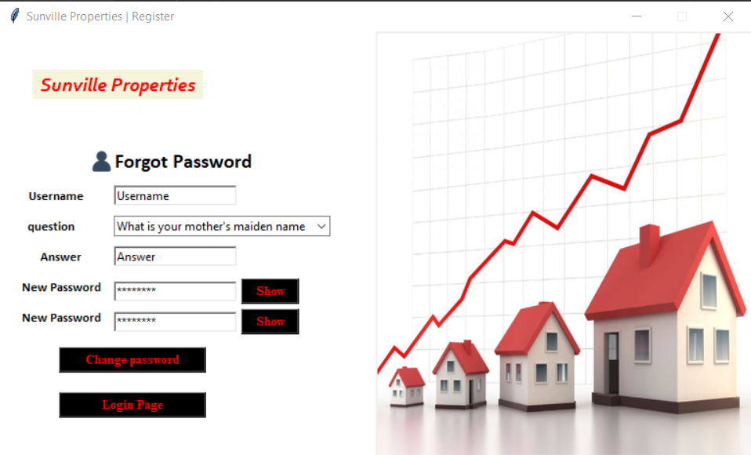

**Section 6:**

**Final code:**

<https://github.com/gaurav2055/Sunville-Properties-python-internship>

**Login Module:**

from tkinter import *  
from PIL import ImageTk, Image  
from tkinter import messagebox  
import db.db  
import menu  
import forgot_password  
  
  
class Login:  
 def __init__(self):  
  
 # creating tkinter window  
 self.root = Tk()  
  
 # setting window title  
 self.root.title("Sunville Properties | Login")  
  
 # determining size of window  
 self.windowWidth = self.root.winfo_screenwidth() / 2  
 self.windowHeight = self.root.winfo_screenheight() / 2  
  
 # determining the the positon to set the window  
 self.positionRight = int(self.root.winfo_screenwidth() / 2 - self.windowWidth / 2)  
 self.positionDown = int(self.root.winfo_screenheight() / 2 - self.windowHeight / 2)  
  
 # Positions the window in the center of the page.  
 self.root.geometry(  
 "{}x{}+{}+{}".format(int(self.windowWidth), int(self.windowHeight), self.positionRight, self.positionDown))  
  
 # disable resize of window  
 self.root.resizable(False, False)  
  
 self.FirstClick = True  
  
 def login(self):  
  
 # variable of entry fields  
 self.username_e = StringVar()  
 self.username_e.set("Username")  
 self.password_e = StringVar()  
 self.password_e.set("password")  
  
 # creating frame for login form  
 self.frame1 = Frame(self.root, bg="White")  
 self.frame1.place(x=0, y=0, width=int(self.windowWidth / 2.5), height=int(self.windowHeight))  
  
 # creating frame for image  
 self.frame2 = Frame(self.root, bg="blue", )  
 self.frame2.place(x=int(self.windowWidth / 2.5), y=0)  
  
 # getting image  
 self.image1 = Image.open("D:/python/classes/Internship/property-consultants-mumbai.jpg")  
 self.image1 = self.image1.resize((int(self.windowWidth -(self.windowWidth/2.5)), int(self.windowHeight)), Image.ANTIALIAS)  
 self.image_bg = ImageTk.PhotoImage(self.image1, master=self.root)  
  
 # placing image  
 self.background_label = Label(self.frame2, image=self.image_bg)  
 self.background_label.pack()  
  
 # heading  
 self.heading = Label(self.frame1, text="Sunville Properties", font=("corbel", 15, "bold italic"), bg="beige",  
 fg="red")  
 self.heading.grid(row=0, column=0, columnspan=4, ipadx=5)  
  
 # login image for entry form  
 self.image2 = Image.open("D:/python/classes/Internship/user.png")  
 self.image2 = self.image2.resize((25, 25), Image.ANTIALIAS)  
 self.login_img = ImageTk.PhotoImage(self.image2, master=self.root)  
  
 # placing login image and heading  
 self.label1 = Label(self.frame1, image=self.login_img, text="LOGIN", compound=LEFT,  
 font=("calibri", 15, "bold"), pady=10, anchor=CENTER, bg='White')  
 self.label1.grid(row=1, column=0, columnspan=4, padx=(30, 0), sticky=S)  
  
 self.frame1.rowconfigure(0, minsize=int(self.windowHeight / 4))  
  
 # username label  
 self.username_lab = Label(self.frame1, text="Username", font=("calibri", 10, "bold"), bg="White")  
 self.username_lab.grid(row=2, column=0, pady=(0, 10), padx=(20, 10))  
  
 # username entry field  
 self.username = Entry(self.frame1, textvariable=self.username_e, relief=SUNKEN, bd=2, )  
 self.username.bind('<FocusIn>', self.on_entry_click)  
 self.username.bind('<Return>', self.login_verify)  
 self.username.grid(row=2, column=1, columnspan=3, pady=(0, 10))  
  
 # password label  
 self.password_lab = Label(self.frame1, text="Password", font=("calibri", 10, "bold"), bg="white")  
 self.password_lab.grid(row=3, column=0, padx=(20, 10))  
  
 # password entry field  
 self.password = Entry(self.frame1, textvariable=self.password_e, relief=SUNKEN, bd=2, show="*")  
 self.password.bind('<FocusIn>', self.on_entry_click)  
 self.password.bind('<Return>', self.login_verify)  
 self.password.grid(row=3, column=1, columnspan=3)  
  
 self.show_btn = Button(self.frame1, text = "Show", font=("times new roman", 10, "bold"), bg="Black",  
 fg="red", width=7, command=lambda :self.show(self.password, self.show_btn))  
 self.show_btn.grid(row=3, column=4, padx = 10)  
  
 # forgot password  
 self.forgot_lab = Label(self.frame1, text = "Forgot password", font = ("Calibri", 10, "bold"), bg = "White", fg = "Blue")  
 self.forgot_lab.grid(row=4, column = 3, sticky = N+E)  
 self.forgot_lab.bind('<Button-1>', self.forgot)  
  
 # login button  
 self.login_button = Button(self.frame1, text="Login", font=("times new roman", 10, "bold"), bg="Black",  
 fg="red",  
 width=20, command=self.login_verify)  
 self.login_button.grid(row=5, column=0, columnspan=4, padx=(30, 0), pady=10, sticky=N)  
  
 self.root.mainloop()  
 def show(self, widget, widget1, event=None):  
 widget.config(show="")  
 widget1.config(text = "Hide", command = lambda :self.hide(widget,widget1))  
  
 def hide(self, widget, widget1, event=None):  
 widget.config(show="*")  
 widget1.config(text = "Show", command = lambda :self.show(widget,widget1))  
  
 def on_entry_click(self, event):  
  
 if self.FirstClick:  
 self.FirstClick = False  
 # delete all the text in entry fields  
 self.username.delete(0, 'end')  
 self.password.delete(0, 'end')  
  
 def login_verify(self, event=None):  
  
 # getting username and password entered  
 self.username_info = self.username.get()  
 self.password_info = self.password.get()  
  
 # checking if all fields are full  
 if self.username_info == "":  
 messagebox.showerror("error", "username can not be blank")  
 self.username_e.set("Username")  
 self.password_e.set("Password")  
 self.FirstClick = True  
 self.username_lab.focus()  
  
 elif self.password_info == "":  
 messagebox.showerror("error", "Password can not be blank")  
 self.password.focus()  
  
 else:  
  
 db.db.cursor.execute("SELECT * FROM `login` WHERE `Username` = '%s' AND `Password`= md5('%s')" % (  
 self.username_info, self.password_info))  
 records = db.db.cursor.fetchall()  
  
 if records:  
 # destroy current window  
 self.root.destroy()  
  
 # open new window  
 Menu = menu.Menu()  
 Menu.menu()  
 else:  
 messagebox.showerror("Error", "Wrong Username or Password")  
 # self.username_e.set("Username")  
 self.password.delete(0, 'end')  
 self.password.focus()  
  
 def forgot(self, event=None):  
 self.root.destroy()  
 forgot = forgot_password.Forgot()  
 forgot.forgot()  
  
  
if __name__ == "__main__":  
 x = Login()  
 x.login()

Forgot Password Module:

from tkinter import *  
from PIL import ImageTk, Image  
from tkinter import messagebox  
from tkinter import ttk  
import db.db  
import Login  
  
  
class Forgot:  
 def __init__(self):  
  
 # creating tkinter window  
 self.root = Tk()  
  
 # setting window title  
 self.root.title("Sunville Properties | Register")  
  
 # determining size of window  
 self.windowWidth = self.root.winfo_screenwidth() / 2  
 self.windowHeight = self.root.winfo_screenheight() / 2  
  
 # determining the the positon to set the window  
 self.positionRight = int(self.root.winfo_screenwidth() / 2 - self.windowWidth / 2)  
 self.positionDown = int(self.root.winfo_screenheight() / 2 - self.windowHeight / 2)  
  
 # Positions the window in the center of the page.  
 self.root.geometry(  
 "{}x{}+{}+{}".format(int(self.windowWidth), int(self.windowHeight), self.positionRight, self.positionDown))  
  
 # disable resize of window  
 self.root.resizable(False, False)  
  
 self.FirstClick = True  
  
 def forgot(self):  
  
 # variable of entry fields  
 self.username_e = StringVar()  
 self.username_e.set("Username")  
 self.password_e = StringVar()  
 self.password_e.set("password")  
 self.answer_var = StringVar()  
 self.answer_var.set("Answer")  
 self.password_e1 = StringVar()  
 self.password_e1.set("password")  
  
 # creating frame for register form  
 self.frame1 = Frame(self.root, bg="White")  
 self.frame1.place(x=0, y=0, width=int(self.windowWidth / 2), height=int(self.windowHeight))  
  
 # creating frame for image  
 self.frame2 = Frame(self.root, bg="blue", )  
 self.frame2.place(x=int(self.windowWidth / 2), y=0)  
  
 # getting image  
 self.image1 = Image.open("D:/python/classes/Internship/property-consultants-mumbai.jpg")  
 self.image1 = self.image1.resize((int(self.windowWidth / 2), int(self.windowHeight)), Image.ANTIALIAS)  
 self.image_bg = ImageTk.PhotoImage(self.image1, master=self.root)  
  
 # placing image  
 self.background_label = Label(self.frame2, image=self.image_bg)  
 self.background_label.pack()  
  
 # heading  
 self.heading = Label(self.frame1, text="Sunville Properties", font=("corbel", 15, "bold italic"), bg="beige",  
 fg="red")  
 self.heading.grid(row=0, column=0, columnspan=4, ipadx=5)  
  
 # login image for entry form  
 self.image2 = Image.open("D:/python/classes/Internship/user.png")  
 self.image2 = self.image2.resize((25, 25), Image.ANTIALIAS)  
 self.login_img = ImageTk.PhotoImage(self.image2, master = self.root)  
  
 # placing login image and heading  
 self.label1 = Label(self.frame1, image=self.login_img, text="Forgot Password", compound=LEFT,  
 font=("calibri", 15, "bold"), pady=10, anchor=CENTER, bg='White')  
 self.label1.grid(row=1, column=0, columnspan=6, padx=(30, 0), sticky=S)  
  
 self.frame1.rowconfigure(0, minsize=int(self.windowHeight / 4))  
  
 # username label  
 self.username_lab = Label(self.frame1, text="Username", font=("calibri", 10, "bold"), bg="White")  
 self.username_lab.grid(row=2, column=0, pady=(0, 10))  
  
 # username entry field  
 self.username = Entry(self.frame1, textvariable=self.username_e, relief=SUNKEN, bd=2, )  
 self.username.bind('<FocusIn>', self.on_entry_click)  
 self.username.bind('<Return>', self.new_pass)  
 self.username.grid(row=2, column=1, columnspan=3, pady=(0, 10))  
  
 # Question label  
 self.question_lab = Label(self.frame1, text="question", font=("calibri", 10, "bold"), bg="white")  
 self.question_lab.grid(row=3, column=0, pady = (0,10), padx = (10, 20))  
  
 # questions list  
 questions = ["What is your mother's maiden name", "What is the name of your first pet", "What is the name of "  
 "your first pet",  
 "What is your father's middle name"]  
  
 # questions drop down  
 self.question = ttk.Combobox(self.frame1, width = 33, values = questions, state = "readonly")  
 self.question.grid(row=3, column=3, columnspan=5, pady = (0, 10))  
 self.question.current(0)  
  
 # answer Label  
 self.answer_lab = Label(self.frame1, text="Answer", font=("calibri", 10, "bold"), bg="white")  
 self.answer_lab.grid(row = 4, column = 0, padx = (20, 10), pady = (0, 10))  
  
 # answer entry field  
 self.answer = Entry(self.frame1, textvariable = self.answer_var, relief=SUNKEN, bd=2)  
 self.answer.bind('<FocusIn>', self.on_entry_click)  
 self.answer.bind('<Return>', self.new_pass)  
 self.answer.grid(row=4, column=1, columnspan=3, pady = (0, 10))  
  
 # password label  
 self.password_lab = Label(self.frame1, text="New Password", font=("calibri", 10, "bold"), bg="white")  
 self.password_lab.grid(row=5, column=0, padx=(20, 10), pady=(0, 10))  
  
 # password entry field  
 self.password = Entry(self.frame1, textvariable=self.password_e, relief=SUNKEN, bd=2, show="*")  
 self.password.bind('<FocusIn>', self.on_entry_click)  
 self.password.bind('<Return>', self.new_pass)  
 self.password.grid(row=5, column=1, columnspan=3)  
  
 # show password button1  
 self.show_btn1 = Button(self.frame1, text = "Show", font=("times new roman", 10, "bold"), bg="Black",  
 fg="red", width=7, command=lambda :self.show(self.password, self.show_btn1))  
 self.show_btn1.grid(row=5, column=4)  
  
 # password confirmation label  
 self.password_lab1 = Label(self.frame1, text="New Password", font=("calibri", 10, "bold"), bg="white")  
 self.password_lab1.grid(row=6, column=0, padx=(20, 10), pady=(0, 10))  
  
 # password confirmation entry field  
 self.password_1 = Entry(self.frame1, textvariable=self.password_e1, relief=SUNKEN, bd=2, show="*")  
 self.password_1.bind('<FocusIn>', self.on_entry_click)  
 self.password_1.bind('<FocusOut>', lambda e: self.password_confirmation(self.password_1))  
 self.password_1.bind('<Return>', self.new_pass)  
 self.password_1.grid(row=6, column=1, columnspan=3)  
  
 # show password button2  
 self.show_btn2 = Button(self.frame1, text="Show", font=("times new roman", 10, "bold"), bg="Black",  
 fg="red", width=7, command=lambda: self.show(self.password_1, self.show_btn2))  
 self.show_btn2.grid(row=6, column=4)  
  
 # register button  
 self.forgot_button = Button(self.frame1, text="Change password", font=("times new roman", 10, "bold"), bg="Black",  
 fg="red",  
 width=20, command=self.new_pass)  
 self.forgot_button.grid(row=7, column=0, columnspan=4, padx=(30, 0), pady=10, sticky=N)  
  
 # back to login button  
 self.login_pg = Button(self.frame1, text = "Login Page", font=("times new roman", 10, "bold"), bg="Black",  
 fg="red",  
 width=20, command=self.login)  
 self.login_pg.grid(row=8, column=0, columnspan=4, padx=(30, 0), pady=10, sticky=N)  
  
 self.root.mainloop()  
  
 def show(self, widget, widget1, event=None):  
 widget.config(show="")  
 widget1.config(text = "Hide", command = lambda :self.hide(widget,widget1))  
  
 def hide(self, widget, widget1, event=None):  
 widget.config(show="*")  
 widget1.config(text = "Show", command = lambda :self.show(widget,widget1))  
  
 def login(self):  
 self.root.destroy()  
 login = Login.Login()  
 login.login()  
  
 def password_confirmation(self, widget):  
 if self.password_e.get() != self.password_e1.get() or self.password_e1.get() =="":  
 widget.config(bg="red")  
 else:  
 widget.config(bg="White")  
  
 def on_entry_click(self, event):  
  
 if self.FirstClick:  
 self.FirstClick = False  
 # delete all the text in entry fields  
 self.username.delete(0, 'end')  
 self.password.delete(0, 'end')  
 self.answer.delete(0, 'end')  
 self.password_1.delete(0, 'end')  
  
 def new_pass(self, event=None):  
  
 # getting username and password entered  
 self.username_info = self.username_e.get()  
 self.password_info = self.password_e.get()  
 self.answer_info = self.answer_var.get()  
 self.password_info1 = self.password_e1.get()  
 self.question_info = self.question.get()  
  
 # checking if all fields are full  
 if self.username_info == "":  
 messagebox.showerror("error", "username can not be blank")  
 self.username_e.set("Username")  
 self.password_e.set("Password")  
 self.password_e1.set("Password")  
 self.answer_var.set("Answer")  
 self.FirstClick = True  
 self.username_lab.focus()  
  
 elif self.answer_info =="":  
 messagebox.showerror("error", "Answer can not be blank")  
 self.answer.focus()  
  
 elif self.password_info == "":  
 messagebox.showerror("error", "Password can not be blank")  
 self.password.focus()  
  
 elif self.password_info1 == "":  
 messagebox.showerror("error", "Password can not be blank")  
 self.password_1.focus()  
  
 else:  
  
 db.db.cursor.execute("SELECT * FROM `login` WHERE `Username` = '%s'" % self.username_info)  
 records = db.db.cursor.fetchall()  
  
 if records:  
 if self.password_info == self.password_info1:  
 if records[0][2] == self.question_info:  
 if records[0][3] == self.answer_info:  
 query = """UPDATE `login` SET `Password`=md5("%s") WHERE `Username` = "%s" """  
 db.db.cursor.execute(query %(self.password_info, self.username_info))  
 db.db.con.commit()  
 messagebox.showinfo("Success", "Password reset successfully")  
 self.root.destroy()  
 login = Login.Login()  
 login.login()  
 else:  
 messagebox.showerror("Error", "Incorrect answer")  
 else:  
 messagebox.showerror("Error", "The question does not match")  
 else:  
 messagebox.showerror("Error", "Passwords don't match")  
  
 else:  
 messagebox.showerror("Error", "Username does not exist")  
  
  
  
if __name__ == "__main__":  
 x = Forgot()  
 x.forgot()

Menu Module:

from tkinter import *  
from PIL import ImageTk, Image  
from tkinter import messagebox  
import Login  
import Register  
import update  
import orders_lookup  
import balance_amount  
import customers  
import insights  
  
  
class Menu:  
 def __init__(self):  
 # creating tkinter window  
 self.root = Tk()  
  
 # Setting title  
 self.root.title("Sunville Properties | Menu")  
  
 # determining size of the window  
 self.windowWidth = self.root.winfo_screenwidth() / 2  
 self.windowHeight = self.root.winfo_screenheight() / 2  
  
 # determining the the positon to set the window  
 self.positionRight = int(self.root.winfo_screenwidth() / 2 - self.windowWidth / 2)  
 self.positionDown = int(self.root.winfo_screenheight() / 2 - self.windowHeight / 2)  
  
 # Positions the window in the center of the page.  
 self.root.geometry(  
 "{}x{}+{}+{}".format(int(self.windowWidth), int(self.windowHeight), self.positionRight, self.positionDown))  
  
 # disable resize of window  
 self.root.resizable(False, False)  
  
 def menu(self):  
  
 # getting image  
 self.image1 = Image.open("D:/python/classes/Internship/property-consultants-mumbai.jpg")  
 self.image1 = self.image1.resize((int(self.windowWidth), int(self.windowHeight)), Image.ANTIALIAS)  
 self.image_bg = ImageTk.PhotoImage(self.image1, master = self.root)  
  
 # placing image  
 self.background_label = Label(self.root, image=self.image_bg)  
 self.background_label.place(x=0, y=0)  
  
 self.head_lab = Label(self.root, text = "Sunville Properties", font = ("corbel", 30,"bold italic"), bg = "beige", fg = "red")  
 self.head_lab.grid(row = 0, column = 0, columnspan = 2, padx = 100, pady = (30,30))  
  
 self.root.rowconfigure(0, minsize=int(self.windowHeight / 4))  
 self.root.columnconfigure(0, minsize = (self.windowWidth/ 2))  
 self.root.columnconfigure(1, minsize=(self.windowWidth / 2))  
  
 self.update_btn = Button(self.root, text="Update", font=("times new roman", 15, "bold"), bg="#1C1B1B", fg="red",  
 width=10, command=self.update, relief=RAISED, bd=3)  
 self.update_btn.grid(row=1, column=0, pady = 20, sticky = E, padx = 20)  
  
 self.orders_btn = Button(self.root, text = "Orders", font=("times new roman", 15, "bold"), bg="#1C1B1B", fg="red",  
 width=10, command=self.orders, relief=RAISED, bd=3)  
 self.orders_btn.grid(row=2, column=0, pady = 20, sticky = E, padx = 20)  
  
 self.balance_amt_btn = Button(self.root, text = "Ballance_Amt", font=("times new roman", 15, "bold"), bg="#1C1B1B", fg="red",  
 width=10, command=self.balamce_amt, relief=RAISED, bd=3)  
 self.balance_amt_btn.grid(row=3, column=0, pady = 20, sticky = E, padx = 20)  
  
 self.customers_btn = Button(self.root, text = "Customers", font=("times new roman", 15, "bold"), bg="#1C1B1B", fg="red",  
 width=10, command=self.customers, relief=RAISED, bd=3)  
 self.customers_btn.grid(row=1, column=1, pady = 20, sticky = W, padx = 20)  
  
 self.insights_btn = Button(self.root, text = "Insights", font=("times new roman", 15, "bold"), bg="#1C1B1B", fg="red",  
 width=10, command=self.insights, relief=RAISED, bd=3)  
 self.insights_btn.grid(row = 2, column = 1, pady = 20, sticky = W, padx = 20)  
  
 self.register_btn = Button(self.root, text = "Register", font=("times new roman", 15, "bold"), bg="#1C1B1B", fg="red",  
 width=10, command=self.register, relief=RAISED, bd=3)  
 self.register_btn.grid(row = 3, column = 1, pady = 20, sticky = W, padx = 20)  
  
 self.log_out_btn = Button(self.root, text = "Log Out", font=("times new roman", 15, "bold"), bg="#1C1B1B", fg="red",  
 width=10, command=self.log_out, relief=RAISED, bd=3)  
 self.log_out_btn.grid(row = 4, column = 0, pady = 10, columnspan=2)  
 self.root.mainloop()  
  
 def update(self):  
 self.root.destroy()  
 Update = update.Update()  
 Update.update()  
 def orders(self):  
 self.root.destroy()  
 orders = orders_lookup.orders_lookup()  
 orders.orders()  
 def balamce_amt(self):  
 self.root.destroy()  
 bal = balance_amount.ballance_amt()  
 bal.balance()  
  
 def customers(self):  
 self.root.destroy()  
 cus = customers.Customers()  
 cus.customers()  
  
 def insights(self):  
 self.root.destroy()  
 ins = insights.Insights()  
 ins.insights()  
  
 def register(self):  
 self.root.destroy()  
 reg = Register.Register()  
 reg.register()  
  
 def log_out(self):  
 response = messagebox.askquestion("Conifirmation","Are you sure you want to Log outt?")  
 if response:  
 self.root.destroy()  
 log = Login.Login()  
 log.login()  
  
if __name__ == "__main__":  
 x = Menu()  
 x.menu()

Update Module:

from tkinter import *  
from PIL import ImageTk, Image  
from tkinter import messagebox  
from tkinter import ttk  
from tkcalendar import *  
from datetime import *  
import re  
import db.db  
import menu  
  
  
class Update:  
 def __init__(self):  
  
 # creating tkinter window  
 self.root = Tk()  
 self.top = Toplevel(self.root)  
 self.top.destroy()  
  
 self.root.config(bg="white")  
  
 # Setting title  
 self.root.title("Sunville Properties | Update")  
  
 # determining size of window  
 self.windowWidth = self.root.winfo_screenwidth() / 2  
 self.windowHeight = self.root.winfo_screenheight() / 2  
  
 # detriming the postion to set the window  
 self.positionRight = int(self.root.winfo_screenwidth() / 2 - self.windowWidth / 2)  
 self.positionDown = int(self.root.winfo_screenheight() / 2 - self.windowHeight / 2)  
  
 # Positions the window in the center of the page.  
 self.root.geometry("{0}x{1}+{2}+{3}".format(int(self.windowWidth), int(self.windowHeight), self.positionRight,  
 self.positionDown))  
  
 # disable resize of window  
 self.root.resizable(False, False)  
  
 self.date = 1  
  
 def validate_num(self, number):  
 try:  
 float('%s' % number)  
 # messagebox.showinfo("ok", "number")  
 return True  
 except ValueError:  
 return False  
  
 def validate_str(self, string):  
 if not (bool(re.search('\d', string))) or string == "":  
 regex = re.compile('[@_!#$%^&*()<>?/\|}{~:]')  
 if (regex.search(string) == None):  
 return True  
 else:  
 return False  
 else:  
 return False  
  
 def validate_phone(self, number):  
 regex = '^[0-9]{3}\-[0-9]{8}'  
 Pattern = re.compile(regex)  
 if number == "":  
 return True  
 else:  
 return Pattern.match(number)  
  
 def validate_date(self, date):  
 try:  
 datetime.strptime(date, '%Y-%m-%d')  
 return True  
 except ValueError:  
 return False  
  
 def Date_validate(self, date, widget, event=None):  
 if self.validate_date(date) or date == "":  
 widget.config(bg="White")  
 else:  
 widget.config(bg="Red")  
  
 def Phone_validate(self, phone, widget, event=None):  
 if self.validate_phone(phone):  
 widget.config(bg="White")  
 else:  
 widget.config(bg="Red")  
  
 def Num_validate(self, num, widget, event=None):  
 if self.validate_num(num) or num == "":  
 widget.config(bg="White")  
 else:  
 widget.config(bg="Red")  
  
 def Str_validate(self, num, widget, event=None):  
 if self.validate_str(num):  
 widget.config(bg="White")  
 else:  
 widget.config(bg="Red")  
  
 def cal_func(self, event=None):  
 def calval(event=None):  
 self.ord_order_date.set(cal.get_date())  
 self.top.destroy()  
 self.order_date.config(bg = "White")  
 self.date = 1  
  
 if self.date == 1:  
 self.top = Toplevel(self.root)  
 # Positions the window in the center of the page.  
 self.top.geometry(  
 "+{0}+{1}".format(self.positionRight,  
 self.positionDown))  
 cal = Calendar(self.top, font="Arial 14", selectmode="day", year=datetime.today().year,  
 month=datetime.today().month, day=datetime.today().day, date_pattern='yyyy-mm-dd')  
 cal.bind_all('<Double-Button-1>', calval)  
 cal.pack()  
 btn = Button(self.top, text="Ok", command=calval)  
 btn.pack()  
 self.date = 2  
  
 def destroycal(self, event=None):  
 if self.top.winfo_exists():  
 self.top.destroy()  
 self.date = 1  
  
 def update(self):  
  
 # setting variables  
  
 self.frame1 = Frame(self.root, bg='white')  
 self.frame1.place(x=0, y=0, width=int(self.windowWidth / 3 * 2), height=int(self.windowHeight))  
  
 # creating frame for image  
 self.frame2 = Frame(self.root, bg="blue")  
 self.frame2.place(x=int(self.windowWidth / 3 * 2), y=0, width=int(self.windowWidth / 3),  
 height=int(self.windowHeight))  
  
 # getting image  
 self.image1 = Image.open("D:/python/classes/Internship/property-consultants-mumbai.jpg")  
 self.image1 = self.image1.resize((int(self.windowWidth / 3), int(self.windowHeight)), Image.ANTIALIAS)  
 self.image_bg = ImageTk.PhotoImage(self.image1, master=self.root)  
  
 # placing image  
 self.background_label = Label(self.frame2, image=self.image_bg)  
 self.background_label.place(x=0, y=0)  
  
 self.Menu = Button(self.frame1, text="Menu", bg="Black", fg="Red", command=self.menu, width=5)  
 self.Menu.place(x=0, y=0)  
  
 # select table option  
 self.table_lab = Label(self.frame1, text="Table", bg="white", font=("calibri", 12, "bold"))  
 self.table_lab.grid(row=0, column=0, padx=(0, 20), pady=(40, 10), sticky=E)  
  
 self.table = ttk.Combobox(self.frame1, values=["agents", "company", "customer", "orders"], state="readonly")  
 self.table.grid(row=0, column=1, pady=(40, 10))  
 self.table.current(0)  
 self.table.bind("<<ComboboxSelected>>", self.get_table)  
  
 '''# get table button  
 self.get = Button(self.frame1, text="Get Table", command=self.get_table, bg='black', fg='red',  
 font=("times new roman", 10, "bold"), width=20)  
 self.get.grid(row=1, column=0, columnspan=2)'''  
  
 # clear button  
 self.clear = Button(self.frame1, text="clear", command=self.clear_btn, bg="black", fg="red",  
 font=("times new roman", 10, "bold"), width=20)  
 self.clear.grid(row=2, column=0, columnspan=2, pady=(10, 0))  
  
 self.frame = Frame(self.frame1, bg="white", width=self.windowWidth / 3 * 2)  
 self.frame.grid(row=3, column=0, columnspan=6, pady=20)  
 self.agents()  
  
 self.root.mainloop()  
  
 def clear_btn(self):  
 for widgets in self.frame.winfo_children():  
 widgets.destroy()  
  
 def get_table(self, event=None):  
  
 for widgets in self.frame.winfo_children():  
 widgets.destroy()  
  
 self.frame.focus()  
  
 self.table_ch = self.table.get()  
  
 if self.table_ch == "agents":  
  
 self.agents()  
  
 elif self.table_ch == "company":  
 self.company()  
  
 elif self.table_ch == "customer":  
 self.customer()  
  
 else:  
 self.orders()  
  
 def agents(self):  
 # defining variables  
 self.agent_code = StringVar()  
 self.agent_name = StringVar()  
 self.working_area = StringVar()  
 self.commission = StringVar()  
 self.phone_no = StringVar()  
 self.country = StringVar()  
  
 self.agent_frame = Frame(self.frame, bg='white')  
 self.agent_frame.pack()  
  
 # Agent code entry  
 self.code_lab = Label(self.agent_frame, text="AGENT_CODE", bg="white")  
 self.code_lab.grid(row=0, column=0, pady=5)  
  
 self.code = Entry(self.agent_frame, textvariable=self.agent_code, bd=2, relief=RIDGE)  
 self.code.focus()  
 self.code.bind('<Return>', lambda e: self.get_data("agents", "AGENT_CODE", str(self.code.get()), variables))  
 self.code.grid(row=0, column=1, pady=5)  
  
 # get button  
 self.get_val = Button(self.agent_frame, text="Get", bg="black", fg="red", width=10,  
 command=lambda: self.get_data("agents", "AGENT_CODE", str(self.code.get()), variables))  
 self.get_val.grid(row=0, column=2, padx=10, pady=5)  
  
 # agent name  
 self.name_lab = Label(self.agent_frame, text="AGENT_NAME", bg="white")  
 self.name_lab.grid(row=1, column=0, pady=20)  
  
 self.name = Entry(self.agent_frame, textvariable=self.agent_name, bd=2, relief=RIDGE)  
 self.name.grid(row=1, column=1, pady=20)  
 self.name.bind('<FocusOut>', lambda e: self.Str_validate(self.agent_name.get(), self.name))  
  
 # working area  
 self.working_lab = Label(self.agent_frame, text="WORKING_AREA", bg="white")  
 self.working_lab.grid(row=2, column=0, pady=20)  
  
 self.working = Entry(self.agent_frame, textvariable=self.working_area, bd=2, relief=RIDGE)  
 self.working.grid(row=2, column=1, pady=20)  
 self.working.bind('<FocusOut>', lambda e: self.Str_validate(self.working_area.get(), self.working))  
  
 # commission  
 self.comm_lab = Label(self.agent_frame, text="COMMISSION", bg="white")  
 self.comm_lab.grid(row=3, column=0, pady=20)  
  
 self.comm = Entry(self.agent_frame, textvariable=self.commission, bd=2, relief=RIDGE)  
 self.comm.grid(row=3, column=1, pady=20)  
 self.comm.bind('<FocusOut>', lambda e: self.Num_validate(self.commission.get(), self.comm))  
  
 # phone no  
 self.phone_lab = Label(self.agent_frame, text="PHONE_NO", bg="white")  
 self.phone_lab.grid(row=1, column=2, pady=20, padx=(20, 0))  
  
 self.phone = Entry(self.agent_frame, textvariable=self.phone_no, bd=2, relief=RIDGE)  
 self.phone.grid(row=1, column=3, pady=20)  
 self.phone.bind('<FocusOut>', lambda e: self.Phone_validate(self.phone_no.get(), self.phone))  
  
 # Country  
  
 self.ctry_lab = Label(self.agent_frame, text="COUNTRY", bg="white")  
 self.ctry_lab.grid(row=2, column=2, pady=20, padx=(20, 0))  
  
 self.ctry = Entry(self.agent_frame, textvariable=self.country, bd=2, relief=RIDGE)  
 self.ctry.grid(row=2, column=3, pady=20)  
 self.ctry.bind('<FocusOut>', lambda e: self.Str_validate(self.ctry.get(), self.ctry))  
  
 variables = [self.code, self.name, self.working, self.comm, self.phone, self.ctry]  
  
 self.clear_data_age = Button(self.agent_frame, text="clear", bg="black", fg="red",  
 font=("times new roman", 10, 'bold'), command=lambda: self.clear_data(variables),  
 width=10)  
 self.clear_data_age.grid(row=0, column=3, padx=10, pady=5)  
  
 # update button  
 self.update_btn = Button(self.agent_frame, text="Update", bg="black", fg="red",  
 font=("times new roman", 10, 'bold'), command=lambda: self.btn_update("agents", variables),  
 width=10)  
 self.update_btn.grid(row=4, column=0, pady=5, padx=5, columnspan=2)  
  
 # add new record button  
 self.add = Button(self.agent_frame, text="ADD", bg="black", fg="red",  
 font=("times new roman", 10, 'bold'), command=lambda: self.btn_add("agents", variables),  
 width=10)  
 self.add.grid(row=4, column=1, pady=5, padx=5, columnspan=2)  
  
 self.delete_age = Button(self.agent_frame, text="Delete", bg="black", fg="red",  
 font=("times new roman", 10, 'bold'),  
 command=lambda: self.btn_delete("agents", "AGENT_CODE",  
 str(self.code.get()),variables), width=10)  
 self.delete_age.grid(row=4, column=2, pady=5, padx=5, columnspan=2)  
  
 def company(self):  
 # defining variables  
 self.company_id = StringVar()  
 self.company_name = StringVar()  
 self.company_city = StringVar()  
  
 self.company_frame = Frame(self.frame, bg="white")  
 self.company_frame.pack()  
  
 # company id  
 self.comp_id_lab = Label(self.company_frame, text="COMPANY_ID", bg="white")  
 self.comp_id_lab.grid(row=0, column=0, rowspan=2, pady=5)  
  
 self.comp_id = Entry(self.company_frame, textvariable=self.company_id, bg="white", relief=RIDGE, bd=2)  
 self.comp_id.focus()  
 self.comp_id.bind('<Return>', lambda e: self.get_data("company", "COMPANY_ID", str(self.comp_id.get()),  
 records))  
 self.comp_id.grid(row=0, column=1, rowspan=2, pady=5)  
  
 # get button  
 self.get_val_comp = Button(self.company_frame, text="Get", bg="black", fg="red", width=10,  
 command=lambda: self.get_data("company", "COMPANY_ID", str(self.comp_id.get()),  
 records))  
 self.get_val_comp.grid(row=0, column=2, padx=10, pady=5)  
  
 # company name  
 self.comp_name_lab = Label(self.company_frame, text="COMPANY_NAME", bg="white")  
 self.comp_name_lab.grid(row=2, column=0, rowspan=2, pady=5, padx=(10, 0))  
  
 self.comp_name = Entry(self.company_frame, textvariable=self.company_name, bg="white", relief=RIDGE, bd=2)  
 self.comp_name.grid(row=2, column=1, rowspan=2, pady=5)  
 self.comp_name.bind('<FocusOut>', lambda e: self.Str_validate(self.company_name.get(), self.comp_name))  
  
 # Company city  
 self.comp_city_lab = Label(self.company_frame, text="COMPANY_CITY", bg="white")  
 self.comp_city_lab.grid(row=2, column=2, rowspan=2, pady=5)  
  
 self.comp_city = Entry(self.company_frame, textvariable=self.company_city, bg="white", relief=RIDGE, bd=2)  
 self.comp_city.grid(row=2, column=3, rowspan=2, pady=5)  
 self.comp_city.bind('<FocusOut>', lambda e: self.Str_validate(self.company_city.get(), self.comp_city))  
  
 self.company_frame.rowconfigure(4, minsize=185)  
  
 records = [self.comp_id, self.comp_name, self.comp_city]  
  
 self.clear_data_comp = Button(self.company_frame, text="clear", bg="black", fg="red",  
 font=("times new roman", 10, 'bold'), command=lambda: self.clear_data(records),  
 width=10)  
 self.clear_data_comp.grid(row=0, column=3, padx=10, pady=5)  
  
 # update button  
 self.update_btn_comp = Button(self.company_frame, text="Update", bg="black", fg="red",  
 font=("times new roman", 10, 'bold'), command=lambda: self.btn_update('company',records),  
 width=10)  
 self.update_btn_comp.grid(row=4, column=0, pady=5, padx=5, columnspan=2, sticky=S)  
  
 # add new record button  
 self.add_comp = Button(self.company_frame, text="ADD", bg="black", fg="red",  
 font=("times new roman", 10, 'bold'), command=lambda: self.btn_add("company", records),  
 width=10)  
 self.add_comp.grid(row=4, column=1, pady=5, padx=5, columnspan=2, sticky=S)  
  
 self.delete_comp = Button(self.company_frame, text="Delete", bg="black", fg="red",  
 font=("times new roman", 10, 'bold'),  
 command=lambda: self.btn_delete("company","COMPANY_ID",str(self.comp_id.get()),records),  
 width=10)  
 self.delete_comp.grid(row=4, column=2, pady=5, padx=5, columnspan=2, sticky=S)  
  
 def customer(self):  
  
 # defining variables  
 self.cust_code = StringVar()  
 self.cust_name = StringVar()  
 self.cust_city = StringVar()  
 self.cust_working_area = StringVar()  
 self.cust_country = StringVar()  
 self.cust_grade = StringVar()  
 self.cust_opening_amt = StringVar()  
 self.cust_receive_amt = StringVar()  
 self.cust_payment_amt = StringVar()  
 self.cust_outstanding_amt = StringVar()  
 self.cust_phone_no = StringVar()  
 self.cust_agent_code = StringVar()  
  
 self.customer_frame = Frame(self.frame, bg="white")  
 self.customer_frame.pack()  
  
 # customer code  
 self.customer_code_lab = Label(self.customer_frame, text="CUST_CODE", bg="white")  
 self.customer_code_lab.grid(row=0, column=0, pady=5)  
  
 self.customer_code = Entry(self.customer_frame, textvariable=self.cust_code, bg="white", relief=RIDGE, bd=2)  
 self.customer_code.focus()  
 self.customer_code.bind('<Return>',  
 lambda e: self.get_data("customer", "CUST_CODE", str(self.customer_code.get()),  
 records))  
 self.customer_code.grid(row=0, column=1, pady=5)  
  
 # get button  
 self.get_val_cust = Button(self.customer_frame, text="Get", bg="black", fg="red", width=10,  
 command=lambda: self.get_data("customer", "CUST_CODE", str(self.customer_code.get()),  
 records))  
 self.get_val_cust.grid(row=0, column=2, padx=10, pady=5)  
  
 # customer name  
  
 self.customer_name_lab = Label(self.customer_frame, text="CUST_NAME", bg="white")  
 self.customer_name_lab.grid(row=1, column=0, pady=5)  
  
 self.customer_name = Entry(self.customer_frame, textvariable=self.cust_name, bg="white", relief=RIDGE, bd=2)  
 self.customer_name.grid(row=1, column=1, padx=5)  
 self.customer_name.bind('<FocusOut>', lambda e: self.Str_validate(self.cust_name.get(), self.customer_name))  
  
 # customer city  
  
 self.customer_city_lab = Label(self.customer_frame, text="CUST_CITY", bg="white")  
 self.customer_city_lab.grid(row=2, column=0, pady=5)  
  
 self.customer_city = Entry(self.customer_frame, textvariable=self.cust_city, bg="white", relief=RIDGE, bd=2)  
 self.customer_city.grid(row=2, column=1, pady=5)  
 self.customer_city.bind('<FocusOut>', lambda e: self.Str_validate(self.cust_city.get(), self.customer_city))  
  
 # working area  
 self.working_area_cust_lab = Label(self.customer_frame, text="WORKING_AREA", bg="white")  
 self.working_area_cust_lab.grid(row=3, column=0, pady=5)  
  
 self.working_area_cust = Entry(self.customer_frame, textvariable=self.cust_working_area, bg="white",  
 relief=RIDGE, bd=2)  
 self.working_area_cust.grid(row=3, column=1, pady=5)  
 self.working_area_cust.bind('<FocusOut>',  
 lambda e: self.Str_validate(self.cust_working_area.get(), self.working_area_cust))  
  
 # customer country  
 self.customer_country_lab = Label(self.customer_frame, text="CUST_COUNTRY", bg="white")  
 self.customer_country_lab.grid(row=4, column=0, pady=5)  
  
 self.customer_country = Entry(self.customer_frame, textvariable=self.cust_country, bg="white",  
 relief=RIDGE, bd=2)  
 self.customer_country.grid(row=4, column=1, pady=5)  
 self.customer_country.bind('<FocusOut>',  
 lambda e: self.Str_validate(self.cust_country.get(), self.customer_country))  
  
 # grade  
 self.grade_lab = Label(self.customer_frame, text="GRADE", bg="white")  
 self.grade_lab.grid(row=5, column=0, pady=5)  
  
 self.grade = Entry(self.customer_frame, textvariable=self.cust_grade, bg="white", relief=RIDGE, bd=2)  
 self.grade.grid(row=5, column=1, padx=5)  
 self.grade.bind('<FocusOut>', lambda e: self.Num_validate(self.cust_grade.get(), self.grade))  
  
 # opening amount  
 self.opening_amt_cust_lab = Label(self.customer_frame, text="OPENING_AMT", bg="white")  
 self.opening_amt_cust_lab.grid(row=6, column=0, pady=5)  
  
 self.opening_amt_cust = Entry(self.customer_frame, textvariable=self.cust_opening_amt, bg="white",  
 relief=RIDGE, bd=2)  
 self.opening_amt_cust.grid(row=6, column=1, pady=5)  
 self.opening_amt_cust.bind('<FocusOut>',  
 lambda e: self.Num_validate(self.cust_opening_amt.get(), self.opening_amt_cust))  
  
 # recieve amount  
  
 self.receive_amt_cust_lab = Label(self.customer_frame, text="RECEIVE_AMT", bg="white")  
 self.receive_amt_cust_lab.grid(row=1, column=2, padx=(20, 0), pady=5)  
  
 self.receive_amt_cust = Entry(self.customer_frame, textvariable=self.cust_receive_amt, bg="white",  
 relief=RIDGE, bd=2)  
 self.receive_amt_cust.grid(row=1, column=3, pady=5)  
 self.receive_amt_cust.bind('<FocusOut>',  
 lambda e: self.Num_validate(self.cust_receive_amt.get(), self.receive_amt_cust))  
  
 # payment amount  
 self.payment_amt_cust_lab = Label(self.customer_frame, text="PAYMENT_AMT", bg="white")  
 self.payment_amt_cust_lab.grid(row=2, column=2, padx=(20, 0), pady=5)  
  
 self.payment_amt_cust = Entry(self.customer_frame, textvariable=self.cust_payment_amt, bg="white",  
 relief=RIDGE, bd=2)  
 self.payment_amt_cust.grid(row=2, column=3, pady=5)  
 self.payment_amt_cust.bind('<FocusOut>',  
 lambda e: self.Num_validate(self.cust_payment_amt.get(), self.payment_amt_cust))  
  
 # outstanding amt  
 self.outstanding_amt_cust_lab = Label(self.customer_frame, text="OUTSTANDING_AMT", bg="white")  
 self.outstanding_amt_cust_lab.grid(row=3, column=2, padx=(20, 0), pady=5)  
  
 self.outstanding_amt_cust = Entry(self.customer_frame, textvariable=self.cust_outstanding_amt, bg="white",  
 relief=RIDGE, bd=2)  
 self.outstanding_amt_cust.grid(row=3, column=3, pady=5)  
 self.outstanding_amt_cust.bind('<FocusOut>', lambda e: self.Num_validate(self.cust_outstanding_amt.get(),  
 self.outstanding_amt_cust))  
  
 # phone no  
 self.phone_no_cust_lab = Label(self.customer_frame, text="PHONE_NO", bg="white")  
 self.phone_no_cust_lab.grid(row=4, column=2, padx=(20, 0), pady=5)  
  
 self.phone_no_cust = Entry(self.customer_frame, textvariable=self.cust_phone_no, bg="white",  
 relief=RIDGE, bd=2)  
 self.phone_no_cust.grid(row=4, column=3, pady=5)  
  
  
 # agent code  
  
 self.agent_code_cust_lab = Label(self.customer_frame, text="AGENT_CODE", bg="white")  
 self.agent_code_cust_lab.grid(row=5, column=2, padx=(20, 0), pady=5)  
  
 self.agent_code_cust = Entry(self.customer_frame, textvariable=self.cust_agent_code, bg="white",  
 relief=RIDGE, bd=2)  
 self.agent_code_cust.grid(row=5, column=3, pady=5)  
  
 records = [self.customer_code, self.customer_name, self.customer_city, self.working_area_cust,  
 self.customer_country,  
 self.grade, self.opening_amt_cust, self.receive_amt_cust, self.payment_amt_cust,  
 self.outstanding_amt_cust,  
 self.phone_no_cust, self.agent_code_cust]  
  
 self.clear_data_cus = Button(self.customer_frame, text="clear", bg="black", fg="red",  
 font=("times new roman", 10, 'bold'), command=lambda: self.clear_data(records),  
 width=10)  
 self.clear_data_cus.grid(row=0, column=3, padx=10, pady=5)  
  
 # update btn  
 self.update_btn_cust = Button(self.customer_frame, text="Update", bg="black", fg="red",  
 font=("times new roman", 10, 'bold'), command=lambda: self.btn_update("customer", records),  
 width=10)  
 self.update_btn_cust.grid(row=7, column=0, pady=5, padx=5, columnspan=2)  
  
 self.add_cust = Button(self.customer_frame, text="ADD", bg="black", fg="red",  
 font=("times new roman", 10, 'bold'), command=lambda: self.btn_add("customer", records),  
 width=10)  
 self.add_cust.grid(row=7, column=1, pady=5, padx=5, columnspan=2)  
 self.delete_cust = Button(self.customer_frame, text="Delete", bg="black", fg="red",  
 font=("times new roman", 10, 'bold'),  
 command=lambda: self.btn_delete('customer','CUST_CODE',str(self.customer_code), records),  
 width=10)  
 self.delete_cust.grid(row=7, column=2, pady=5, padx=5, columnspan=2)  
  
 def orders(self):  
 # setting variables  
 self.ord_order_num = StringVar()  
 self.ord_order_amount = StringVar()  
 self.ord_advance_amt = StringVar()  
 self.ord_order_date = StringVar()  
 self.ord_cust_code = StringVar()  
 self.ord_agent_code = StringVar()  
 self.ord_order_desc = StringVar()  
  
 self.orders_frame = Frame(self.frame, bg="White")  
 self.orders_frame.pack()  
  
 self.order_num_lab = Label(self.orders_frame, text="ORD_NUM", bg="White")  
 self.order_num_lab.grid(row=0, column=0, pady=5)  
  
 self.order_num = Entry(self.orders_frame, textvariable=self.ord_order_num, bg="white",  
 relief=RIDGE, bd=2)  
 self.order_num.focus()  
 self.order_num.bind('<Return>', lambda e: self.get_data("orders", "ORD_NUM", str(self.order_num.get()),  
 records))  
 self.order_num.grid(row=0, column=1, pady=5)  
 self.order_num.bind('<FocusOut>', lambda e: self.Num_validate(self.ord_order_num.get(), self.order_num))  
  
 # get button  
 self.get_val_ord = Button(self.orders_frame, text="Get", bg="black", fg="red", width=10,  
 command=lambda: self.get_data("orders", "ORD_NUM", str(self.order_num.get()),  
 records))  
 self.get_val_ord.grid(row=0, column=2, padx=10, pady=5)  
  
 # order amount  
 self.order_amt_lab = Label(self.orders_frame, text="ORD_AMOUNT", bg="White")  
 self.order_amt_lab.grid(row=1, column=0, pady=20)  
  
 self.order_amt = Entry(self.orders_frame, textvariable=self.ord_order_amount, bg="white",  
 relief=RIDGE, bd=2)  
 self.order_amt.grid(row=1, column=1, pady=20)  
 self.order_amt.bind('<FocusIn>', self.destroycal)  
 self.order_amt.bind('<FocusOut>', lambda e: self.Num_validate(self.ord_order_amount.get(), self.order_amt))  
  
 # advance amount  
 self.advance_amt_lab = Label(self.orders_frame, text="ADVANCE_AMT", bg="White")  
 self.advance_amt_lab.grid(row=2, column=0, pady=20)  
  
 self.advance_amt = Entry(self.orders_frame, textvariable=self.ord_advance_amt, bg="white",  
 relief=RIDGE, bd=2)  
 self.advance_amt.grid(row=2, column=1, pady=20)  
 self.advance_amt.bind('<FocusIn>', self.destroycal)  
 self.advance_amt.bind('<FocusOut>', lambda e: self.Num_validate(self.ord_advance_amt.get(), self.advance_amt))  
  
 # order date  
 self.order_date_lab = Label(self.orders_frame, text=" ORD_DATE", bg="White")  
 self.order_date_lab.grid(row=3, column=0, pady=20)  
  
 self.order_date = Entry(self.orders_frame, textvariable=self.ord_order_date, bg="White",  
 relief=RIDGE, bd=2)  
 self.order_date.grid(row=3, column=1, pady=20)  
 self.order_date.bind('<Button-1>', self.cal_func)  
 self.order_date.bind('<FocusOut>', lambda e: self.Date_validate(self.ord_order_date.get(), self.order_date))  
  
 # customer code  
 self.customer_code_ord_lab = Label(self.orders_frame, text="CUST_CODE", bg="white")  
 self.customer_code_ord_lab.grid(row=1, column=2, pady=20, padx=(20, 0))  
  
 self.customer_code_ord = Entry(self.orders_frame, textvariable=self.ord_cust_code, bg="white",  
 relief=RIDGE, bd=2)  
 self.customer_code_ord.bind('<FocusIn>', self.destroycal)  
 self.customer_code_ord.grid(row=1, column=3, pady=20)  
  
 # agent code  
 self.agent_code_ord_lab = Label(self.orders_frame, text="AGENT_CODE", bg="White")  
 self.agent_code_ord_lab.grid(row=2, column=2, pady=20, padx=(20, 0))  
  
 self.agent_code_ord = Entry(self.orders_frame, textvariable=self.ord_agent_code, bg="white",  
 relief=RIDGE, bd=2)  
 self.agent_code_ord.bind('<FocusIn>', self.destroycal)  
 self.agent_code_ord.grid(row=2, column=3, pady=20)  
  
 # order description  
 self.order_desc_lab = Label(self.orders_frame, text="ORD_DESCRIPTION", bg="White")  
 self.order_desc_lab.grid(row=3, column=2, padx=(20, 0), pady=20)  
  
 self.order_desc = Entry(self.orders_frame, textvariable=self.ord_order_desc, bg="white",  
 relief=RIDGE, bd=2)  
 self.order_desc.grid(row=3, column=3, pady=20)  
 self.order_desc.bind('<FocusIn>', self.destroycal)  
 self.order_desc.bind('<FocusOut>', lambda e: self.Num_validate(self.ord_order_desc.get(), self.order_desc))  
  
 records = [self.order_num, self.order_amt, self.advance_amt, self.order_date,  
 self.customer_code_ord, self.agent_code_ord, self.order_desc]  
  
 self.clear_data_ord = Button(self.orders_frame, text="clear", bg="black", fg="red",  
 font=("times new roman", 10, 'bold'), command=lambda: self.clear_data(records),  
 width=10)  
 self.clear_data_ord.grid(row=0, column=3, padx=10, pady=5)  
  
 # update button  
 self.update_btn_ord = Button(self.orders_frame, text="Update", bg="black", fg="red",  
 font=("times new roman", 10, 'bold'), command=lambda: self.btn_update("orders",records),  
 width=10)  
 self.update_btn_ord.grid(row=4, column=0, pady=5, padx=5, columnspan=2)  
  
 # add new record button  
 self.add_ord = Button(self.orders_frame, text="ADD", bg="black", fg="red",  
 font=("times new roman", 10, 'bold'), command=lambda: self.btn_add("orders",records),  
 width=10)  
 self.add_ord.grid(row=4, column=1, pady=5, padx=5, columnspan=2)  
  
 self.delete_ord = Button(self.orders_frame, text="Delete", bg="black", fg="red",  
 font=("times new roman", 10, 'bold'),  
 command=lambda: self.btn_delete("orders","ORD_NUM", str(self.order_num.get()),records),  
 width=10)  
 self.delete_ord.grid(row=4, column=2, pady=5, padx=5, columnspan=2)  
  
 def get_data(self, table, column, value, records, event=None):  
  
 db.db.cursor.execute("SELECT * from `%s` WHERE `%s` = '%s'" % (table, column, value))  
 data = db.db.cursor.fetchall()  
  
 if data:  
 for j in data:  
 for i, k in zip(records, j):  
 i.delete(0, 'end')  
 i.insert(0, k)  
 i.config(bg="White")  
 else:  
 messagebox.showerror("Error", "No such record exist")  
  
 def clear_data(self,records):  
 for i in records:  
 i.delete(0,'end')  
 records[0].focus()  
  
 def btn_update(self, table, widgets):  
  
 if table == "agents":  
 agent_code_age = self.agent_code.get()  
 agent_name_age = self.agent_name.get()  
 working_area_age = self.working_area.get()  
 commission_age = self.commission.get()  
 phone_no_age = self.phone_no.get()  
 country_age = self.country.get()  
  
 if self.validate_str(agent_name_age) and self.validate_str(working_area_age) and self.validate_num(  
 commission_age) and self.validate_phone(phone_no_age) and self.validate_str(country_age):  
  
 db.db.cursor.execute("SELECT * from `agents` WHERE `AGENT_CODE` = '%s'" % (agent_code_age))  
 records = db.db.cursor.fetchall()  
 query1 = "UPDATE `agents` SET `AGENT_NAME`='%s',`WORKING_AREA`='%s',`COMMISSION`='%s'," \  
 "`PHONE_NO`='%s',`COUNTRY`='%s' WHERE `AGENT_CODE`='%s' "  
 if records:  
 db.db.cursor.execute(query1 % (  
 agent_name_age, working_area_age, commission_age, phone_no_age, country_age, agent_code_age))  
 db.db.con.commit()  
 messagebox.showinfo("success", "Record updated successfully!")  
 self.clear_data(widgets)  
 else:  
 messagebox.showerror("Error!", "data entered in incorrect format")  
  
 elif table == "company":  
 company_id_comp = self.company_id.get()  
 company_name_comp = self.company_name.get()  
 company_city_comp = self.company_city.get()  
  
 if self.validate_str(company_name_comp) and self.validate_str(company_city_comp):  
  
 db.db.cursor.execute("SELECT * from `company` WHERE `COMPANY_ID` = '%s'" % company_id_comp)  
 records = db.db.cursor.fetchall()  
 query2 = "UPDATE `company` SET `COMPANY_NAME` = '%s', `COMPANY_CITY` = '%s' WHERE `COMPANY_ID` = '%s'"  
 if records:  
 db.db.cursor.execute(query2 % (company_name_comp, company_city_comp, company_id_comp))  
 db.db.con.commit()  
 messagebox.showinfo("success", "Record updated successfully!")  
 self.clear_data(widgets)  
 else:  
 messagebox.showerror("Error!", "data entered in incorrect format")  
  
 elif table == "customer":  
 cust_code_cust = self.cust_code.get()  
 cust_name_cust = self.cust_name.get()  
 cust_city_cust = self.cust_city.get()  
 cust_woring_cust = self.cust_working_area.get()  
 cust_country_cust = self.cust_country.get()  
 cust_grade_cust = self.cust_grade.get()  
 cust_opening_amt_cust = self.cust_opening_amt.get()  
 cust_recieve_amt_cust = self.cust_receive_amt.get()  
 cust_payment_amt_cust = self.cust_payment_amt.get()  
 cust_outstanding_amt_cust = self.cust_outstanding_amt.get()  
 cust_phone_no_cust = self.cust_phone_no.get()  
 cust_agent_code_cust = self.cust_agent_code.get()  
  
 if self.validate_str(cust_name_cust) and self.validate_str(cust_city_cust) and self.validate_str(  
 cust_woring_cust) and self.validate_str(cust_country_cust) and self.validate_num(  
 cust_grade_cust) and self.validate_num(cust_opening_amt_cust) and self.validate_num(  
 cust_recieve_amt_cust) and self.validate_num(cust_payment_amt_cust) and self.validate_num(  
 cust_outstanding_amt_cust):  
  
 db.db.cursor.execute("SELECT * from `customer` WHERE `CUST_CODE` = '%s'" % (cust_code_cust))  
 records = db.db.cursor.fetchall()  
  
 query3_1 = "UPDATE `customer` SET `CUST_NAME`='%s',`CUST_CITY`='%s',`WORKING_AREA`='%s'," \  
 "`CUST_COUNTRY`='%s',`GRADE`='%s', "  
 query3_2 = "`OPENING_AMT`='%s',`RECEIVE_AMT`='%s',`PAYMENT_AMT`='%s',`OUTSTANDING_AMT`='%s'," \  
 "`PHONE_NO`='%s',`AGENT_CODE`='%s' WHERE `CUST_CODE`='%s' "  
 query3 = query3_1 + query3_2  
 if records:  
 db.db.cursor.execute(  
 query3 % (cust_name_cust, cust_city_cust, cust_woring_cust, cust_country_cust, cust_grade_cust,  
 cust_opening_amt_cust, cust_recieve_amt_cust, cust_payment_amt_cust,  
 cust_outstanding_amt_cust,  
 cust_phone_no_cust, cust_agent_code_cust, cust_code_cust))  
 db.db.con.commit()  
 messagebox.showinfo("success", "Record updated successfully!")  
 self.clear_data(widgets)  
 else:  
 messagebox.showerror("Error!", "data entered in incorrect format")  
  
 else:  
 order_num = self.ord_order_num.get()  
 order_amt = self.ord_order_amount.get()  
 advance_amt = self.ord_advance_amt.get()  
 order_date = self.ord_order_date.get()  
 cust_code = self.ord_cust_code.get()  
 agent_code = self.ord_agent_code.get()  
 order_desc = self.ord_order_desc.get()  
  
 if self.validate_num(order_num) and self.validate_num(order_amt) and self.validate_num(advance_amt) and self.validate_date(  
 order_date) and self.validate_str(order_desc):  
  
 db.db.cursor.execute("SELECT * from `orders` WHERE `ORD_NUM` = '%s'" % (order_num))  
 records = db.db.cursor.fetchall()  
  
 query4 = "UPDATE `orders` SET `ORD_AMOUNT`='%s',`ADVANCE_AMOUNT`='%s',`ORD_DATE`='%s',`CUST_CODE`='%s'," \  
 "`AGENT_CODE`='%s',`ORD_DESCRIPTION`= '%s' WHERE `ORD_NUM`='%s'"  
  
 if records:  
 db.db.cursor.execute(  
 query4 % (order_amt, advance_amt, order_date, cust_code, agent_code, order_desc, order_num))  
 db.db.con.commit()  
 messagebox.showinfo("success", "Record updated successfully!")  
 self.clear_data(widgets)  
 else:  
 messagebox.showerror("Error!", "data entered in incorrect format")  
  
 def btn_add(self, table, widgets):  
 if table == "agents":  
 agent_code_age = self.agent_code.get()  
 agent_name_age = self.agent_name.get()  
 working_area_age = self.working_area.get()  
 commission_age = self.commission.get()  
 phone_no_age = self.phone_no.get()  
 country_age = self.country.get()  
 if self.validate_str(agent_name_age) and self.validate_str(working_area_age) and self.validate_num(  
 commission_age) and self.validate_phone(phone_no_age) and self.validate_str(country_age):  
  
 db.db.cursor.execute("SELECT * from `agents` WHERE `AGENT_CODE` = '%s'" % (agent_code_age))  
 records = db.db.cursor.fetchall()  
 query1 = "UPDATE `agents` SET `AGENT_NAME`='%s',`WORKING_AREA`='%s',`COMMISSION`='%s',`PHONE_NO`='%s',`COUNTRY`='%s' WHERE `AGENT_CODE`='%s'"  
 query2 = "INSERT INTO `agents`(`AGENT_CODE`, `AGENT_NAME`, `WORKING_AREA`, `COMMISSION`, `PHONE_NO`, `COUNTRY`) VALUES " \  
 "('%s','%s','%s','%s','%s','%s')"  
 if records:  
 response = messagebox.askyesno("alert", "The record already exist, do yoy wish to update")  
 if response:  
 db.db.cursor.execute(query1 % (  
 agent_name_age, working_area_age, commission_age, phone_no_age, country_age,  
 agent_code_age))  
 db.db.con.commit()  
 messagebox.showinfo("success", "Record updated successfully!")  
 self.clear_data(widgets)  
 else:  
 db.db.cursor.execute(query2 % (  
 agent_code_age, agent_name_age, working_area_age, commission_age, phone_no_age, country_age))  
 db.db.con.commit()  
 messagebox.showinfo("success", "Record added successfully!")  
 self.clear_data(widgets)  
 else:  
 messagebox.showerror("Error!", "data entered in incorrect format")  
  
 elif table == "company":  
 company_id_comp = self.company_id.get()  
 company_name_comp = self.company_name.get()  
 company_city_comp = self.company_city.get()  
  
 if self.validate_str(company_name_comp) and self.validate_str(company_city_comp):  
  
 db.db.cursor.execute("SELECT * from `company` WHERE `COMPANY_ID` = '%s'" % (company_id_comp))  
 records = db.db.cursor.fetchall()  
 query1 = "UPDATE `company` SET `COMPANY_NAME` = '%s', 'COMPANY_CITY' = '%s' WHERE `COMPANY_ID` = '%s'"  
 query2 = "INSERT INTO `company`(`COMPANY_ID`, `COMPANY_NAME`, `COMPANY_CITY`) VALUES ('%s','%s','%s')"  
 if records:  
 response = messagebox.askyesno("alert", "The record already exist, do yoy wish to update")  
 if response:  
 db.db.cursor.execute(query1 % (company_name_comp, company_city_comp, company_id_comp))  
 db.db.con.commit()  
 messagebox.showinfo("success", "Record updated successfully!")  
 self.clear_data(widgets)  
 else:  
 db.db.cursor.execute(query2 % (company_id_comp, company_name_comp, company_city_comp))  
 db.db.con.commit()  
 messagebox.showinfo("success", "Record added successfully!")  
 self.clear_data(widgets)  
 else:  
 messagebox.showerror("Error!", "data entered in incorrect format")  
  
 elif table == "customer":  
 cust_code_cust = self.cust_code.get()  
 cust_name_cust = self.cust_name.get()  
 cust_city_cust = self.cust_city.get()  
 cust_woring_cust = self.cust_working_area.get()  
 cust_country_cust = self.cust_country.get()  
 cust_grade_cust = self.cust_grade.get()  
 cust_opening_amt_cust = self.cust_opening_amt.get()  
 cust_recieve_amt_cust = self.cust_receive_amt.get()  
 cust_payment_amt_cust = self.cust_payment_amt.get()  
 cust_outstanding_amt_cust = self.cust_outstanding_amt.get()  
 cust_phone_no_cust = self.cust_phone_no.get()  
 cust_agent_code_cust = self.cust_agent_code.get()  
  
 if self.validate_str(cust_name_cust) and self.validate_str(cust_city_cust) and self.validate_str(  
 cust_woring_cust) and self.validate_str(cust_country_cust) and self.validate_num(  
 cust_grade_cust) and self.validate_num(cust_opening_amt_cust) and self.validate_num(  
 cust_recieve_amt_cust) and self.validate_num(cust_payment_amt_cust) and self.validate_num(  
 cust_outstanding_amt_cust):  
  
 db.db.cursor.execute("SELECT * from `customer` WHERE `CUST_CODE` = '%s'" % (cust_code_cust))  
 records = db.db.cursor.fetchall()  
  
 query3_1 = "UPDATE `customer` SET `CUST_NAME`='%s',`CUST_CITY`='%s',`WORKING_AREA`='%s'," \  
 "`CUST_COUNTRY`='%s',`GRADE`='%s', "  
 query3_2 = "`OPENING_AMT`='%s',`RECEIVE_AMT`='%s',`PAYMENT_AMT`='%s',`OUTSTANDING_AMT`='%s'," \  
 "`PHONE_NO`='%s',`AGENT_CODE`='%s' WHERE `CUST_CODE`='%s' "  
 query1 = query3_1 + query3_2  
 query2 = "INSERT INTO `customer`(`CUST_CODE`, `CUST_NAME`, `CUST_CITY`, `WORKING_AREA`, `CUST_COUNTRY`, " \  
 "`GRADE`, `OPENING_AMT`, `RECEIVE_AMT`, `PAYMENT_AMT`, `OUTSTANDING_AMT`, `PHONE_NO`, " \  
 "`AGENT_CODE`) VALUES ('%s','%s','%s','%s','%s','%s','%s','%s','%s','%s','%s','%s') "  
 if records:  
 response = messagebox.askyesno("alert", "The record already exist, do yoy wish to update")  
 if response:  
 db.db.cursor.execute(  
 query1 % (  
 cust_name_cust, cust_city_cust, cust_woring_cust, cust_country_cust, cust_grade_cust,  
 cust_opening_amt_cust, cust_recieve_amt_cust, cust_payment_amt_cust,  
 cust_outstanding_amt_cust,  
 cust_phone_no_cust, cust_agent_code_cust, cust_code_cust))  
 db.db.con.commit()  
 messagebox.showinfo("success", "Record updated successfully!")  
 self.clear_data(widgets)  
  
 else:  
 db.db.cursor.execute(query2 % (  
 cust_code_cust, cust_name_cust, cust_city_cust, cust_woring_cust, cust_country_cust,  
 cust_grade_cust,  
 cust_opening_amt_cust, cust_recieve_amt_cust, cust_payment_amt_cust, cust_outstanding_amt_cust,  
 cust_phone_no_cust, cust_agent_code_cust))  
 db.db.con.commit()  
 messagebox.showinfo("success", "Record added successfully!")  
 self.clear_data(widgets)  
 else:  
 messagebox.showerror("Error!", "data entered in incorrect format")  
  
 else:  
 order_num = self.ord_order_num.get()  
 order_amt = self.ord_order_amount.get()  
 advance_amt = self.ord_advance_amt.get()  
 order_date = self.ord_order_date.get()  
 cust_code = self.ord_cust_code.get()  
 agent_code = self.ord_agent_code.get()  
 order_desc = self.ord_order_desc.get()  
  
 if self.validate_num(order_num) and self.validate_num(order_amt) and self.validate_num(advance_amt) and self.validate_date(  
 order_date) and self.validate_str(order_desc):  
  
 db.db.cursor.execute("SELECT * from `orders` WHERE `ORD_NUM` = '%s'" % (order_num))  
 records = db.db.cursor.fetchall()  
  
 query1 = "UPDATE `orders` SET `ORD_AMOUNT`='%s',`ADVANCE_AMOUNT`='%s',`ORD_DATE`='%s',`CUST_CODE`='%s'," \  
 "`AGENT_CODE`='%s',`ORD_DESCRIPTION`= '%s' WHERE `ORD_NUM`='%s'"  
 query2 = "INSERT INTO `orders`(`ORD_NUM`, `ORD_AMOUNT`, `ADVANCE_AMOUNT`, `ORD_DATE`, `CUST_CODE`, " \  
 "`AGENT_CODE`, `ORD_DESCRIPTION`) VALUES ('%s','%s','%s','%s','%s'," \  
 "'%s','%s') "  
  
 if records:  
 response = messagebox.askyesno("alert", "The record already exist, do yoy wish to update")  
 if response:  
 db.db.cursor.execute(  
 query1 % (order_amt, advance_amt, order_date, cust_code, agent_code, order_desc, order_num))  
 db.db.con.commit()  
 messagebox.showinfo("success", "Record updated successfully!")  
 self.clear_data(widgets)  
 else:  
 db.db.cursor.execute(query2 % (order_num, order_amt, advance_amt, order_date, cust_code, agent_code,  
 order_desc))  
 db.db.con.commit()  
 messagebox.showinfo("success", "Record added successfully!")  
 self.clear_data(widgets)  
 else:  
 messagebox.showerror("Error!", "data entered in incorrect format")  
  
 def btn_delete(self, table, column, value, widgets):  
 if table == "agents":  
 response = messagebox.askyesno("confirm", "Are you sure you want to delete the record")  
 if response:  
 db.db.cursor.execute("DELETE FROM `%s` WHERE `%s` = '%s'" % (table, column, value))  
 messagebox.showinfo("Success", "Record has been deleted")  
 self.clear_data(widgets)  
 elif table == "company":  
 response = messagebox.askyesno("confirm", "Are you sure you want to delete the record")  
 if response:  
 db.db.cursor.execute("DELETE FROM `%s` WHERE `%s` = '%s'" % (table, column, value))  
 db.db.con.commit()  
 messagebox.showinfo("Success", "Record has been deleted")  
 self.clear_data(widgets)  
 elif table == "customer":  
 response = messagebox.askyesno("confirm", "Are you sure you want to delete the record")  
 if response:  
 db.db.cursor.execute("DELETE FROM `%s` WHERE `%s` = '%s'" % (table, column, value))  
 db.db.con.commit()  
 messagebox.showinfo("Success", "Record has been deleted")  
 self.clear_data(widgets)  
 else:  
 response = messagebox.askyesno("confirm", "Are you sure you want to delete the record")  
 if response:  
 db.db.cursor.execute("DELETE FROM `%s` WHERE `%s` = '%s'" % (table, column, value))  
 db.db.con.commit()  
 messagebox.showinfo("Success", "Record has been deleted")  
 self.clear_data(widgets)  
  
 def menu(self):  
 self.root.destroy()  
 x = menu.Menu()  
 x.menu()  
  
  
if __name__ == "__main__":  
 x = Update()  
 x.update()

Orders lookup Module:

from tkinter import *  
from PIL import ImageTk, Image  
from tkinter import messagebox  
from tkinter import ttk  
from tkcalendar import *  
from datetime import *  
import db.db  
import menu  
  
  
class orders_lookup:  
 def __init__(self):  
  
 # creating tkinter window  
 self.root = Tk()  
 self.top = Toplevel(self.root)  
 self.top.destroy()  
  
 # Setting title  
 self.root.title("Sunville Properties | Orders")  
  
 # determining size of the window  
 self.windowWidth = self.root.winfo_screenwidth() / 2  
 self.windowHeight = self.root.winfo_screenheight() / 2  
  
 # determining the the positon to set the window  
 self.positionRight = int(self.root.winfo_screenwidth() / 2 - self.windowWidth / 2)  
 self.positionDown = int(self.root.winfo_screenheight() / 2 - self.windowHeight / 2)  
  
 # Positions the window in the center of the page.  
 self.root.geometry(  
 "{}x{}+{}+{}".format(int(self.windowWidth), int(self.windowHeight), self.positionRight, self.positionDown))  
  
 # disable resize of window  
 self.root.resizable(False, False)  
 self.date = 1  
 self.firstclick = 1  
  
 def validate_num(self, number):  
 try:  
 float('%s' % number)  
 # messagebox.showinfo("ok", "number")  
 return True  
 except ValueError:  
 return False  
 def Num_validate(self, num, widget, event=None):  
 if self.validate_num(num) or num == "":  
 widget.config(bg="White")  
 else:  
 widget.config(bg="Red")  
  
 def validate_date(self, date):  
 if date=='yyyy-mm-dd':  
 return True  
 else:  
 try:  
 datetime.strptime(date, '%Y-%m-%d')  
 return True  
 except ValueError:  
 return False  
  
 def Date_validate(self, date, widget, event=None):  
 if self.validate_date(date) or date == "":  
 widget.config(bg="White")  
 else:  
 widget.config(bg="Red")  
  
 def cal_func(self, event=None):  
 def calval(event=None):  
 self.date_var.set(cal.get_date())  
 self.top.destroy()  
 self.order_date.config(bg="White")  
 self.date = 1  
  
 if self.firstclick == 1:  
 self.date_var.set("")  
 self.firstclick = 2  
  
 if self.date == 1:  
 self.top = Toplevel(self.root)  
 # Positions the window in the center of the page.  
 self.top.geometry(  
 "+{0}+{1}".format(self.positionRight,  
 self.positionDown))  
 cal = Calendar(self.top, font="Arial 14", selectmode="day", year=datetime.today().year,  
 month=datetime.today().month, day=datetime.today().day, date_pattern='yyyy-mm-dd')  
 cal.pack()  
 btn = Button(self.top, text="Ok", command=calval)  
 btn.pack()  
 self.date = 2  
  
 def destroycal(self, event=None):  
 if self.top.winfo_exists():  
 self.top.destroy()  
 self.date = 1  
  
 def orders(self):  
  
 self.query = "SELECT * from `orders` WHERE 1"  
  
 # getting image  
 self.image1 = Image.open("D:/python/classes/Internship/property-consultants-mumbai.jpg")  
 self.image1 = self.image1.resize((int(self.windowWidth), int(self.windowHeight)), Image.ANTIALIAS)  
 self.image_bg = ImageTk.PhotoImage(self.image1, master=self.root)  
  
 # placing image  
 self.background_label = Label(self.root, image=self.image_bg)  
 self.background_label.place(x=0, y=0)  
  
 self.Menu = Button(self.root, text="Menu", bg="Black", fg="Red", command=self.menu, width=5)  
 self.Menu.place(x=0, y=0)  
  
 # Entry fields and labels for search  
 self.order_no_lab = Label(self.root, text="Order number", bg="White")  
 self.order_no_lab.grid(row=0, column=0, sticky=E, padx=10, pady=(50, 0))  
  
 self.order_no = Entry(self.root, bd=2, relief=RIDGE)  
 self.order_no.bind("<Return>", self.search)  
 self.order_no.bind('<FocusIn>', self.destroycal)  
 self.order_no.bind('<FocusOut>', lambda e:self.Num_validate(self.order_no.get(),self.order_no))  
 self.order_no.grid(row=0, column=1, sticky=W, padx=(0, 10), pady=(50, 0))  
  
 self.order_date_lab = Label(self.root, text="Order date ", bg="White")  
 self.order_date_lab.grid(row=0, column=2, sticky=E, pady=(50, 0))  
 self.date_var = StringVar()  
 self.date_var.set("yyyy-mm-dd")  
  
 self.order_date = Entry(self.root, bd=2, relief=RIDGE, textvariable=self.date_var)  
 #self.order_date.bind('<FocusIn>', self.clear_date)  
 self.order_date.bind('<Button-1>', lambda e: self.cal_func())  
 self.order_date.bind("<Return>", self.search)  
 self.order_date.bind('<FocusOut>', lambda e: self.Date_validate(self.date_var.get(), self.order_date))  
 self.order_date.grid(row=0, column=3, sticky=W, pady=(50, 0))  
  
 self.cus_code_lab = Label(self.root, text="Customer code", bg="White")  
 self.cus_code_lab.grid(row=0, column=4, sticky=E, pady=(50, 0))  
  
 self.cus_code = Entry(self.root, bd=2, relief=RIDGE)  
 self.cus_code.bind("<Return>", self.search)  
 self.cus_code.bind('<FocusIn>', self.destroycal)  
 self.cus_code.grid(row=0, column=5, sticky=W, pady=(50, 0))  
  
 # search button  
  
 self.search_btn = Button(self.root, text="Search", font=("times new roman", 10, "bold"), bg="#1C1B1B", fg="red",  
 width=10, command=self.search, relief=RAISED, bd=3)  
 self.search_btn.grid(row=1, column=0, columnspan=6, pady=(10, 0))  
  
 # clear button  
 self.clear_btn = Button(self.root, text="Clear", font=("times new roman", 10, "bold"), bg="#1C1B1B", fg="red",  
 width=10, command=self.clear, relief=RAISED, bd=3)  
 self.clear_btn.grid(row=2, column=0, columnspan=6, pady=(10, 0))  
  
 # creating treeview for table  
 self.table = ttk.Treeview(self.root, height=10)  
  
 # creating columns  
 self.table["columns"] = ("column 2", "column 3", "column 4", "column 5", "column 6", "column 7")  
  
 # formating columns  
 self.table.column("#0", width=80, minwidth=65, stretch=NO)  
 self.table.column("column 2", width=100, minwidth=90, stretch=NO)  
 self.table.column("column 3", width=140, minwidth=120, stretch=NO)  
 self.table.column("column 4", width=90, minwidth=70, stretch=NO)  
 self.table.column("column 5", width=100, minwidth=80, stretch=NO)  
 self.table.column("column 6", width=100, minwidth=80, stretch=NO)  
 self.table.column("column 7", width=140, minwidth=120, stretch=NO)  
  
 # defining headings  
 self.table.heading("#0", text="ORD_NUM")  
 self.table.heading("column 2", text="ORD_AMOUNT")  
 self.table.heading("column 3", text="ADVANCE_AMOUNT")  
 self.table.heading("column 4", text="ORD_DATE")  
 self.table.heading("column 5", text="CUST_CODE")  
 self.table.heading("column 6", text="AGENT_CODE")  
 self.table.heading("column 7", text="ORD_DESCRIPTION")  
  
 # getting records to insert into treeview  
 db.db.cursor.execute(self.query)  
 records = db.db.cursor.fetchall()  
  
 # inserting records into treeview  
 for i in records:  
 self.table.insert("", 'end', text=i[0], values=i[1:])  
  
 # placing the treeview  
 self.table.grid(row=3, column=0, columnspan=6, padx=(10, 10), pady=(20, 0))  
  
 self.root.mainloop()  
  
 def search(self, Event=None):  
 self.order_num = self.order_no.get()  
 self.ord_dated = self.order_date.get()  
 self.cus_cod = self.cus_code.get()  
  
 # 1 search field is used  
  
 if self.order_num != "" and self.ord_dated == "" and self.cus_cod == "":  
 self.one("ORD_NUM", self.order_num)  
  
 if self.order_num == "" and self.ord_dated != "" and self.cus_cod == "":  
 self.one("ORD_DATE", self.ord_dated)  
  
 if self.order_num == "" and self.ord_dated == "" and self.cus_cod != "":  
 self.one("CUST_CODE", self.cus_cod)  
  
 # 2 search fields are used  
  
 if self.order_num != "" and self.ord_dated != "" and self.cus_cod == "":  
 self.two("ORD_NUM", "ORD_DATE", self.order_num, self.ord_dated)  
  
 if self.order_num != "" and self.ord_dated == "" and self.cus_cod != "":  
 self.two("ORD_NUM", "CUST_CODE", self.order_num, self.cus_cod)  
  
 if self.order_num == "" and self.ord_dated != "" and self.cus_cod != "":  
 self.two("ORD_DATE", "CUST_CODE", self.ord_dated, self.cus_cod)  
  
 # all 3 search fields are used  
 if self.order_num != "" and self.ord_dated != "" and self.cus_cod != "":  
 self.three("ORD_NUM", "ORD_DATE", "CUST_CODE", self.order_num, self.ord_dated, self.cus_cod)  
  
 def one(self, column, value):  
  
 self.query = "SELECT * FROM `orders` WHERE `%s` = '%s'"  
  
 db.db.cursor.execute(self.query % (column, value))  
 records = db.db.cursor.fetchall()  
  
 if records:  
 self.table.delete(*self.table.get_children())  
 for i in records:  
 self.table.insert("", 'end', text=i[0], values=i[1:])  
 else:  
 messagebox.showerror("error", "No Record Exists")  
  
 def two(self, column1, column2, value1, value2):  
  
 self.query = "SELECT * FROM `orders` WHERE `%s` = '%s' AND `%s` = '%s'"  
  
 db.db.cursor.execute(self.query % (column1, value1, column2, value2))  
 records = db.db.cursor.fetchall()  
  
 if records:  
 self.table.delete(*self.table.get_children())  
 for i in records:  
 self.table.insert("", 'end', text=i[0], values=i[1:])  
 else:  
 messagebox.showerror("error", "No Record Exists")  
  
 def three(self, column1, column2, column3, value1, value2, value3):  
  
 self.query = "SELECT * FROM `orders` WHERE `%s` = '%s' AND `%s` = '%s' AND `%s` = '%s'"  
  
 db.db.cursor.execute(self.query % (column1, value1, column2, value2, column3, value3))  
 records = db.db.cursor.fetchall()  
  
 if records:  
 self.table.delete(*self.table.get_children())  
 for i in records:  
 self.table.insert("", 'end', text=i[0], values=i[1:])  
 else:  
 messagebox.showerror("error", "No Record Exists")  
  
 def clear(self):  
 self.order_no.delete(0, 'end')  
 self.order_date.delete(0, 'end')  
 self.order_date.insert(0,"yyyy-mm-dd")  
 self.cus_code.delete(0, 'end')  
  
 # reseting treeview  
 self.table.delete(*self.table.get_children())  
  
 # setting query  
 self.query = "SELECT * from `orders` WHERE 1"  
  
 # getting records to insert into treeview  
 db.db.cursor.execute(self.query)  
 records = db.db.cursor.fetchall()  
  
 # inserting records into treeview  
 for i in records:  
 self.table.insert("", 'end', text=i[0], values=i[1:])  
 self.order_date.config(bg="White")  
 self.firstclick=1  
  
 def menu(self):  
 self.root.destroy()  
 x = menu.Menu()  
 x.menu()  
  
  
if __name__ == "__main__":  
 x = orders_lookup()  
 x.orders()

Balance amount module:

from tkinter import *  
from PIL import ImageTk, Image  
from tkinter import messagebox  
from tkinter import ttk  
import db.db  
import menu  
  
  
class ballance_amt:  
 def __init__(self):  
  
 # creating tkinter window  
 self.root = Tk()  
  
 self.root.config(bg="white")  
  
 # Setting title  
 self.root.title("Sunville Properties | Balance Amt")  
  
 # determining size of window  
 self.windowWidth = self.root.winfo_screenwidth() / 2  
 self.windowHeight = self.root.winfo_screenheight() / 2  
  
 # detriming the postion to set the window  
 self.positionRight = int(self.root.winfo_screenwidth() / 2 - self.windowWidth / 2)  
 self.positionDown = int(self.root.winfo_screenheight() / 2 - self.windowHeight / 2)  
  
 # Positions the window in the center of the page.  
 self.root.geometry("{0}x{1}+{2}+{3}".format(int(self.windowWidth), int(self.windowHeight), self.positionRight,  
 self.positionDown))  
  
 # disable resize of window  
 self.root.resizable(False, False)  
  
 def validate_num(self, number):  
 try:  
 float('%s' % number)  
 # messagebox.showinfo("ok", "number")  
 return True  
 except ValueError:  
 return False  
  
 def validate_str(self, string):  
 if not (bool(re.search('\d', string))) or string == "":  
 regex = re.compile('[@_!#$%^&*()<>?/\|}{~:]')  
 if (regex.search(string) == None):  
 return True  
 else:  
 return False  
 else:  
 return False  
  
 def Num_validate(self, num, widget, event=None):  
 if self.validate_num(num) or num == "":  
 widget.config(bg="White")  
 else:  
 widget.config(bg="Red")  
  
 def Str_validate(self, num, widget, event=None):  
 if self.validate_str(num):  
 widget.config(bg="White")  
 else:  
 widget.config(bg="Red")  
  
 def balance(self):  
  
 # getting image  
 self.image1 = Image.open("D:/python/classes/Internship/property-consultants-mumbai.jpg")  
 self.image1 = self.image1.resize((int(self.windowWidth), int(self.windowHeight)), Image.ANTIALIAS)  
 self.image_bg = ImageTk.PhotoImage(self.image1, master=self.root)  
  
 # placing image  
 self.background_label = Label(self.root, image=self.image_bg)  
 self.background_label.place(x=0, y=0)  
 self.Menu = Button(self.root, text="Menu", bg="Black", fg="Red", command=self.menu, width=5)  
 self.Menu.place(x=0, y=0)  
  
 self.frame1 = Frame(self.root, bg="White")  
 self.frame1.pack(pady=10, padx=75, fill=BOTH, expand=True)  
 self.frame2 = Frame(self.root, bg="white")  
 self.frame2.pack(padx=(0, 320), fill=BOTH, expand=True)  
  
 self.background_label = Label(self.frame2, image=self.image_bg)  
 self.background_label.place(x=0, y=-258)  
  
 # creating search fields  
 # order num search field  
 # order num Label  
 self.order_num_lab = Label(self.frame1, text="Order Num", bg="White")  
 self.order_num_lab.grid(row=0, column=0, pady=(0, 10))  
  
 self.var_order_num = StringVar()  
 self.var_order_num.set("")  
  
 self.order_num = Entry(self.frame1, bd=2, relief=RIDGE, textvariable =self.var_order_num)  
 self.order_num.bind('<Return>', self.search)  
 self.order_num.grid(row=0, column=1, pady=(0, 10))  
  
 # agent code  
 self.age_code_lab = Label(self.frame1, text="Agent Code", bg="White")  
 self.age_code_lab.grid(row=0, column=2, pady=(0, 10))  
  
 self.var_age_code = StringVar()  
 self.var_age_code.set("")  
  
 self.age_code = Entry(self.frame1, bd=2, relief=RIDGE, textvariable = self.var_age_code)  
 self.age_code.bind('<Return>', self.search)  
 self.age_code.grid(row=0, column=3, pady=(0, 10))  
  
 # Agent name  
 self.age_name_lab = Label(self.frame1, text="Agent Name", bg="White")  
 self.age_name_lab.grid(row=0, column=4, pady=(0, 10))  
  
 self.var_age_name = StringVar()  
 self.var_age_name.set("")  
  
 self.age_name = Entry(self.frame1, bd=2, relief=RIDGE, textvariable=self.var_age_name)  
 self.age_name.bind('<Return>', self.search)  
 self.age_name.bind('<FocusOut>', lambda e:self.Str_validate(self.var_age_name.get(),self.age_name))  
 self.age_name.grid(row=0, column=5, pady=(0, 10))  
  
 # search button  
 self.search_btn = Button(self.frame1, text = "Search", font = ("calibri",10,"bold"), command=self.search,  
 relief=RAISED, bd=3, bg="Black", fg = "Red", width = 10)  
 self.search_btn.grid(row=1, column=0, columnspan=6)  
  
 # clear button  
 self.clear_btn = Button(self.frame1, text = "Clear", font = ("calibri",10,"bold"), command=self.clear,  
 relief=RAISED, bd=3, bg="Black", fg = "Red", width = 10)  
 self.clear_btn.grid(row=2, column=0, columnspan=6, pady=(10, 0))  
  
 # creating treeview for table  
 self.table = ttk.Treeview(self.frame1, show="headings", height=5)  
  
 # creating columns  
 self.table["columns"] = ("column 1", "column 2", "column 3", "column 4", "column 5", "column 6")  
  
 # formating columns  
 self.table.column("column 1", width=80, minwidth=65, stretch=NO)  
 self.table.column("column 2", width=100, minwidth=90, stretch=NO)  
 self.table.column("column 3", width=140, minwidth=120, stretch=NO)  
 self.table.column("column 4", width=90, minwidth=70, stretch=NO)  
 self.table.column("column 5", width=100, minwidth=80, stretch=NO)  
 self.table.column("column 6", width=100, minwidth=80, stretch=NO)  
  
 # defining headings  
 self.table.heading("column 1", text="ORD_NUM")  
 self.table.heading("column 2", text="ORD_AMOUNT")  
 self.table.heading("column 3", text="ADVANCE_AMOUNT")  
 self.table.heading("column 4", text="BAL_AMOUNT")  
 self.table.heading("column 5", text="AGENT_CODE")  
 self.table.heading("column 6", text="AGENT_NAME")  
  
 self.query = "SELECT `ORD_NUM` , `ORD_AMOUNT`, `ADVANCE_AMOUNT`, orders.AGENT_CODE, `AGENT_NAME` FROM orders " \  
 "INNER JOIN agents ON orders.AGENT_CODE=agents.AGENT_CODE "  
 db.db.cursor.execute(self.query)  
 records = db.db.cursor.fetchall()  
 data = []  
  
 for i in records:  
 data.append([i[0], i[1], i[2], i[1] - i[2], i[3], i[4]])  
  
 # inserting records into treeview  
 for i in data:  
 self.table.insert("", 'end', values=i)  
  
 self.table.bind('<Double 1>', self.get_row)  
 self.table.grid(row=3, column=0, columnspan=6)  
  
 # data fields  
  
 self.ord_num_ord = StringVar()  
 self.ord_amt_ord = StringVar()  
 self.adv_amt_ord = StringVar()  
 self.bal_amt_ord = StringVar()  
 self.agent_code_ord = StringVar()  
 self.agent_name_ord = StringVar()  
  
 # order num  
  
 self.ord_num_lab = Label(self.frame2, text="ORD_NUM", bg="White")  
 self.ord_num_lab.grid(row=0, column=0, pady=10)  
  
 self.ord_num = Entry(self.frame2, textvariable=self.ord_num_ord, bg="White", relief=RIDGE, bd=2)  
 self.ord_num.grid(row=0, column=1, pady=10)  
 self.ord_num.bind('<FocusOut>', lambda e: self.Num_validate(self.ord_num_ord.get(), self.ord_num))  
  
 # order amt  
 self.ord_amt_lab = Label(self.frame2, text="ORD_AMT", bg="White")  
 self.ord_amt_lab.grid(row=1, column=0, pady=10)  
  
 self.ord_amt = Entry(self.frame2, textvariable=self.ord_amt_ord, bg="White", relief=RIDGE, bd=2)  
 self.ord_amt.grid(row=1, column=1, pady=10)  
 self.ord_amt.bind('<FocusOut>', lambda e: self.Num_validate(self.ord_amt_ord.get(), self.ord_amt))  
  
 # adv amt  
 self.adv_amt_lab = Label(self.frame2, text="ADVANCE_AMT", bg="White")  
 self.adv_amt_lab.grid(row=2, column=0, pady=10)  
  
 self.adv_amt = Entry(self.frame2, textvariable=self.adv_amt_ord, bg="White", relief=RIDGE, bd=2)  
 self.adv_amt.grid(row=2, column=1, pady=10)  
 self.adv_amt.bind('<FocusOut>', lambda e: self.Num_validate(self.adv_amt_ord.get(), self.adv_amt))  
  
 # bal amt  
 self.bal_amt_lab = Label(self.frame2, text="BAL_AMT", bg="White")  
 self.bal_amt_lab.grid(row=0, column=2, pady=10, padx=(20, 0))  
  
 self.bal_amt = Entry(self.frame2, textvariable=self.bal_amt_ord, bg="White", relief=RIDGE, bd=2)  
 self.bal_amt.grid(row=0, column=3, pady=10)  
 self.bal_amt.bind('<FocusOut>', lambda e: self.Num_validate(self.bal_amt_ord.get(), self.bal_amt))  
  
 # agent code  
 self.agent_code_lab = Label(self.frame2, text="AGENT_CODE", bg="White")  
 self.agent_code_lab.grid(row=1, column=2, pady=10, padx=(20, 0))  
  
 self.agent_code = Entry(self.frame2, textvariable=self.agent_code_ord, bg="White", relief=RIDGE, bd=2)  
 self.agent_code.grid(row=1, column=3, pady=10)  
  
 # agent name  
 self.agent_name_lab = Label(self.frame2, text="AGENT_NAME", bg="White")  
 self.agent_name_lab.grid(row=2, column=2, pady=10)  
  
 self.agent_name = Entry(self.frame2, textvariable=self.agent_name_ord, bg="White", relief=RIDGE, bd=2)  
 self.agent_name.grid(row=2, column=3, pady=10)  
 self.agent_name.bind('<FocusOut>', lambda e: self.Str_validate(self.agent_name_ord.get(), self.agent_name))  
  
 self.update = Button(self.frame2, text="Update", font=("times new roman", 10, 'bold'), bg="black",  
 fg="red", command=self.btn_update, width=10)  
 self.update.grid(row=3, column=0, columnspan=2, pady=10)  
  
 self.clear_btn1 = Button(self.frame2, text="Clear", font=("times new roman", 10, 'bold'), bg="black",  
 fg="red", command=self.clear1, width=10)  
 self.clear_btn1.grid(row=3, column=2, columnspan=2, pady=10)  
  
 self.root.mainloop()  
  
 def clear1(self):  
 self.ord_num_ord.set("")  
 self.ord_amt_ord.set("")  
 self.adv_amt_ord.set("")  
 self.bal_amt_ord.set("")  
 self.agent_code_ord.set("")  
 self.agent_name_ord.set("")  
  
 def search(self, Event=None):  
 self.order_num_var = self.var_order_num.get()  
 self.age_code_var = self.var_age_code.get()  
 self.age_name_var = self.age_name.get()  
 print(self.order_num_var, self.age_code_var, self.age_name_var)  
 # 1 search field is used  
  
 if self.order_num_var != "" and self.age_code_var == "" and self.age_name_var == "":  
 self.one("ORD_NUM", self.order_num_var)  
  
 if self.order_num_var == "" and self.age_code_var != "" and self.age_name_var == "":  
 self.one("orders.AGENT_CODE", self.age_code_var)  
  
 if self.order_num_var == "" and self.age_code_var == "" and self.age_name_var != "":  
 self.one("agents.AGENT_NAME", self.age_name_var)  
  
 # 2 search fields are used  
  
 if self.order_num_var != "" and self.age_code_var != "" and self.age_name_var == "":  
 self.two("ORD_NUM", "orders.AGENT_CODE", self.order_num_var, self.age_code_var)  
  
 if self.order_num_var != "" and self.age_code_var == "" and self.age_name_var != "":  
 self.two("ORD_NUM", "AGENT_NAME", self.order_num, self.age_name_var)  
  
 if self.order_num_var == "" and self.age_code_var != "" and self.age_name_var != "":  
 self.two("orders.AGENT_CODE", "AGENT_NAME", self.age_code_var, self.age_name_var)  
  
 # all 3 search fields are used  
 if self.order_num_var != "" and self.age_code_var != "" and self.age_name_var != "":  
 self.three("ORD_NUM", "orders.AGENT_CODE", "AGENT_NAME", self.order_num, self.age_code_var, self.age_name_var)  
  
 def one(self, column, value):  
 self.query = "SELECT `ORD_NUM` , `ORD_AMOUNT`, `ADVANCE_AMOUNT`, orders.AGENT_CODE, `AGENT_NAME` FROM orders " \  
 "INNER JOIN agents ON orders.AGENT_CODE=agents.AGENT_CODE WHERE %s = '%s' "  
 db.db.cursor.execute(self.query % (column, value))  
 records = db.db.cursor.fetchall()  
  
 if bool(records):  
 self.table.delete(*self.table.get_children())  
 data = []  
  
 for i in records:  
 data.append([i[0], i[1], i[2], i[1] - i[2], i[3], i[4]])  
  
 # inserting records into treeview  
 for i in data:  
 self.table.insert("", 'end', values=i)  
 elif len(records) ==0:  
 messagebox.showerror("error", "No Record Exists")  
  
 def two(self, column1, column2, value1, value2):  
  
 self.query = "SELECT `ORD_NUM` , `ORD_AMOUNT`, `ADVANCE_AMOUNT`, orders.AGENT_CODE, `AGENT_NAME` FROM orders " \  
 "INNER JOIN agents ON orders.AGENT_CODE=agents.AGENT_CODE WHERE %s = '%s' AND %s = '%s'"  
 db.db.cursor.execute(self.query % (column1, value1, column2, value2))  
 records = db.db.cursor.fetchall()  
  
 if records:  
 self.table.delete(*self.table.get_children())  
 data = []  
  
 for i in records:  
 data.append([i[0], i[1], i[2], i[1] - i[2], i[3], i[4]])  
  
 # inserting records into treeview  
 for i in data:  
 self.table.insert("", 'end', values=i)  
 else:  
 messagebox.showerror("error", "No Record Exists")  
  
 def three(self, column1, column2, column3, value1, value2, value3):  
  
 self.query = "SELECT `ORD_NUM` , `ORD_AMOUNT`, `ADVANCE_AMOUNT`, orders.AGENT_CODE, `AGENT_NAME` FROM orders " \  
 "INNER JOIN agents ON orders.AGENT_CODE=agents.AGENT_CODE WHERE %s = '%s' AND %s = '%s' AND %s = '%s' "  
 db.db.cursor.execute(self.query % (column1, value1, column2, value2, column3, value3))  
 records = db.db.cursor.fetchall()  
 if records:  
 self.table.delete(*self.table.get_children())  
 data = []  
  
 for i in records:  
 data.append([i[0], i[1], i[2], i[1] - i[2], i[3], i[4]])  
  
 # inserting records into treeview  
 for i in data:  
 self.table.insert("", 'end', values=i)  
 else:  
 messagebox.showerror("error", "No Record Exists")  
  
  
 def clear(self):  
 self.order_num.delete(0, 'end')  
 self.age_name.delete(0, 'end')  
 self.age_code.delete(0, 'end')  
  
 # reseting treeview  
 self.table.delete(*self.table.get_children())  
  
 self.query = "SELECT `ORD_NUM` , `ORD_AMOUNT`, `ADVANCE_AMOUNT`, orders.AGENT_CODE, `AGENT_NAME` FROM orders " \  
 "INNER JOIN agents ON orders.AGENT_CODE=agents.AGENT_CODE "  
 db.db.cursor.execute(self.query)  
 records = db.db.cursor.fetchall()  
 data = []  
  
 for i in records:  
 data.append([i[0], i[1], i[2], i[1] - i[2], i[3], i[4]])  
  
 # inserting records into treeview  
 for i in data:  
 self.table.insert("", 'end', values=i)  
  
 def btn_update(self):  
 ord_num = self.ord_num_ord.get()  
 ord_amt = self.ord_amt_ord.get()  
 adv_amt = self.adv_amt_ord.get()  
  
 if self.validate_num(ord_num) and self.validate_num(ord_amt) and self.validate_num(adv_amt):  
 db.db.cursor.execute("SELECT * FROM `orders` WHERE `ORD_NUM` = '%s'" % ord_num)  
 record = db.db.cursor.fetchall()  
 if record:  
 response = messagebox.askyesno("Confirmation", "Are you sure you want to update")  
 if response:  
 db.db.cursor.execute(  
 "UPDATE `orders` SET `ORD_AMOUNT` = '%s', `ADVANCE_AMOUNT` = '%s' WHERE `ORD_NUM` "  
 "= '%s'" % (ord_amt, adv_amt, ord_num))  
 db.db.con.commit()  
 messagebox.showinfo("Success", "Record updated successfully")  
 # reseting treeview  
 self.table.delete(*self.table.get_children())  
  
 self.query = "SELECT `ORD_NUM` , `ORD_AMOUNT`, `ADVANCE_AMOUNT`, orders.AGENT_CODE, `AGENT_NAME` FROM orders " \  
 "INNER JOIN agents ON orders.AGENT_CODE=agents.AGENT_CODE "  
 db.db.cursor.execute(self.query)  
 records = db.db.cursor.fetchall()  
 data = []  
  
 for i in records:  
 data.append([i[0], i[1], i[2], i[1] - i[2], i[3], i[4]])  
  
 # inserting records into treeview  
 for i in data:  
 self.table.insert("", 'end', values=i)  
 else:  
 messagebox.showerror("error", "No such Oreder Number exist")  
 else:  
 messagebox.showerror("Error", "Error in data entry")  
  
 def get_row(self, event):  
 rowid = self.table.identify_row(event.y)  
 item = self.table.item(self.table.focus())  
 self.ord_num_ord.set(item['values'][0])  
 self.ord_amt_ord.set(item['values'][1])  
 self.adv_amt_ord.set(item['values'][2])  
 self.bal_amt_ord.set(item['values'][3])  
 self.agent_code_ord.set(item['values'][4])  
 self.agent_name_ord.set(item['values'][5])  
  
 def menu(self):  
 self.root.destroy()  
 x = menu.Menu()  
 x.menu()  
  
  
if __name__ == "__main__":  
 x = ballance_amt()  
 x.balance()

Customers Module:

from tkinter import *  
from PIL import ImageTk, Image  
import db.db  
import menu  
  
  
class Customers:  
 def __init__(self):  
 # creating tkinter window  
 self.root = Tk()  
  
 # setting window title  
 self.root.title("Sunville Properties | Customers")  
  
 # determining size of window  
 self.windowWidth = self.root.winfo_screenwidth() / 2  
 self.windowHeight = self.root.winfo_screenheight() / 2  
  
 # determining the the positon to set the window  
 self.positionRight = int(self.root.winfo_screenwidth() / 2 - self.windowWidth / 2)  
 self.positionDown = int(self.root.winfo_screenheight() / 2 - self.windowHeight / 2)  
  
 # Positions the window in the center of the page.  
 self.root.geometry(  
 "{}x{}+{}+{}".format(int(self.windowWidth), int(self.windowHeight), self.positionRight, self.positionDown))  
  
 # disable resize of window  
 self.root.resizable(False, False)  
  
 def customers(self):  
 self.name = StringVar()  
 self.payment_amt = StringVar()  
 self.outstanding_amt = StringVar()  
  
 # creating frame for customers  
 self.frame1 = Frame(self.root, bg="White")  
 self.frame1.place(x=0, y=0, width=int(self.windowWidth / 3), height=int(self.windowHeight))  
  
 # creating frame for image  
 self.frame2 = Frame(self.root, bg="blue", )  
 self.frame2.place(x=int(self.windowWidth / 3), y=0)  
  
 # getting image  
 self.image1 = Image.open("D:/python/classes/Internship/property-consultants-mumbai.jpg")  
 self.image1 = self.image1.resize((int(self.windowWidth / 3 * 2), int(self.windowHeight)), Image.ANTIALIAS)  
 self.image_bg = ImageTk.PhotoImage(self.image1, master=self.root)  
  
 # placing image  
 self.background_label = Label(self.frame2, image=self.image_bg)  
 self.background_label.pack()  
  
 self.Menu = Button(self.root, text="Menu", bg="Black", fg="Red", command=self.menu, width=5)  
 self.Menu.place(x=0, y=0)  
  
 self.country_lab = Label(self.frame1, text="Max Customers", bg="White")  
 self.country_lab.grid(row=0, column=0, sticky=W + S, padx=(10, 5))  
  
 self.country = Entry(self.frame1, textvariable=self.name, bg="White", relief=RIDGE,  
 bd=2, state="readonly")  
 self.country.focus()  
 self.country.bind('<FocusIn>', self.cust_max())  
 self.country.grid(row=0, column=1, sticky=S)  
  
 self.pay_amt_lab = Label(self.frame1, text="Total Payment", bg="White", )  
 self.pay_amt_lab.grid(row=1, column=0, padx=(10, 5), pady=10, sticky=W)  
  
 self.pay_amt = Entry(self.frame1, textvariable=self.payment_amt, bg="White", relief=RIDGE,  
 bd=2, state="readonly")  
 self.pay_amt.grid(row=1, column=1, pady=10)  
  
 self.out_amt_lab = Label(self.frame1, text="Total Outstanding", bg="White", )  
 self.out_amt_lab.grid(row=2, column=0, padx=(10, 5), pady=10)  
  
 self.out_amt = Entry(self.frame1, textvariable=self.outstanding_amt, bg="White", relief=RIDGE,  
 bd=2, state="readonly")  
 self.out_amt.grid(row=2, column=1, pady=10)  
  
 self.frame1.rowconfigure(0, minsize=int(self.windowHeight / 3))  
  
 self.root.mainloop()  
  
 def cust_max(self, event=None):  
 Australia = []  
 Canada = []  
 India = []  
 UK = []  
 USA = []  
 country = [Australia, Canada, India, UK, USA]  
 country_name = ["Australia", "Canada", "India", "UK", "USA"]  
 self.query = "SELECT `CUST_COUNTRY` FROM `customer` WHERE `CUST_COUNTRY` = '%s'"  
  
 for (i, j) in zip(country, country_name):  
 db.db.cursor.execute(self.query % j)  
 i.append(db.db.cursor.fetchall())  
 max = 0  
 name = ""  
 for i in country:  
 for j in i:  
 if len(j) > max:  
 max = len(j)  
 name = j[0]  
 self.name.set(name)  
  
 pay_amt = 0  
  
 db.db.cursor.execute("SELECT `PAYMENT_AMT` FROM `customer` WHERE `CUST_COUNTRY` = '%s'" % name)  
 records = db.db.cursor.fetchall()  
 for i in records:  
 pay_amt += i[0]  
 print(pay_amt)  
 self.payment_amt.set(pay_amt)  
  
 out_amt = 0  
 db.db.cursor.execute("SELECT `OUTSTANDING_AMT` FROM `customer` WHERE `CUST_COUNTRY` = '%s'" % name)  
 records = db.db.cursor.fetchall()  
 for i in records:  
 out_amt += i[0]  
  
 self.outstanding_amt.set(out_amt)  
  
 def menu(self):  
 self.root.destroy()  
 x = menu.Menu()  
 x.menu()  
  
  
if __name__ == "__main__":  
 x = Customers()  
 x.customers()

Insights Module:

from tkinter import *  
from PIL import ImageTk, Image  
from tkinter import ttk  
from tkinter import messagebox  
from numpy import *  
from pandas import *  
from statistics import mode  
import matplotlib.pyplot as plt  
import Graphs  
import db.db  
import menu  
  
  
class Insights:  
  
 def __init__(self):  
 # creating tkinter window  
 self.root = Tk()  
  
 # Setting title  
 self.root.title("Sunville Properties | Insights")  
  
 # determining size of the window  
 self.windowWidth = self.root.winfo_screenwidth() / 2  
 self.windowHeight = self.root.winfo_screenheight() / 2  
  
 # determining the the positon to set the window  
 self.positionRight = int(self.root.winfo_screenwidth() / 2 - self.windowWidth / 2)  
 self.positionDown = int(self.root.winfo_screenheight() / 2 - self.windowHeight / 2)  
  
 # Positions the window in the center of the page.  
 self.root.geometry(  
 "{}x{}+{}+{}".format(int(self.windowWidth), int(self.windowHeight), self.positionRight, self.positionDown))  
  
 # disable resize of window  
 # self.root.resizable(False, False)  
  
 def insights(self):  
 self.df = read_csv('D:/python/classes/Internship/property(dataset).csv')  
 self.leased_var = StringVar()  
 self.owned_var = StringVar()  
 self.CA_var = StringVar()  
 self.WS_var = StringVar()  
 self.agent_var = StringVar()  
 self.area_var = StringVar()  
 # getting image  
 self.image1 = Image.open("D:/python/classes/Internship/property-consultants-mumbai.jpg")  
 self.image1 = self.image1.resize((int(self.windowWidth), int(self.windowHeight)), Image.ANTIALIAS)  
 self.image_bg = ImageTk.PhotoImage(self.image1, master=self.root)  
  
 self.root.columnconfigure(3, minsize=100)  
 # placing image  
 self.background_label = Label(self.root, image=self.image_bg)  
 self.background_label.place(x=0, y=0)  
  
 self.Menu = Button(self.root, text="Menu", bg="Black", fg="Red", command=self.menu, width=5)  
 self.Menu.place(x=0, y=0)  
  
 self.head0_lab = Label(self.root, text="Total area owned/leased", bg="beige")  
 self.head0_lab.grid(row=0, column=0, columnspan=3, padx=40, pady=(20, 0))  
  
 self.date_lab = Label(self.root, text="Year", bg="White")  
 self.date_lab.grid(row=1, column=0, padx=(40, 0))  
  
 self.date = ttk.Combobox(self.root, values=[2017, 2018, 2019], state="readonly")  
 self.date.grid(row=1, column=1)  
 self.date.current(0)  
 self.date.focus()  
 self.date.bind('<<ComboboxSelected>>', self.data)  
 self.data()  
  
 self.leased_lab = Label(self.root, text="Leased", bg="white")  
 self.leased_lab.grid(row=2, column=0, padx=(40, 0), pady=5)  
  
 self.leased = Entry(self.root, textvariable=self.leased_var, relief=RIDGE, bd=2, state="readonly")  
 self.leased.grid(row=2, column=1, pady=5)  
  
 self.leased_sqm = Label(self.root, text="SQ-M", bg="white")  
 self.leased_sqm.grid(row=2, column=2, pady=5, sticky=W)  
  
 self.owned_lab = Label(self.root, text="Owned", bg="white")  
 self.owned_lab.grid(row=3, column=0, padx=(40, 0), pady=5)  
  
 self.owned = Entry(self.root, textvariable=self.owned_var, relief=RIDGE, bd=2, state="readonly")  
 self.owned.grid(row=3, column=1, pady=5)  
  
 self.owned_sqm = Label(self.root, text="SQ-M", bg="white")  
 self.owned_sqm.grid(row=3, column=2, pady=5, sticky=W)  
  
 self.head_label = Label(self.root, text="Max Area leased", bg="beige")  
 self.head_label.grid(row=4, column=0, columnspan=2, pady=10, padx=40)  
  
 self.CA_lab = Label(self.root, text="CA Countries", bg="White")  
 self.CA_lab.grid(row=5, column=0, pady=5, padx=(40, 0))  
  
 self.CA = Entry(self.root, textvariable=self.CA_var, relief=RIDGE, bd=2, state="readonly")  
 self.CA.grid(row=5, column=1, pady=5)  
  
 self.CA_sqm = Label(self.root, text="SQ-M", bg="white")  
 self.CA_sqm.grid(row=5, column=2, pady=5, sticky=W)  
  
 self.WS_lab = Label(self.root, text="WS Countries", bg="White")  
 self.WS_lab.grid(row=6, column=0, pady=5, padx=(40, 0))  
  
 self.WS = Entry(self.root, textvariable=self.WS_var, relief=RIDGE, bd=2, state="readonly")  
 self.WS.grid(row=6, column=1, pady=5)  
  
 self.WS_sqm = Label(self.root, text="SQ-M", bg="white")  
 self.WS_sqm.grid(row=6, column=2, pady=5, sticky=W)  
 self.CA_WS()  
  
 self.head2_lab = Label(self.root, text="Agents with deals as owned", bg="beige")  
 self.head2_lab.grid(row=7, column=0, columnspan=7, pady=10, padx = (150,0))  
  
 self.agents_table = ttk.Treeview(self.root, height=5, show="headings")  
 self.agents_table['columns'] = ['column 1', 'column 2', 'column 3', 'column 4']  
  
 self.agents_table.column("column 1", width=80, minwidth=65, stretch=NO)  
 self.agents_table.column("column 2", width=100, minwidth=90, stretch=NO)  
 self.agents_table.column("column 3", width=100, minwidth=90, stretch=NO)  
 self.agents_table.column("column 4", width=90, minwidth=70, stretch=NO)  
  
 self.agents_table.heading("column 1", text="AGENT_CODE")  
 self.agents_table.heading("column 2", text="AGENT_NAME")  
 self.agents_table.heading("column 3", text="WORKING_AREA")  
 self.agents_table.heading("column 4", text="PHONE_NO")  
 self.agents_table.place(x=200, y=300)  
 #self.agents_table.grid(row=8, column=1, columnspan=4, rowspan=6, padx=(50,0))  
  
 self.agents()  
  
 self.head3_lab = Label(self.root, text="Maximums deals leased", bg="beige")  
 self.head3_lab.grid(row=0, column=4, padx=10, pady=(20, 5), columnspan=3)  
 self.city_lab = Label(self.root, text="City", bg="White")  
 self.city_lab.grid(row=1, column=4, pady=5)  
  
 df = self.df.infer_objects()  
  
 a = df['City'].size  
 my_dict = {}  
 city1 = []  
 for i in range(a):  
 my_dict[df['City'][i]] = i  
  
 for keys in my_dict.keys():  
 city1.append(keys)  
 c = city1.index('Chilliwack')  
 city = []  
 city.append(city1[c])  
 city1.pop(c)  
 for citys in city1:  
 city.append(citys)  
  
 self.city = ttk.Combobox(self.root, values=city, state='readonly', font=('times new roman', 10, ''))  
 self.city.grid(row=1, column=5, pady=5)  
 self.city.current(0)  
 self.city.bind('<<ComboboxSelected>>', self.citys)  
  
 self.agent_lab = Label(self.root, text="Agent", bg="White")  
 self.agent_lab.grid(row=2, column=4, pady=5)  
 self.agent = Entry(self.root, textvariable=self.agent_var, relief=RIDGE, bd=2, state="readonly")  
 self.agent.grid(row=2, column=5, pady=5)  
 self.citys()  
  
 '''self.head4_lab = Label(self.root, text="Agent performance", bg="beige")  
 self.head4_lab.grid(row=3, column=4, columnspan=3, pady=5)  
  
 self.year_agent_lab = Label(self.root, text="Year", bg="White")  
 self.year_agent_lab.grid(row=4, column=4)  
  
 agent_year= ['2017', '2018', '2019', '2020', '2017-2020']  
 years = [2017, 2018, 2019, 2020]  
  
 self.year_agent = ttk.Combobox(self.root, values= agent_year, state='readonly')  
 self.year_agent.current(0)  
 self.year_agent.bind('<Return>', self.agent_performance)  
 self.year_agent.grid(row=4, column=5)  
  
 self.agent_perf = Button(self.root, text="Agent Performance", bg="Black", fg="Red", width=15, relief=RIDGE,  
 font=("times new roman", 10, 'bold'), command=self.agent_performance)  
 self.agent_perf.grid(row=5, column=4, columnspan=3, pady=5)'''  
  
 self.head5_lab = Label(self.root, text="Area sold in July", bg="beige")  
 self.head5_lab.grid(row=4, column=5, columnspan=3, pady=5)  
  
 years = [2017, 2018, 2019, 2020]  
  
 self.year_lab = Label(self.root, text="Year", bg="White")  
 self.year_lab.grid(row=5, column=4)  
  
 self.year = ttk.Combobox(self.root, values=years, state='readonly')  
 self.year.current(0)  
 self.year.bind('<<ComboboxSelected>>', self.area_sold)  
 self.year.grid(row=5, column=5)  
 self.area_sold()  
  
 self.area_lab = Label(self.root, text="Area Sold", bg="white")  
 self.area_lab.grid(row=6, column=4)  
  
 self.area = Entry(self.root, textvariable=self.area_var, bg="White", relief=RIDGE, state='readonly', bd=2)  
 self.area.grid(row=6, column=5)  
  
 self.area_sqm = Label(self.root, text="SQ-M", bg="white")  
 self.area_sqm.grid(row=6, column=7, pady=5, sticky=W)  
  
 '''self.head6_lab = Label(self.root, text="Time analysis of orders", bg="beige")  
 self.head6_lab.grid(row=9, column=4, columnspan=3, pady=5)  
  
 self.time_ana = Button(self.root, text="Time Analysis", bg="Black", fg="Red", width=15, relief=RIDGE,  
 font=("times new roman", 10, 'bold'), command=self.time_analysis)  
 self.time_ana.grid(row=10, column=4, columnspan=3, pady=5)'''  
  
 self.next_btn = Button(self.root, text="Next", bg="Black", fg="Red", width=10, relief=RIDGE,  
 font=("times new roman", 10, 'bold'), command=self.next)  
 self.next_btn.place(x = int(self.windowWidth)-80, y =int(self.windowHeight)-25)  
  
 self.root.mainloop()  
  
 def next(self):  
 self.root.destroy()  
 gra = Graphs.Graphs()  
 gra.graphs()  
  
 def data(self, event=None):  
  
 year = self.date.get()  
 leased = 0  
 owned = 0  
 df = self.df.infer_objects()  
 a = df['Tenure'].size  
 for i in range(a):  
 if df['Year'][i] == year:  
 if df['Tenure'][i] == "Leased":  
 if df['UoM'][i] == 'HA':  
 leased += (df['Area'][i] * 10000)  
 else:  
 leased += df['Area'][i]  
 else:  
 if df['UoM'][i] == 'HA':  
 owned += (df['Area'][i] * 10000)  
 else:  
 owned += df['Area'][i]  
 self.leased_var.set('%.2f' % leased)  
 self.owned_var.set('%.2f' % owned)  
  
 def CA_WS(self):  
  
 sum17 = 0  
 sum18 = 0  
 sum19 = 0  
 sum20 = 0  
 sum17_WS = 0  
 sum18_WS = 0  
 sum19_WS = 0  
 sum20_WS = 0  
 df = self.df.infer_objects()  
 a = df['Country'].size  
 for i in range(a):  
 if df['Country'][i] == "CA":  
 if df['Year'][i] == '2017':  
 if df['UoM'][i] == 'HA':  
 sum17 += (df['Area'][i] * 10000)  
 else:  
 sum17 += df['Area'][i]  
 elif df['Year'][i] == '2018':  
 if df['UoM'][i] == 'HA':  
 sum18 += (df['Area'][i] * 10000)  
 else:  
 sum18 += df['Area'][i]  
 elif df['Year'][i] == '2019':  
 if df['UoM'][i] == 'HA':  
 sum19 += (df['Area'][i] * 10000)  
 else:  
 sum19 += df['Area'][i]  
 elif df['Year'][i] == '2020':  
 if df['UoM'][i] == 'HA':  
 sum20 += (df['Area'][i] * 10000)  
 else:  
 sum20 += df['Area'][i]  
 elif df['Country'][i] == "WS":  
 if df['Year'][i] == '2017':  
 if df['UoM'][i] == 'HA':  
 sum17_WS += (df['Area'][i] * 10000)  
 else:  
 sum17_WS += df['Area'][i]  
 elif df['Year'][i] == '2018':  
 if df['UoM'][i] == 'HA':  
 sum18_WS += (df['Area'][i] * 10000)  
 else:  
 sum18_WS += df['Area'][i]  
 elif df['Year'][i] == '2019':  
 if df['UoM'][i] == 'HA':  
 sum19_WS += (df['Area'][i] * 10000)  
 else:  
 sum19_WS += df['Area'][i]  
 elif df['Year'][i] == '2020':  
 if df['UoM'][i] == 'HA':  
 sum20_WS += (df['Area'][i] * 10000)  
 else:  
 sum20_WS += df['Area'][i]  
 ans_c = '%.2f' % max(sum20, sum19, sum18, sum17)  
 ans_w = '%.2f' % max(sum20_WS, sum19_WS, sum18_WS, sum17_WS)  
 self.CA_var.set(ans_c)  
 self.WS_var.set(ans_w)  
  
 def agents(self):  
 df = self.df.infer_objects()  
 a = df['Tenure'].size  
 my_dict = {}  
 my_list = []  
 for i in range(a):  
 if df['Tenure'][i] == 'Owned':  
 my_dict[df['Agent'][i]] = df['Identifier'][i]  
 for keys in my_dict.keys():  
 my_list.append(keys)  
  
 db.db.cursor.execute("SELECT `AGENT_CODE`, `AGENT_NAME`, `WORKING_AREA`, `PHONE_NO` FROM `agents` WHERE "  
 "`AGENT_NAME` IN " + str(tuple(tuple(my_list))))  
 record = db.db.cursor.fetchall()  
  
 for i in record:  
 self.agents_table.insert("", 'end', values=i)  
  
 def citys(self, event=None):  
 df = self.df.infer_objects()  
 a = df['Tenure'].size  
 city = self.city.get()  
 agent = []  
 for i in range(a):  
 if df['Tenure'][i] == 'Leased' and df['City'][i] == city:  
 agent.append(df['Agent'][i])  
 if agent:  
 agent_mode = mode(agent)  
 self.agent_var.set(agent_mode)  
 else:  
 messagebox.showinfo("Info", "No deals leased in "+city)  
 self.city.current(0)  
 self.citys()  
  
 def area_sold(self, event=None):  
 df = self.df.infer_objects()  
 area = 0  
 year = self.year.get()  
 for i in range(len(df['Area'])):  
 if df['Year'][i] == year:  
 if df['UoM'][i] == 'HA':  
 area += (df['Area'][i] * 10000)  
  
 elif df['UoM'][i] == 'SQ-M':  
 area += df['Area'][i]  
 ans = '%0.2f' % area  
 self.area_var.set(ans)  
  
 def menu(self):  
 self.root.destroy()  
 x = menu.Menu()  
 x.menu()  
  
  
if __name__ == "__main__":  
 x = Insights()  
 x.insights()

Graphs Module:

from tkinter import *  
from PIL import Image, ImageTk  
from tkinter import ttk  
from numpy import *  
from pandas import *  
from statistics import mode  
import matplotlib.pyplot as plt  
from matplotlib.backends.backend_tkagg import FigureCanvasTkAgg  
from matplotlib.backends.backend_tkagg import NavigationToolbar2Tk  
import insights  
import db.db  
import menu  
  
class Graphs:  
 def __init__(self):  
 # creating tkinter window  
 self.root = Tk()  
  
 # setting window title  
 self.root.title("Sunville Properties | Insights | Graphs")  
  
 # determining size of window  
 self.windowWidth = self.root.winfo_screenwidth() / 2  
 self.windowHeight = self.root.winfo_screenheight() / 2  
  
 # determining the the positon to set the window  
 self.positionRight = int(self.root.winfo_screenwidth() / 2 - self.windowWidth / 2)  
 self.positionDown = int(self.root.winfo_screenheight() / 2 - self.windowHeight / 2)  
  
 # Positions the window in the center of the page.  
 self.root.geometry(  
 "{}x{}+{}+{}".format(int(self.windowWidth), int(self.windowHeight), self.positionRight, self.positionDown))  
  
 # disable resize of window  
 self.root.resizable(False, False)  
  
 def graphs(self):  
 self.df = read_csv('D:/python/classes/Internship/property(dataset).csv')  
  
 # getting image  
 self.image1 = Image.open("D:/python/classes/Internship/property-consultants-mumbai.jpg")  
 self.image1 = self.image1.resize((int(self.windowWidth), int(self.windowHeight)), Image.ANTIALIAS)  
 self.image_bg = ImageTk.PhotoImage(self.image1, master=self.root)  
  
 self.root.columnconfigure(3, minsize=100)  
 # placing image  
 self.background_label = Label(self.root, image=self.image_bg)  
 self.background_label.place(x=0, y=0)  
  
 self.Menu = Button(self.root, text="Menu", bg="Black", fg="Red", command=self.menu, width=5)  
 self.Menu.place(x=0, y=0)  
  
 self.Back = Button(self.root, text="Back", bg="Black", fg="Red", command=self.back, width=5)  
 self.Back.place(x=0, y=30)  
  
 self.parent_frame = Frame(self.root, bg = "White")  
 self.parent_frame.pack()  
  
  
 self.graph_chg = Button(self.parent_frame, text="Time Series", bg="Black", fg="Red", command=lambda :self.next(self.graph_chg), width=10)  
 self.graph_chg.pack(side = LEFT, anchor=N)  
  
 self.frame = Frame(self.parent_frame, bg = "White")  
 self.frame.pack()  
  
 self.frame1 = LabelFrame(self.frame, text = "Agent performance", bg = "White")  
 self.frame1.pack(side = LEFT, expand = True, fill = BOTH)  
  
 agent_year = ['2017', '2018', '2019', '2020', '2017-2020']  
 self.year_agent = ttk.Combobox(self.frame1, values=agent_year, state='readonly')  
 self.year_agent.current(0)  
 self.year_agent.bind('<<ComboboxSelected>>', self.agent_performance)  
 self.year_agent.pack()  
  
 self.agent_performance()  
  
 self.root.mainloop()  
  
 def agent_performance(self, event=None):  
 year = self.year_agent.get()  
 df = self.df.infer_objects()  
 db.db.cursor.execute("SELECT `AGENT_NAME` from `agents`")  
 records = db.db.cursor.fetchall()  
 self.agents_list = []  
 area = 0  
 self.area_list = []  
 a = df['Tenure'].size  
 for i in records:  
 for j in i:  
 self.agents_list.append(j)  
  
 if year == '2017' or year == '2018' or year == '2019' or year == '2020':  
  
 try:  
 self.canvas.get_tk_widget().pack_forget()  
 self.toolbar.pack_forget()  
 except AttributeError:  
 pass  
 for i in self.agents_list:  
 area = 0  
 for j in range(a):  
 if df['Year'][j] == year:  
 if df['Agent'][j] == i:  
 if df['UoM'][j] == 'HA':  
 area += (df['Area'][j] * 10000)  
  
 elif df['UoM'][j] == 'SQ-M':  
 area += df['Area'][j]  
 self.area_list.append('%0.2f' % area)  
 self.area_list = [float(i) for i in self.area_list]  
  
 x = arange(len(self.agents_list))  
 f = plt.Figure(figsize=(5,5), dpi=100, tight_layout=True)  
 a = f.add_subplot(111)  
 a.bar(x, self.area_list)  
 a.set_xticks(x)  
 a.set_xticklabels(self.agents_list, rotation=60)  
 a.set_xlabel('Agents')  
 a.set_ylabel('Area(owned+leased) SQ-M')  
  
  
 #plt.show()  
 self.canvas = FigureCanvasTkAgg(f, self.frame1)  
 self.canvas.draw()  
 self.toolbar = NavigationToolbar2Tk(self.canvas, self.frame1)  
 self.toolbar.update()  
 self.canvas.get_tk_widget().pack(side=TOP, fill=BOTH, expand=True)  
  
  
  
 elif year == '2017-2020':  
 try:  
 self.canvas.get_tk_widget().pack_forget()  
 self.toolbar.pack_forget()  
 except AttributeError:  
 pass  
 for i in self.agents_list:  
 area = 0  
 for j in range(a):  
 if df['Agent'][j] == i:  
 if df['UoM'][j] == 'HA':  
 area += (df['Area'][j] * 10000)  
  
 elif df['UoM'][j] == 'SQ-M':  
 area += df['Area'][j]  
 self.area_list.append('%0.2f' % area)  
 self.area_list = [float(i) for i in self.area_list]  
  
 x = arange(len(self.agents_list))  
 f = plt.Figure(figsize=(5,6), dpi=100)  
 a = f.add_subplot(111)  
 f.subplots_adjust(bottom =0.338, top = 0.945, left=0.171, right=0.94)  
 a.bar(x, self.area_list)  
 a.set_xticks(x)  
 a.set_xticklabels(self.agents_list, rotation=60)  
 a.set_xlabel('Agents')  
 a.set_ylabel('Area(owned+leased) SQ-M')  
  
 # plt.show()  
 self.canvas = FigureCanvasTkAgg(f, self.frame1)  
 self.canvas.draw()  
 self.toolbar = NavigationToolbar2Tk(self.canvas, self.frame1)  
 self.toolbar.update()  
 self.canvas.get_tk_widget().pack()  
  
  
 def time_analysis(self):  
  
 try:  
 self.canvas1.get_tk_widget().pack_forget()  
 self.toolbar1.pack_forget()  
 except AttributeError:  
 pass  
  
 db.db.cursor.execute("SELECT `ORD_DATE` FROM `orders` ORDER BY `orders`.`ORD_DATE` ASC")  
 records1 = db.db.cursor.fetchall()  
  
 date = []  
  
 for i in records1:  
 for j in i:  
 date.append(j)  
  
 db.db.cursor.execute("SELECT `ORD_AMOUNT` FROM `orders` ORDER BY `orders`.`ORD_DATE` ASC")  
 records2 = db.db.cursor.fetchall()  
  
 ord_amt = []  
  
 for i in records2:  
 for j in i:  
 ord_amt.append(j)  
 ord_amt = [float(i) for i in ord_amt]  
  
 #plt.plot_date(date, ord_amt, linestyle = 'solid')  
 #plt.gcf().autofmt_xdate()  
 #plt.tight_layout()  
 fig = plt.Figure(figsize=(5.5,5),dpi=100)  
 fig.add_subplot(111).plot(date, ord_amt,"bo", linestyle = "solid")  
 fig.subplots_adjust(top=0.93, left=0.09, right=0.988)  
 fig.autofmt_xdate()  
 self.canvas1 = FigureCanvasTkAgg(fig, self.frame2)  
 self.canvas1.draw()  
 self.toolbar1 = NavigationToolbar2Tk(self.canvas1, self.frame2)  
 self.toolbar1.update()  
 self.canvas1.get_tk_widget().pack()  
 #plt.show()  
  
 def menu(self):  
 self.root.destroy()  
 x = menu.Menu()  
 x.menu()  
  
 def back(self):  
 self.root.destroy()  
 x = insights.Insights()  
 x.insights()  
 def next(self, widget):  
 for widgets in self.frame.winfo_children():  
 widgets.destroy()  
 self.frame2 = LabelFrame(self.frame, text="Time series analysis of orders", bg = "White")  
 self.frame2.pack(side=LEFT, expand=True, fill=BOTH)  
  
 widget.config(text="Agent performance", width=15, command=lambda :self.next1(widget))  
 self.time_analysis()  
  
 def next1(self, widget):  
 for widgets in self.frame.winfo_children():  
 widgets.destroy()  
  
 self.frame1 = LabelFrame(self.frame, text="Agent performance", bg = "White")  
 self.frame1.pack(side=LEFT, expand=True, fill=BOTH)  
  
 agent_year = ['2017', '2018', '2019', '2020', '2017-2020']  
 self.year_agent = ttk.Combobox(self.frame1, values=agent_year, state='readonly')  
 self.year_agent.current(0)  
 self.year_agent.bind('<<ComboboxSelected>>', self.agent_performance)  
 self.year_agent.pack()  
  
 widget.config(text="Time Series", width=10, command=lambda: self.next(widget))  
 self.agent_performance()  
  
  
if __name__ == "__main__":  
 x = Graphs()  
 x.graphs()

Register module:

from tkinter import *  
from PIL import ImageTk, Image  
from tkinter import messagebox  
from tkinter import ttk  
import db.db  
import Login  
import menu  
  
  
class Register:  
 def __init__(self):  
  
 # creating tkinter window  
 self.root = Tk()  
  
 # setting window title  
 self.root.title("Sunville Properties | Register")  
  
 # determining size of window  
 self.windowWidth = self.root.winfo_screenwidth() / 2  
 self.windowHeight = self.root.winfo_screenheight() / 2  
  
 # determining the the positon to set the window  
 self.positionRight = int(self.root.winfo_screenwidth() / 2 - self.windowWidth / 2)  
 self.positionDown = int(self.root.winfo_screenheight() / 2 - self.windowHeight / 2)  
  
 # Positions the window in the center of the page.  
 self.root.geometry(  
 "{}x{}+{}+{}".format(int(self.windowWidth), int(self.windowHeight), self.positionRight, self.positionDown))  
  
 # disable resize of window  
 self.root.resizable(False, False)  
  
 self.FirstClick = True  
  
 def register(self):  
  
 # variable of entry fields  
 self.username_e = StringVar()  
 self.username_e.set("Username")  
 self.password_e = StringVar()  
 self.password_e.set("password")  
 self.answer_var = StringVar()  
 self.answer_var.set("Answer")  
 self.password_e1 = StringVar()  
 self.password_e1.set("password")  
  
 # creating frame for register form  
 self.frame1 = Frame(self.root, bg="White")  
 self.frame1.place(x=0, y=0, width=int(self.windowWidth / 2), height=int(self.windowHeight))  
  
 # creating frame for image  
 self.frame2 = Frame(self.root, bg="blue", )  
 self.frame2.place(x=int(self.windowWidth / 2), y=0)  
  
 # getting image  
 self.image1 = Image.open("D:/python/classes/Internship/property-consultants-mumbai.jpg")  
 self.image1 = self.image1.resize((int(self.windowWidth / 2), int(self.windowHeight)), Image.ANTIALIAS)  
 self.image_bg = ImageTk.PhotoImage(self.image1, master=self.root)  
  
 # placing image  
 self.background_label = Label(self.frame2, image=self.image_bg)  
 self.background_label.pack()  
  
 # heading  
 self.heading = Label(self.frame1, text="Sunville Properties", font=("corbel", 15, "bold italic"), bg="beige",  
 fg="red")  
 self.heading.grid(row=0, column=0, columnspan=4, ipadx=5)  
  
 # login image for entry form  
 self.image2 = Image.open("D:/python/classes/Internship/user.png")  
 self.image2 = self.image2.resize((25, 25), Image.ANTIALIAS)  
 self.login_img = ImageTk.PhotoImage(self.image2, master = self.root)  
  
 # placing login image and heading  
 self.label1 = Label(self.frame1, image=self.login_img, text="Register", compound=LEFT,  
 font=("calibri", 15, "bold"), pady=10, anchor=CENTER, bg='White')  
 self.label1.grid(row=1, column=0, columnspan=4, padx=(30, 0), sticky=S)  
  
 self.frame1.rowconfigure(0, minsize=int(self.windowHeight / 4))  
  
 # username label  
 self.username_lab = Label(self.frame1, text="Username", font=("calibri", 10, "bold"), bg="White")  
 self.username_lab.grid(row=2, column=0, pady=(0, 10))  
  
 # username entry field  
 self.username = Entry(self.frame1, textvariable=self.username_e, relief=SUNKEN, bd=2, )  
 self.username.bind('<FocusIn>', self.on_entry_click)  
 self.username.bind('<Return>', self.register_user)  
 self.username.grid(row=2, column=1, columnspan=3, pady=(0, 10))  
  
 # Question label  
 self.question_lab = Label(self.frame1, text="question", font=("calibri", 10, "bold"), bg="white")  
 self.question_lab.grid(row=3, column=0, pady = (0,10), padx = (10, 20))  
  
 # questions list  
 questions = ["What is your mother's maiden name", "What is the name of your first pet", "What is the name of "  
 "your first pet",  
 "What is your father's middle name"]  
  
 # questions drop down  
 self.question = ttk.Combobox(self.frame1, width = 33, values = questions, state = "readonly")  
 self.question.grid(row=3, column=3, columnspan=5, pady = (0, 10))  
 self.question.current(0)  
  
 # answer Label  
 self.answer_lab = Label(self.frame1, text="Answer", font=("calibri", 10, "bold"), bg="white")  
 self.answer_lab.grid(row = 4, column = 0, padx = (20, 10), pady = (0, 10))  
  
 # answer entry field  
 self.answer = Entry(self.frame1, textvariable = self.answer_var, relief=SUNKEN, bd=2)  
 self.answer.bind('<FocusIn>', self.on_entry_click)  
 self.answer.bind('<Return>', self.register_user)  
 self.answer.grid(row=4, column=1, columnspan=3, pady = (0, 10))  
  
 # password label  
 self.password_lab = Label(self.frame1, text="Password", font=("calibri", 10, "bold"), bg="white")  
 self.password_lab.grid(row=5, column=0, padx=(20, 10), pady=(0, 10))  
  
 # password entry field  
 self.password = Entry(self.frame1, textvariable=self.password_e, relief=SUNKEN, bd=2, show="*")  
 self.password.bind('<FocusIn>', self.on_entry_click)  
 self.password.bind('<Return>', self.register_user)  
 self.password.grid(row=5, column=1, columnspan=3)  
  
 # show password button1  
 self.show_btn1 = Button(self.frame1, text="Show", font=("times new roman", 10, "bold"), bg="Black",  
 fg="red", width=7, command=lambda: self.show(self.password, self.show_btn1))  
 self.show_btn1.grid(row=5, column=4)  
  
 # password confirmation label  
 self.password_lab1 = Label(self.frame1, text="Password", font=("calibri", 10, "bold"), bg="white")  
 self.password_lab1.grid(row=6, column=0, padx=(20, 10), pady=(0, 10))  
  
 # password confirmation entry field  
 self.password_1 = Entry(self.frame1, textvariable=self.password_e1, relief=SUNKEN, bd=2, show="*")  
 self.password_1.bind('<FocusIn>', self.on_entry_click)  
 self.password_1.bind('<FocusOut>', lambda e: self.password_confirmation(self.password_1))  
 self.password_1.bind('<Return>', self.register_user)  
 self.password_1.grid(row=6, column=1, columnspan=3)  
  
 # show password button2  
 self.show_btn2 = Button(self.frame1, text="Show", font=("times new roman", 10, "bold"), bg="Black",  
 fg="red", width=7, command=lambda: self.show(self.password_1, self.show_btn2))  
 self.show_btn2.grid(row=6, column=4)  
  
 # register button  
 self.register_button = Button(self.frame1, text="Register", font=("times new roman", 10, "bold"), bg="Black",  
 fg="red",  
 width=20, command=self.register_user)  
 self.register_button.grid(row=7, column=0, columnspan=4, padx=(30, 0), pady=10, sticky=N)  
  
 # back to login button  
 self.login_pg = Button(self.frame1, text = "Login Pg", font=("times new roman", 10, "bold"), bg="Black",  
 fg="red",  
 width=20, command=self.login)  
 self.login_pg.grid(row=8, column=0, columnspan=4, padx=(30, 0), pady=10, sticky=N)  
 # Menu page  
 self.Menu = Button(self.frame1, text="Menu", bg="Black", fg="Red", command=self.menu, width=5)  
 self.Menu.place(x=0, y=0)  
  
 self.root.mainloop()  
  
 def show(self, widget, widget1, event=None):  
 widget.config(show="")  
 widget1.config(text = "Hide", command = lambda :self.hide(widget,widget1))  
  
 def hide(self, widget, widget1, event=None):  
 widget.config(show="*")  
 widget1.config(text = "Show", command = lambda :self.show(widget,widget1))  
  
 def menu(self):  
 self.root.destroy()  
 x = menu.Menu()  
 x.menu()  
  
 def login(self):  
 self.root.destroy()  
 login = Login.Login()  
 login.login()  
  
 def password_confirmation(self, widget):  
 if self.password_e.get() != self.password_e1.get() or self.password_e1.get() =="":  
 widget.config(bg="red")  
 else:  
 widget.config(bg="White")  
  
 def on_entry_click(self, event):  
  
 if self.FirstClick:  
 self.FirstClick = False  
 # delete all the text in entry fields  
 self.username.delete(0, 'end')  
 self.password.delete(0, 'end')  
 self.answer.delete(0, 'end')  
 self.password_1.delete(0, 'end')  
  
 def register_user(self, event=None):  
  
 # getting username and password entered  
 self.username_info = self.username_e.get()  
 self.password_info = self.password_e.get()  
 self.answer_info = self.answer_var.get()  
 self.password_info1 = self.password_e1.get()  
 self.question_info = self.question.get()  
  
 # checking if all fields are full  
 if self.username_info == "":  
 messagebox.showerror("error", "username can not be blank")  
 self.username_e.set("Username")  
 self.password_e.set("Password")  
 self.password_e1.set("Password")  
 self.answer_var.set("Answer")  
 self.FirstClick = True  
 self.username_lab.focus()  
  
 elif self.answer_info =="":  
 messagebox.showerror("error", "Answer can not be blank")  
 self.answer.focus()  
  
 elif self.password_info == "":  
 messagebox.showerror("error", "Password can not be blank")  
 self.password.focus()  
  
 elif self.password_info1 == "":  
 messagebox.showerror("error", "Password can not be blank")  
 self.password_1.focus()  
  
 else:  
  
 db.db.cursor.execute("SELECT * FROM `login` WHERE `Username` = '%s'" % self.username_info)  
 records = db.db.cursor.fetchall()  
  
 if records:  
 messagebox.showerror("Error", "Username already exist")  
  
 else:  
 if self.password_info == self.password_info1:  
 query = """INSERT INTO `login`(`Username`, `Password`, `Question`, `Answer`)   
 VALUES ("%s",md5("%s"), "%s","%s")"""  
  
 db.db.cursor.execute(query % (self.username_info, self.password_info, self.question_info, self.answer_info))  
 db.db.con.commit()  
 messagebox.showinfo("Success", "Registered successfully")  
 else:  
 messagebox.showerror("Error", "Passwords don't match")  
  
  
  
if __name__ == "__main__":  
 x = Register()  
 x.register()

CONCLUSION

The project entitled “Sunville Properties App” is developed using Python Tkinter

as front-end MySQL database in the back end to computerize and ease the

process of Sunville Properties, which can help them seamlessly navigate via

different forms of storage and which can also help them to fetch, modify and

analyse their data.